**{Node Object And Search**

In this lesson we are going to learn about the node object.

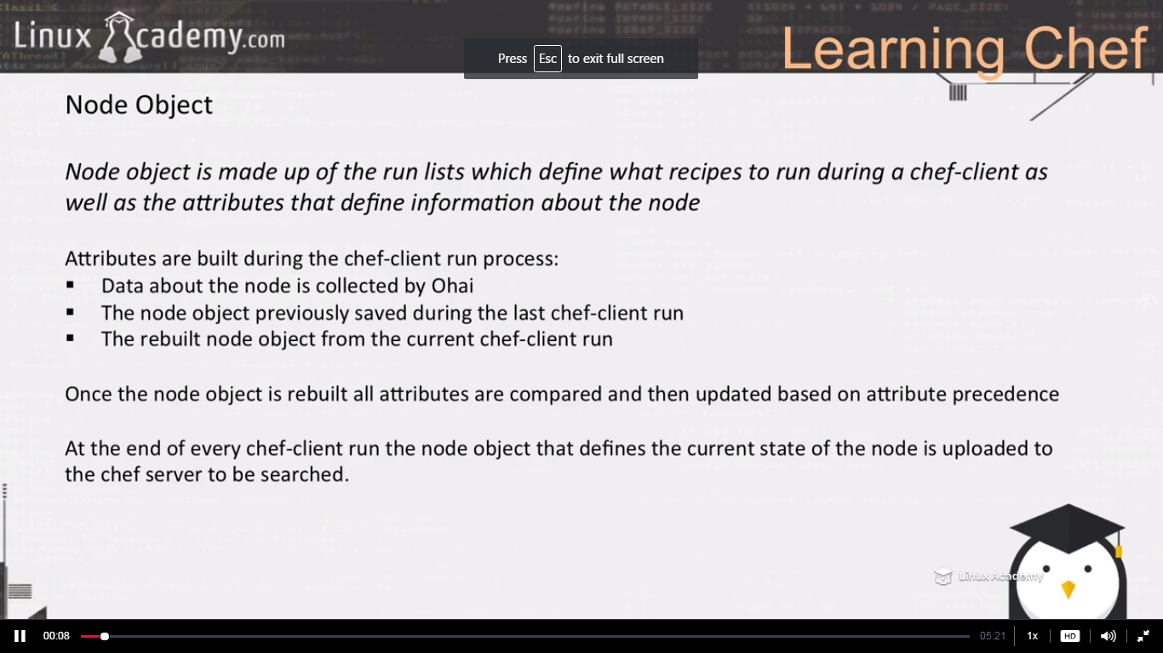

The ohai collects information the attributes information about the node. That information includes memory, OS, users on the system, groups on the system. Its system information about the node. That information cant be updated by us. We cant override those node attributes created by ohai.

When we run the chef-client on our node, loads the previous information about our node and then resets the attributes, runs the ohai node object, recreates the attribute based on the precedence and it creates a node object. So the node object consists of the recipe run_list information as well as all the attributes created on your system created inside of our cookbooks, environments, roles, as well as created by our ohai node object.

Once that node object is built, its essentially the snapshot of information about the node or the current state of the node, its then upload this to the chef server. Once its uploaded to the chef server it then becomes accessible to us to search that node object information. So we can use a tool on our workstation inorder to search that node object information on the chef server . We can search information such as the OS, what nodes are running whats OS’s . Really any attribute information that is stored within that node object, we have the ability to search so that we can write recipes that allow us to search information about a node and performs certain tasks. So we can search with any node object and also we can search for nodes that contains specific attribute information from within the node object .So we can say in short that the node object is a snapshort containing all attribute information and information about a node. Its also consist of the run_list which determines what recipes are to be run on a node during a chef-client convergence.

WE can go to the chef management console and select the node and go down to the attribute section and there you see the attributes

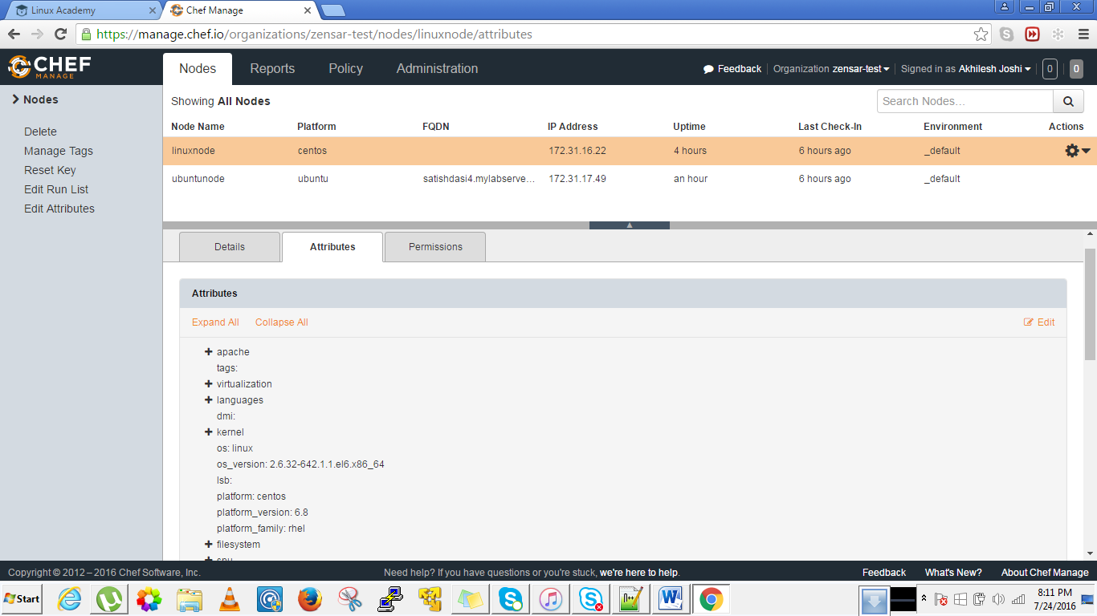

These above attributes are populated by the ohai node object. These attributes are essentially our node objects, stores information about our node. All these attributes are searchable because its stored on our chef-server. We can also use this information inside our recipes, we can access this information. Like we have done before everytime we access an attribute inside our recipe, we can access it by calling the node and then the attribute name. We can also use the search function to search through this information within a recipe. So everthing in here makes our node object.

Lets take a look to the ohai tool. Just login to any of your node and type the ohai command as

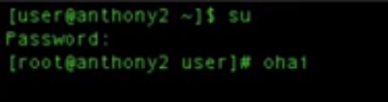

The ohai runs the information about our node

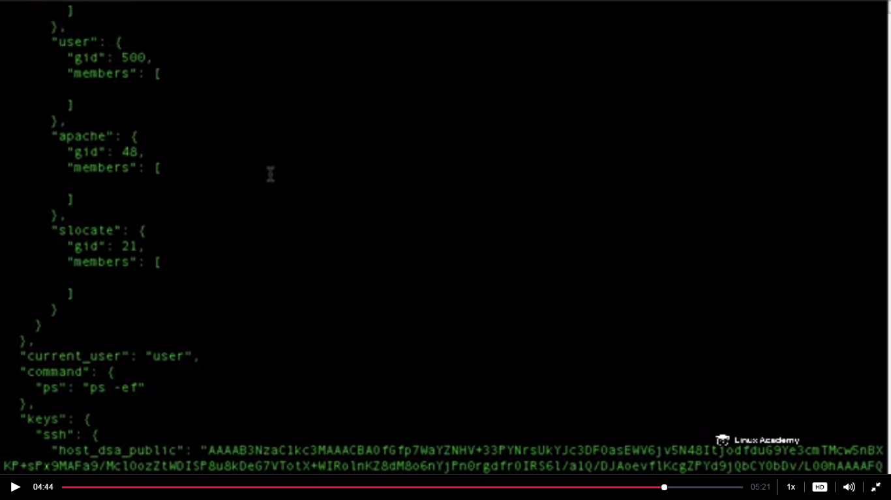

This tool ohai runs every time the chef-client runs on our node. We can look for the information here which looks like in json format. The ohai maintains all the information about the system and updates our node object every time our chef-client is run.

**Lecture: Search Concepts**

In this lesson we are going to learn a little about search and what search can do for us in our Chef environment.

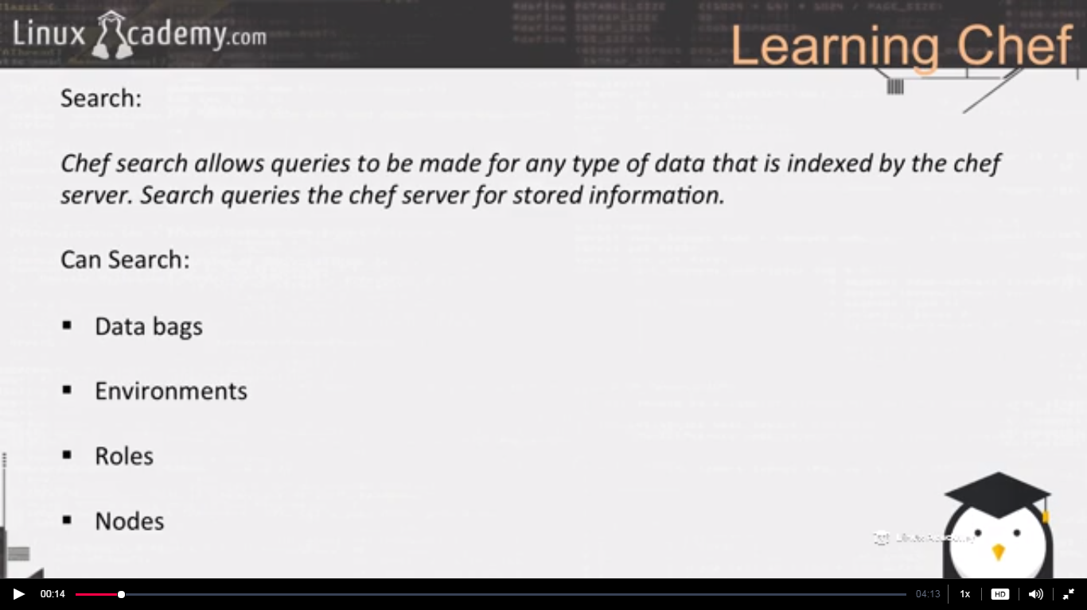

Data bags are json variables that stores information .If we are able to search the node that means we can search the node object and the node object contains everything we learn in the previous lecture. So we can search for the recipes, the swap space, CPU information on the node, we can search for node running a specific platform.

Lets now talk about some different method of search

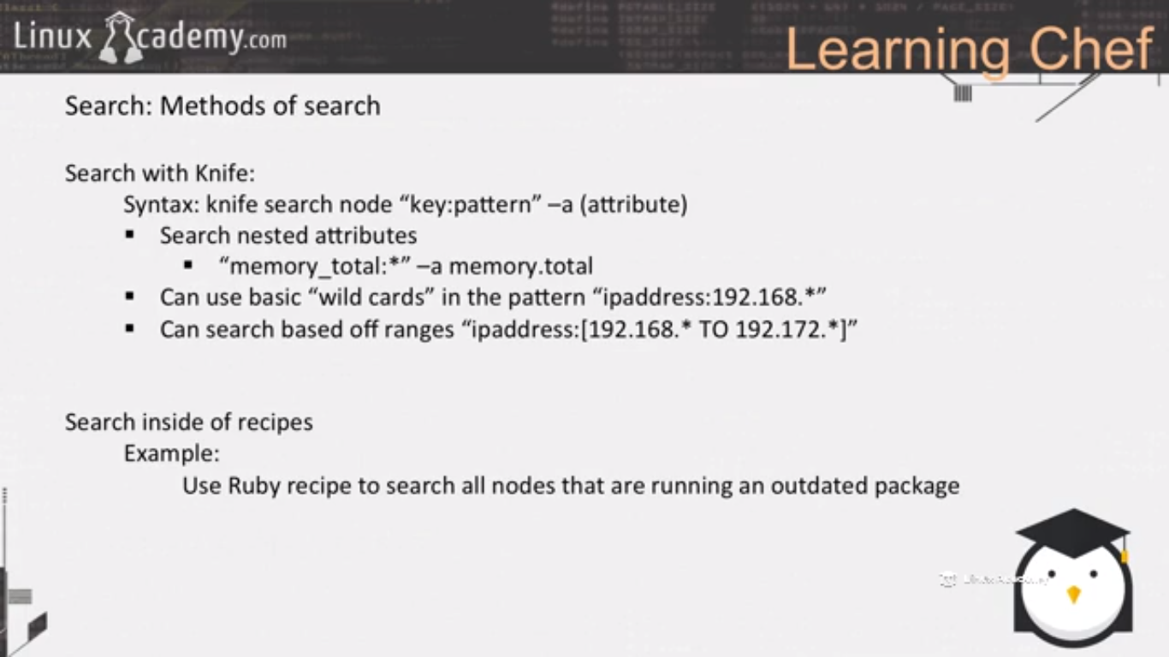

After this lecture we will use knife to search attributes from our node object to the chef server. The syntax for the knife search is above.

**Lecture: Searching Node Attributes Using Knife**

In this lesson we are going to work with the knife command line interface to learn how to search node attributes from the workstation.

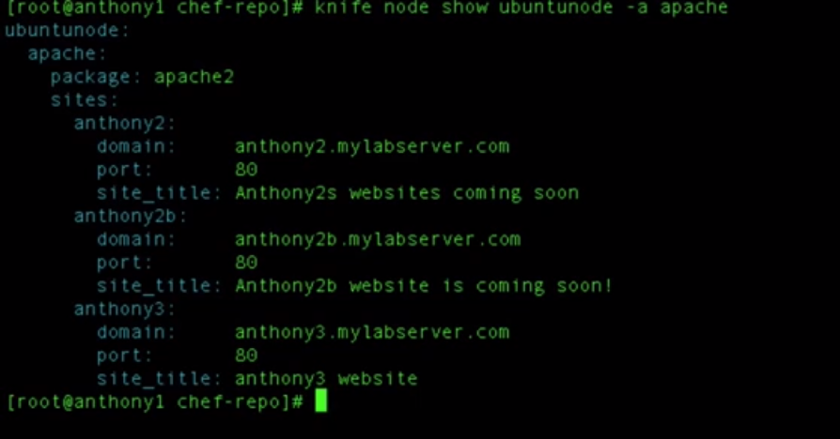

This gave us a list of attributes named as apache inside the ubuntunode. As we will see from the chef interface the apache attribute is nested.

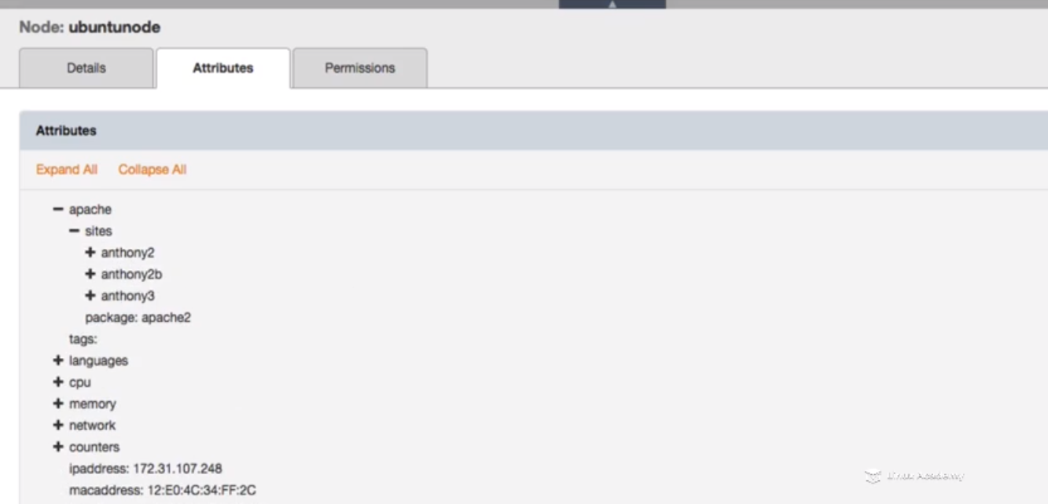

We see apache is a nested attribute from the attribute section inside the chef interface.

Above knife search gave us a list of attribute So lets search for a specific attribute

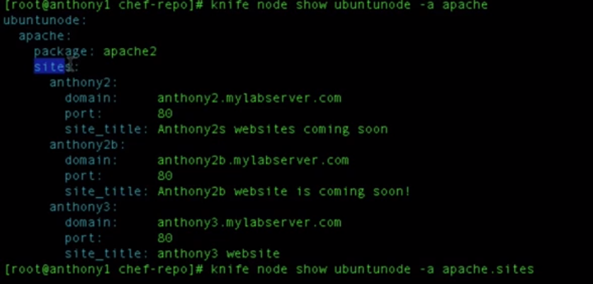

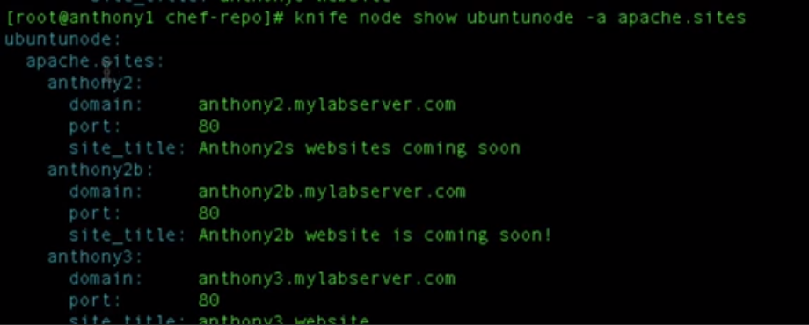

The above search returned the next level of attributes ie all attributes with attribute.sites



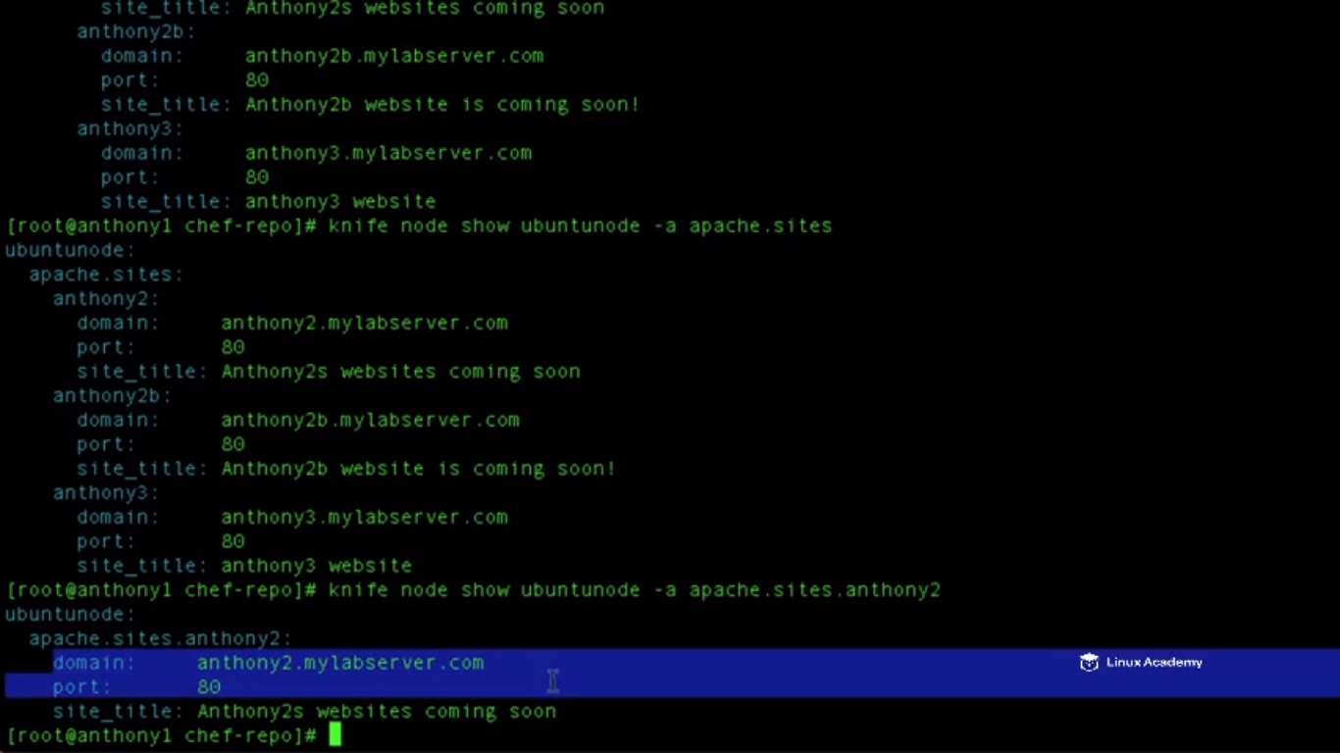

So now the values for anthony2 are listed .

We can beyond that lets say we want to see the domain name for anthony2 as



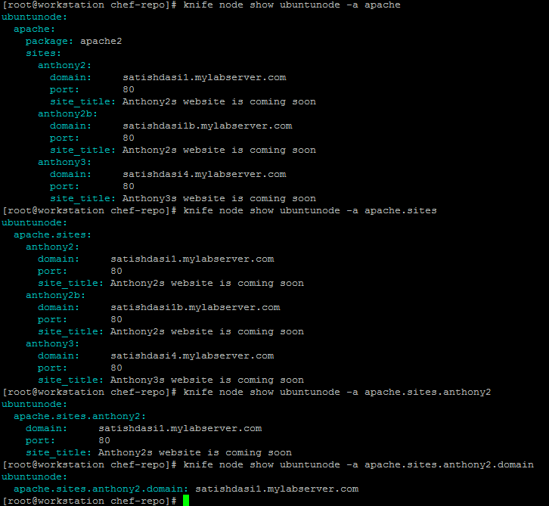

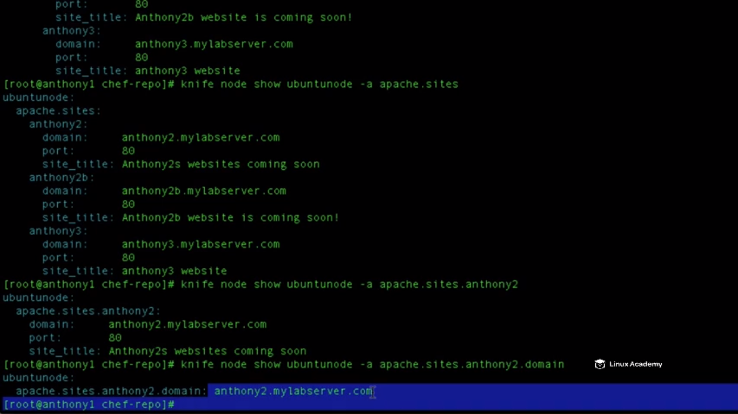

Lets look it like we want to see information about the system lets say memory.



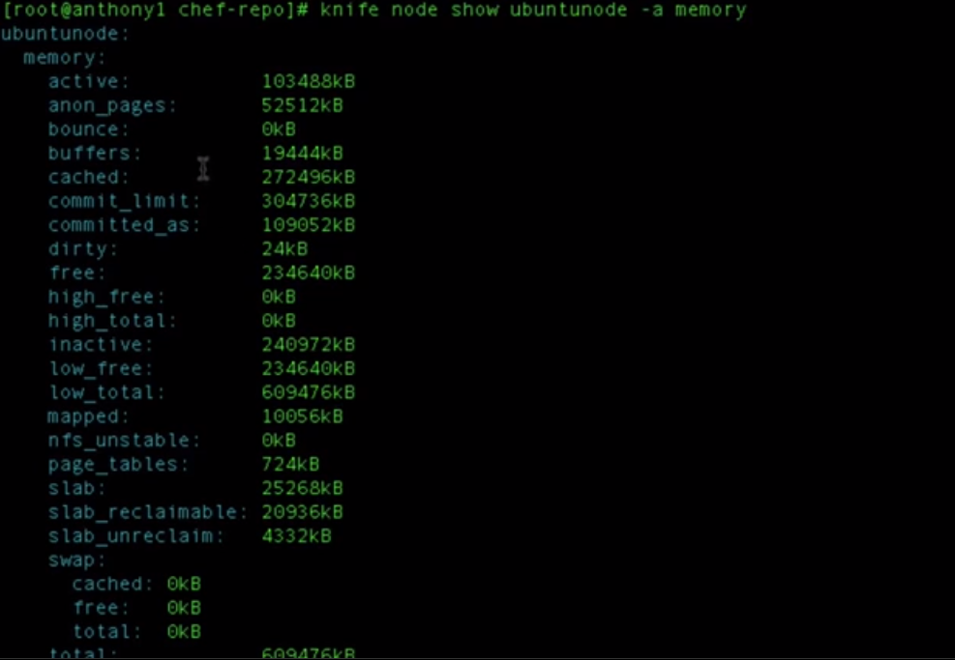

There are attributes inside memory as memory attribute is nested so lets get the attribute active memory.





Lets say we want to pull the swap memory information

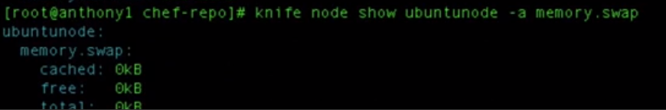



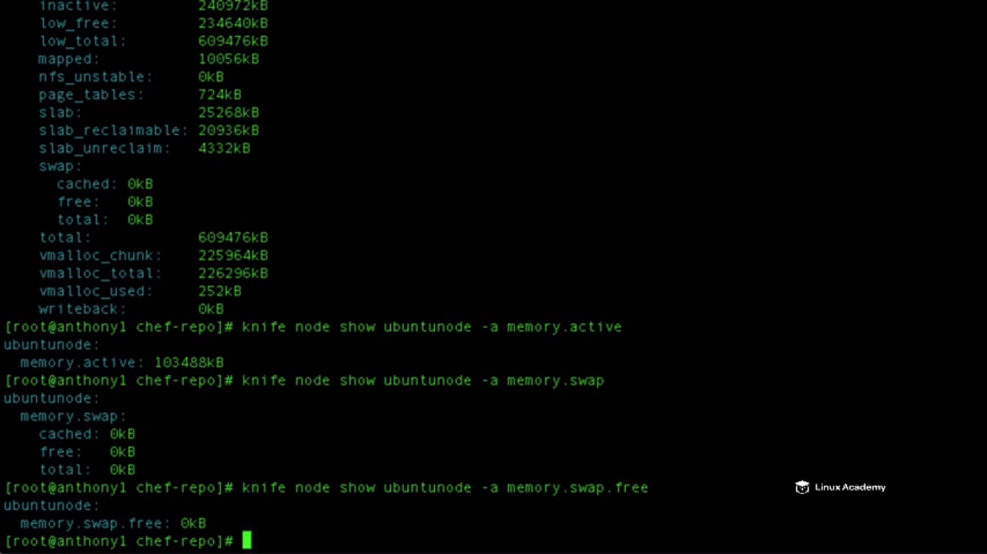

This information is based of the last time our chef-client convergence occurred on this node because the node object was built and was sent back to the chef server. So this is the real time information, this is the information the last time our node checked in to our actual chef enterprise server during our chef-client.

So now as we learnt how to search for nested attribute lets use that advantage while learning to search inside to our workstation to our enterprise server.

Lets search for a key pattern as

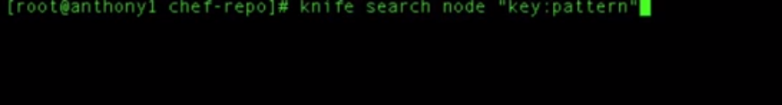

Replace the key with a name and pattern as well for e.g

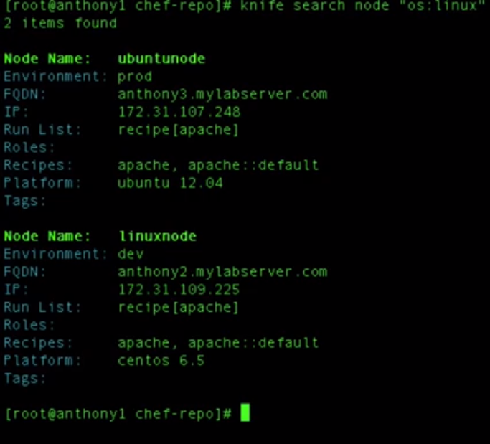

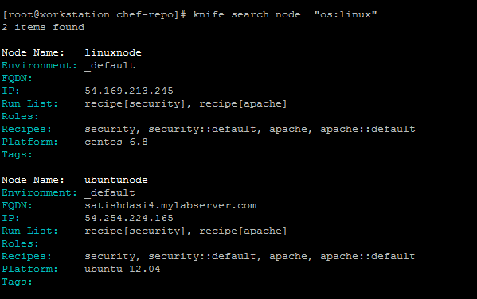

So above we searched for all the nodes that have that have the OS attribute as linux which was populated by the ohai tool during our chef-client run . We can do –a to view the actual attribute

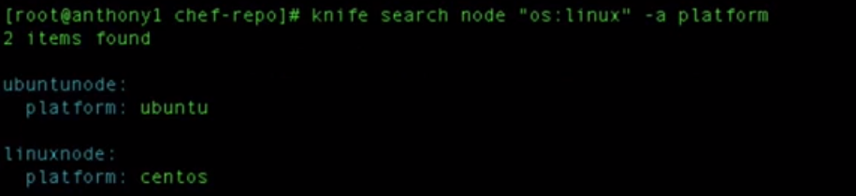

Lets extend the search and search for the pattern “platform: Ubuntu”

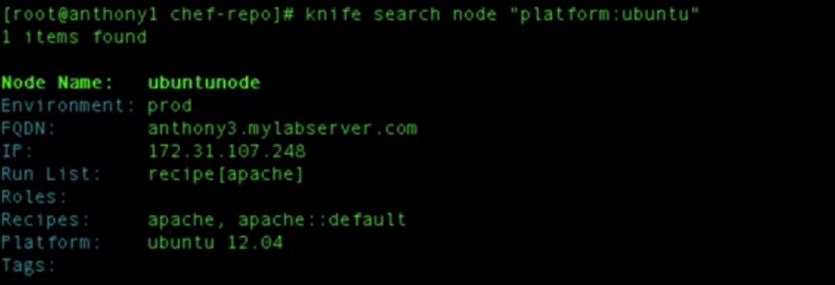

Lets us see what the swap space for a node which has a platform Ubuntu.

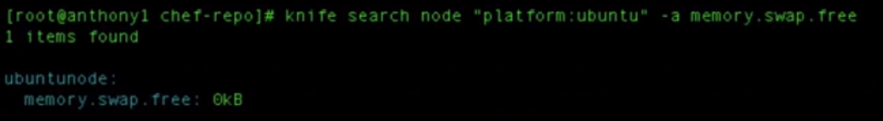

Lets do the same above search for memory.swap.free for all nodes with any platform

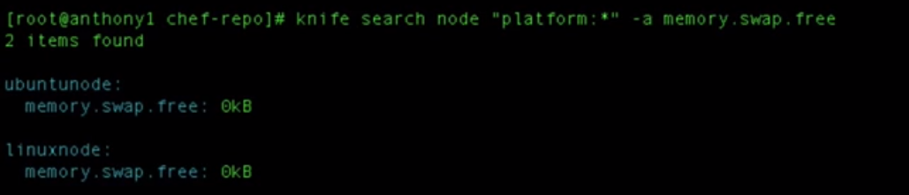

So how to search for nested attributes

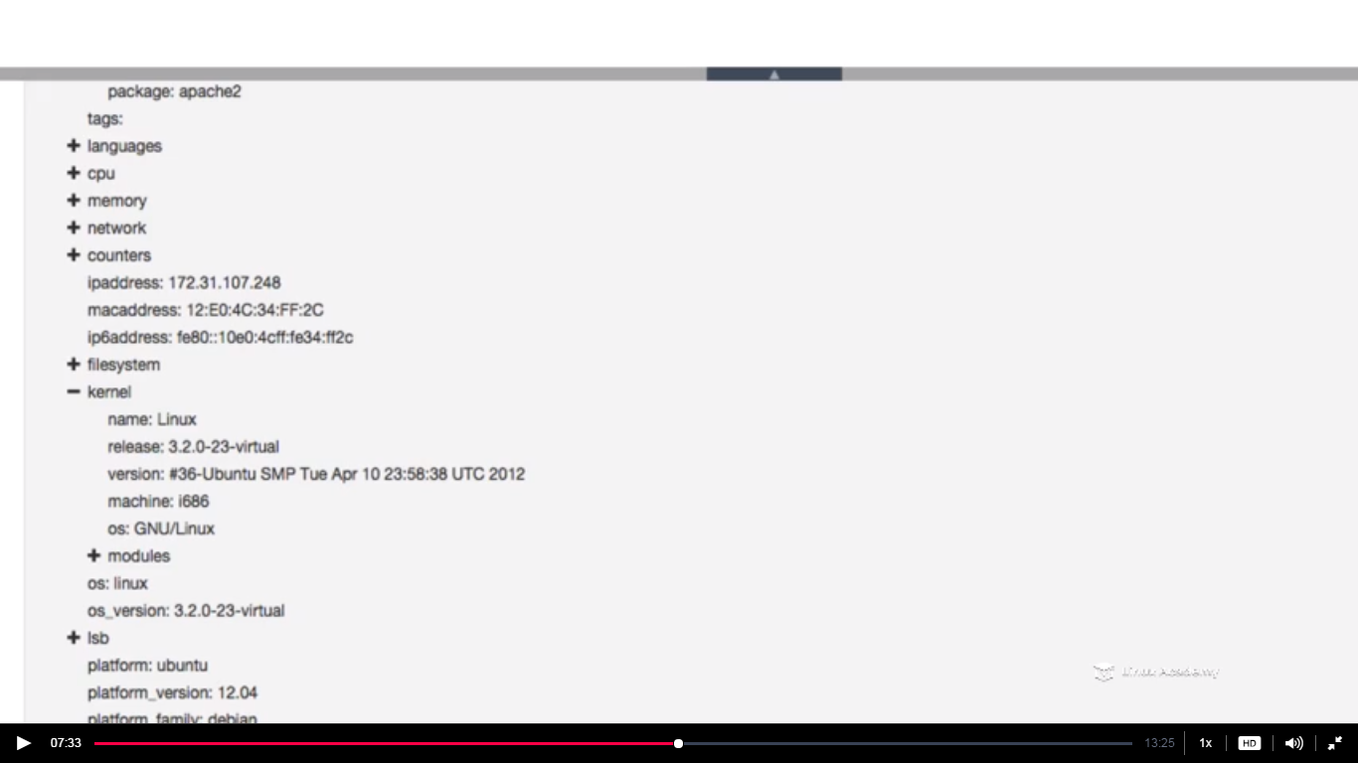

Lets take kernel attribute and we want to search for all nodes having kernel release as

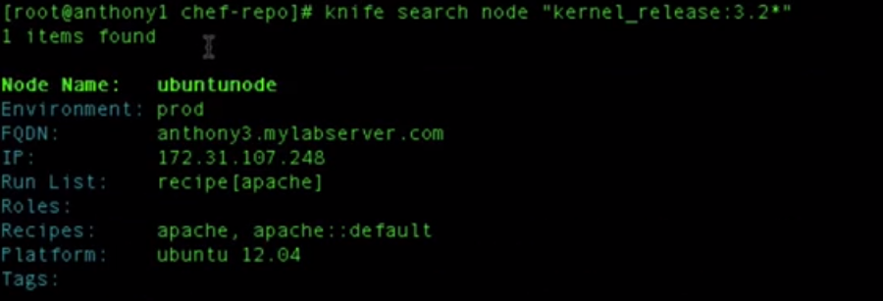

IT returns all node running kernel releases 3.2

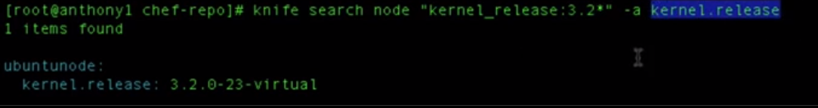

There is single node running the kernel release as 3.2. Lets see the kernel.release for all nodes of any kernel version as

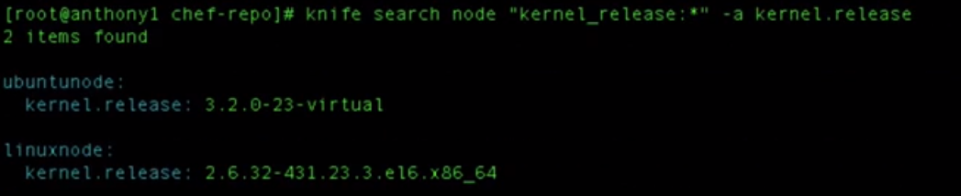

A few new search patterns as

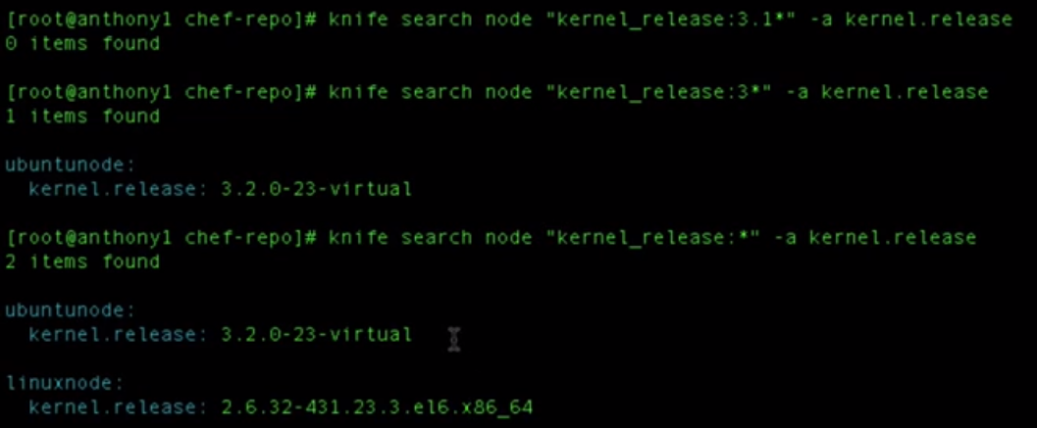

Lets use an AND inside the search as

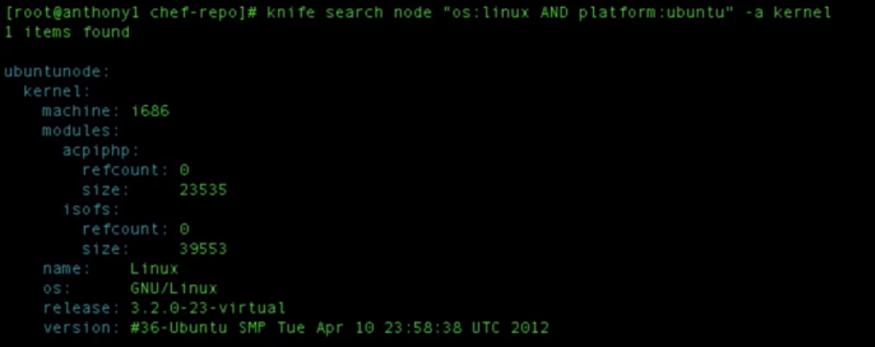

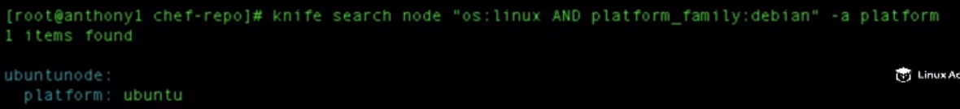

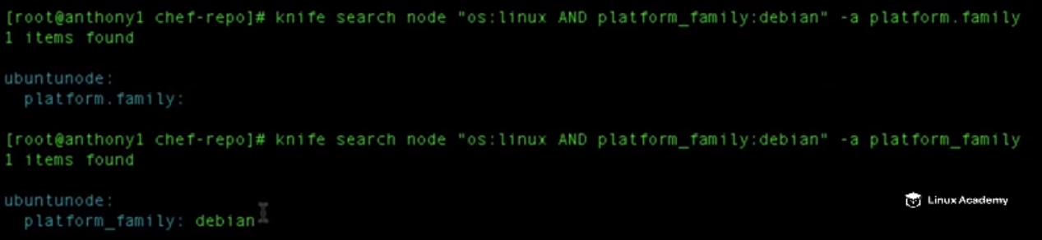

In the above search i.e

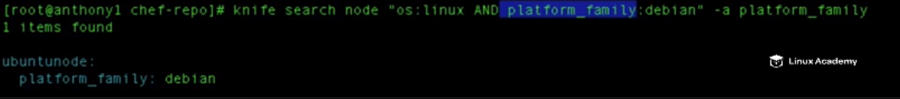

We are not searching for a nested attribute but search for an attribute name as **platform_family.**



**Data-Bags**

**Lecture: What Are Data Bags?**

In this lesson we are going to learn about data bags and what they can be used for on the Chef server.

What we can do is that we can create a recipe that search for the specific databags and then create the users based of the data inside of the datatbags so would have something as the username, the shell for the user, the user’s home directory, the users id, the default primary group for the user.

We can encrypt databags since they are a set of variable information , the json object we can encrypt and decrypt on the server. So we can securely store API credentials, passwords, information that we don’t want normal people to see within our cookbook upload it to the node and decript it. So we can send the proper credential to the proper node securely without having any type of security vulnerabilities or compromises within our security. So data bags are better option for that.

Databags are independent of cookbooks. These are uploaded to the chef server and our cookbooks and recipes can use them as they are independent standalone environment variables that we can use within anyone of our cookbooks and recipes which are on the chef-server.

Lets take an example of a data bag

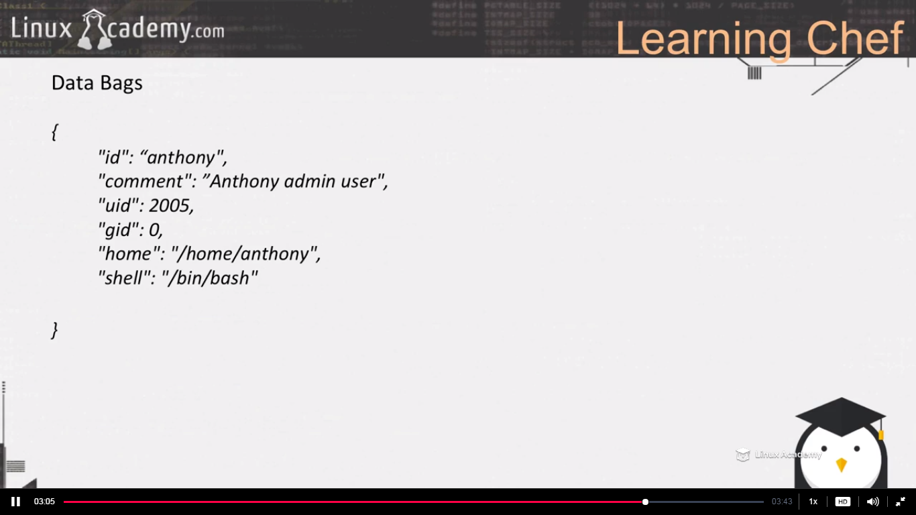

###################################################################

**Lecture: Creating User And Sudo Group Data Bags**

In this lesson we are going to create our user and our group data bags and upload them to the Chef server for usage

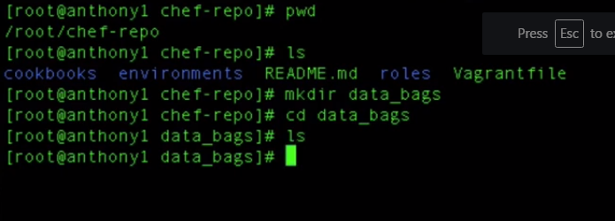

Lets discuss what databags we are going to create on our chef server. Our goal as a part of this lecture is to learn how we can use databags to deploy out administrative users to our node and assign those administrative users sudo privileges by having them to join either the sudo, admin or wheel groups. It depends on which distribution they are running on.

In our case we would be creating two databags one users and one groups data bag.

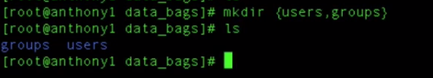

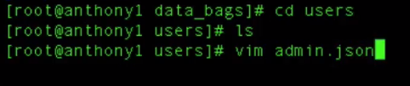

This is the name of the user we want to have a databag for.

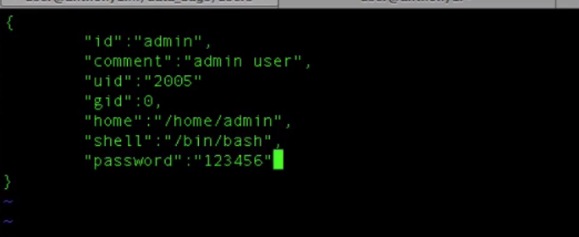

There is no comma at the end of the last attribute.

Save and quit

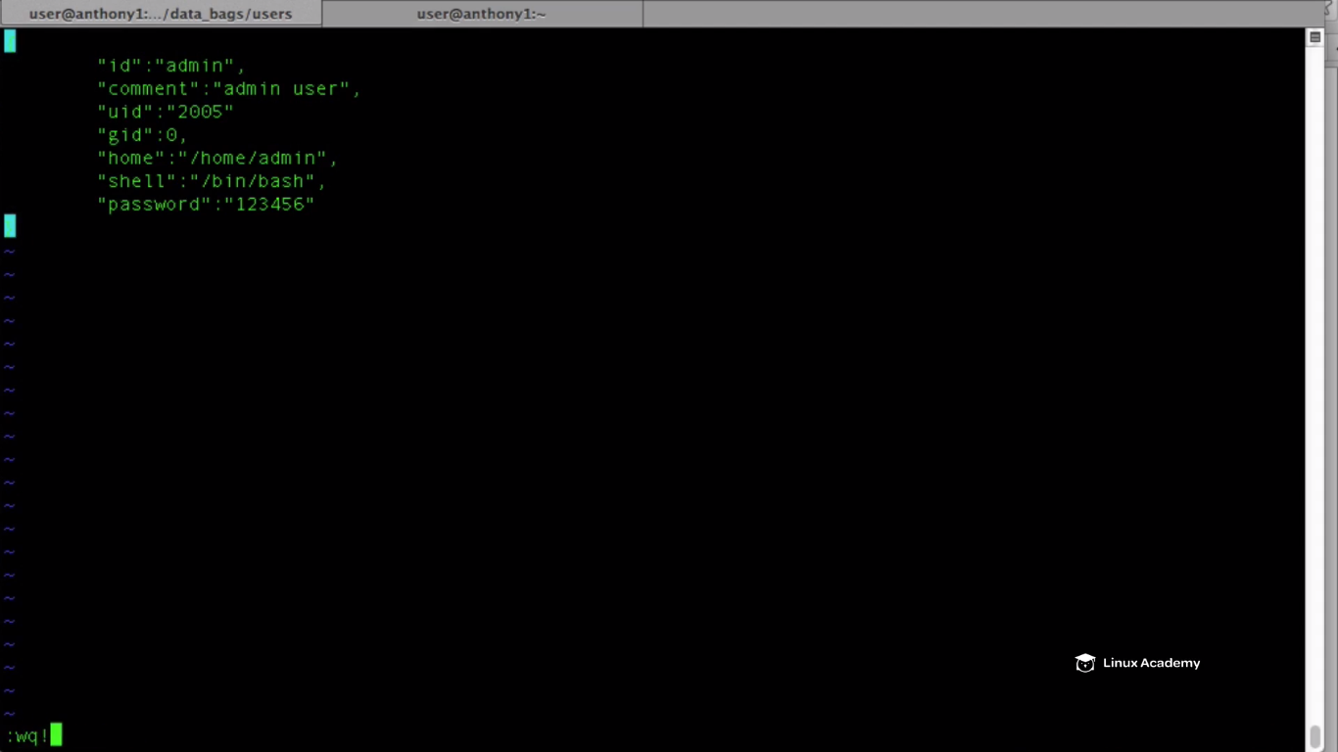

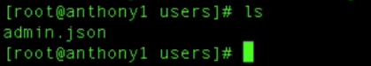

Now we can see we have a admin.json user and now this is going to represent the user that we are creating on our local machine or our local node .

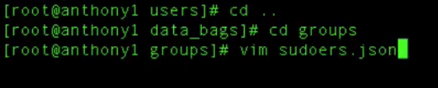

So these databags are just the bags of information that are stored on the chef server. They don’t do anything until we write a recipe to do something with it. So we are creating the data here. If we want to create local users on lots of the server so that’s we are doing . Then we have to write a recipe which actually provides the instructions on what to do with the databags information.

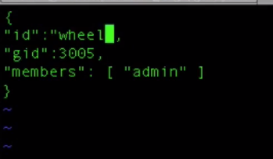

Save and exit

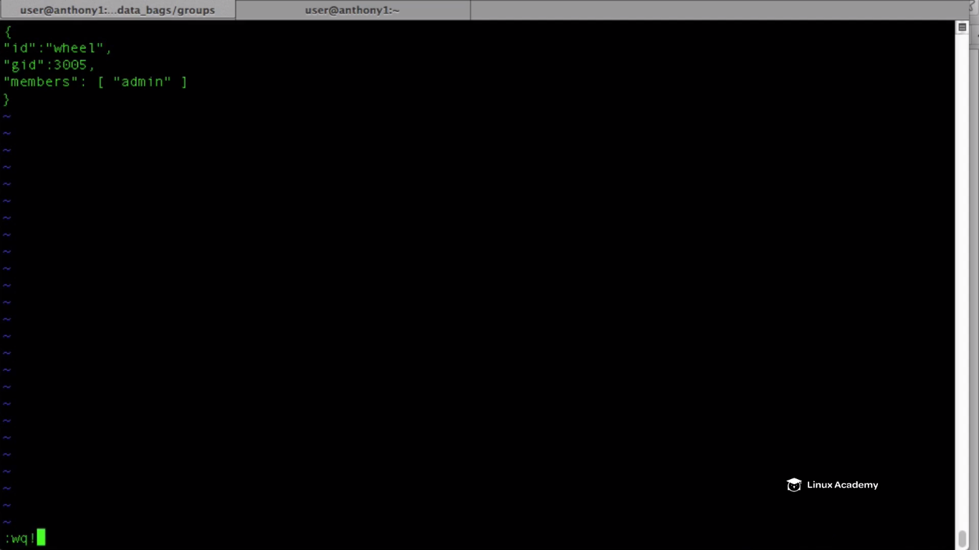

Now lets create the databags as

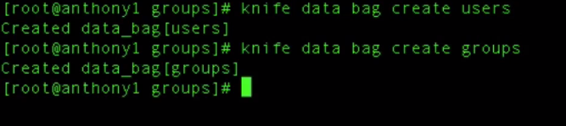

And go to chef interface and see if data bags are created. Go to the console and go to policies

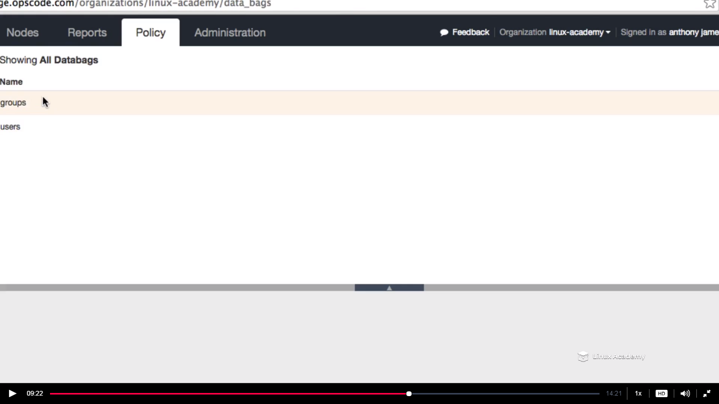

However we wont be able to see the data items yet

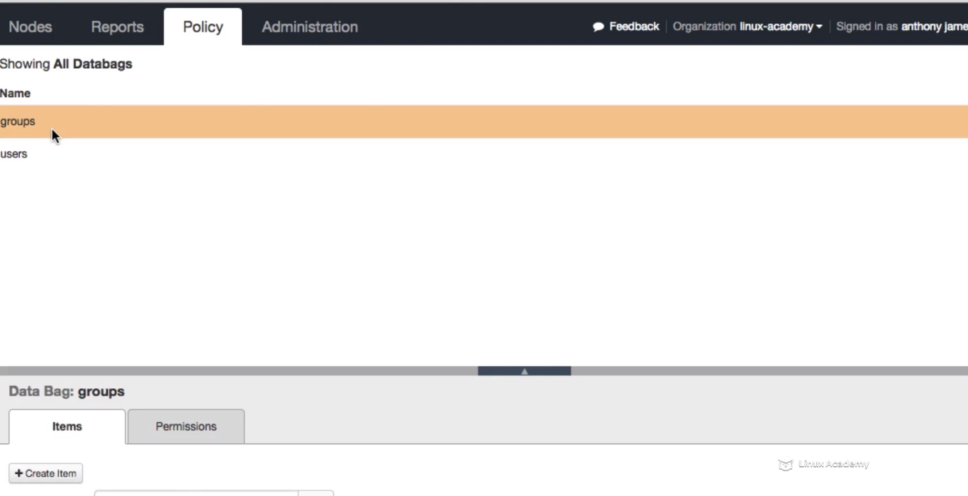

So lets go and add our databags items.



This is going to look inside our chef-repo/databags/users directory.Its also going to edit inside our users databag inside our chef server.



Error lets issue this command from the chef-repo directory hence go to /chef-repo

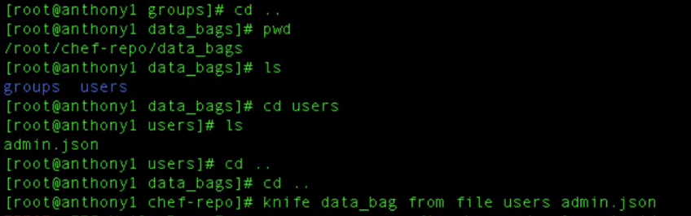



There is a parsing error so lets get back to our databags

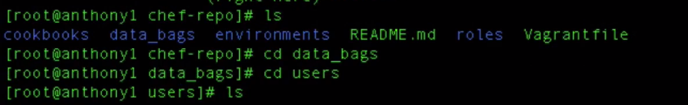

Vim admin.json

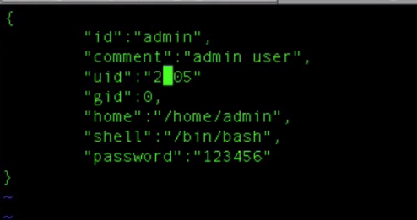

We are missing a comma after the uid

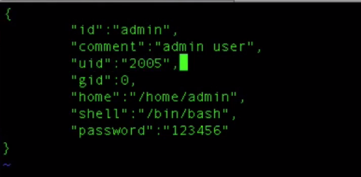

Save and quit

Go back to /chef-repo and upload admin.json to the databag as





Lets upload our sudoers.json as well to the groups databag

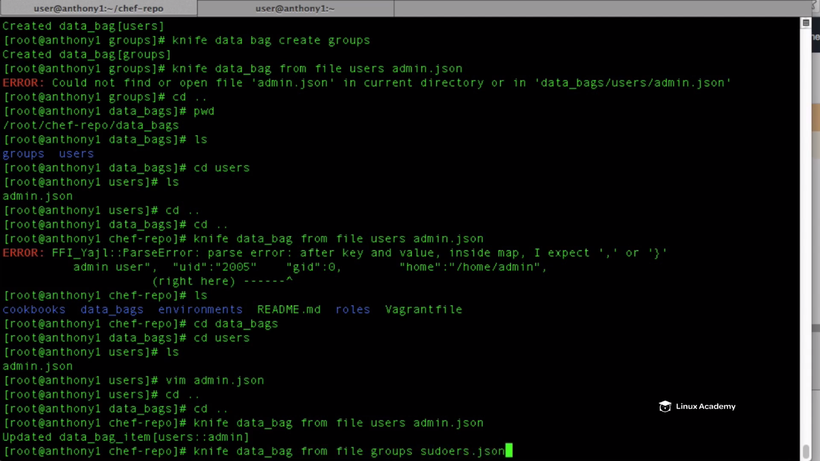

Last line was the addition of sudoers.json to the groups databag.

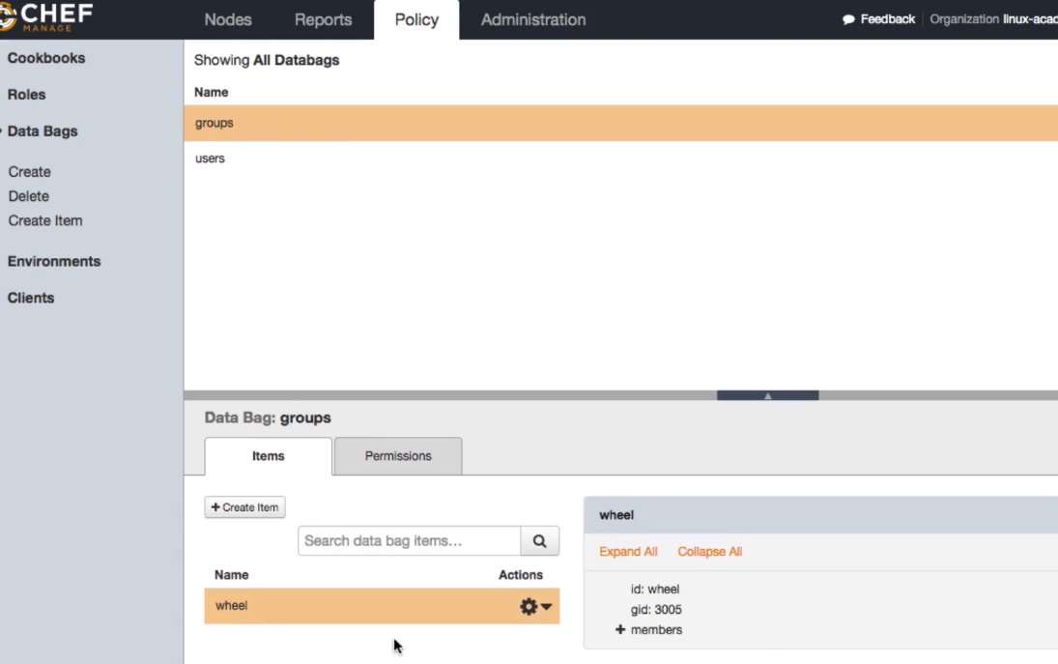

Under our group I see the data item wheel we added. So this doesn’t do anything except containing data. We have to write the recipe which takes the data from the databags and does something with it on our node.

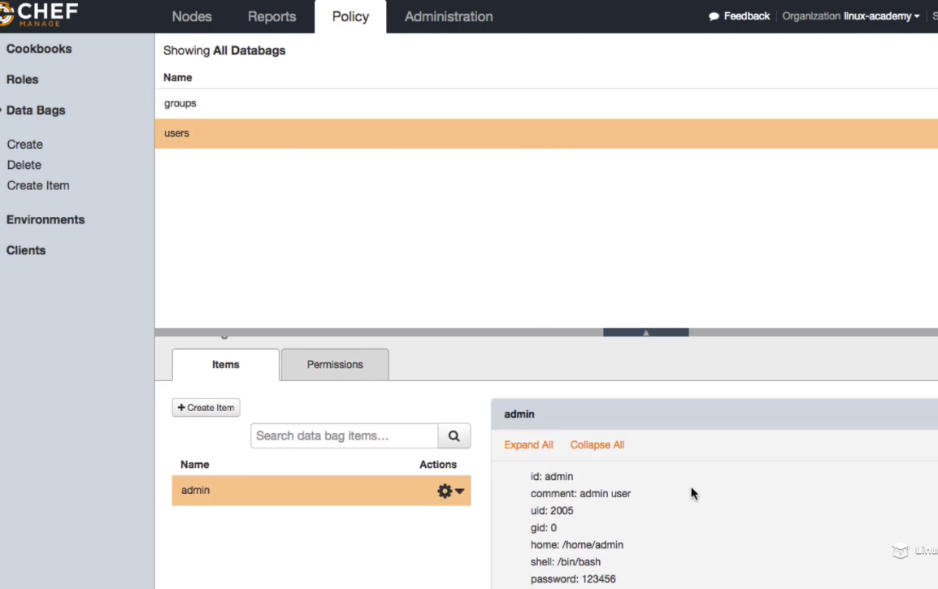

Now lets see how to search our databags from our commandline

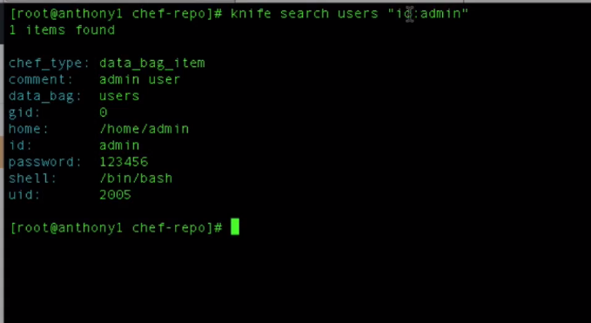

Users is the name of the data bag and the attribute name is id:admin. Id is the key and admin is the value. So we are searching for a attribute within a databag users.

If we want to get the information of a specific attribute then we need to do is

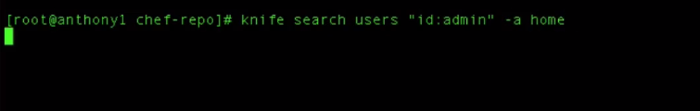

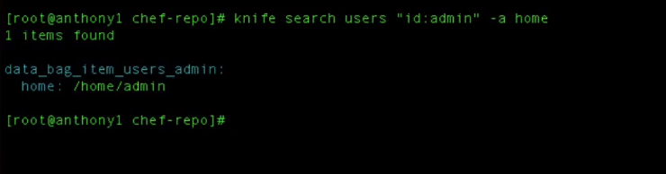

**Lecture: Building A Recipe To Deploy Local User Accounts From Data Bags**

In this lesson we are going to build our recipes that will utilize our user and groups data bags. From within our recipes we are going to search the chef server for data bags and then create our admin user and assign the admin user to the wheel group.

**So databags are stored globally on the chef-server which means that anyone of the cookbooks in any environment thoroughout our organization has the ability to use the information stored inside of the databags.**

So we just need to write the recipes now that will add our user admin to the system and then create the user group wheel if it doesn’t exists and then add the admin user to that wheel group so that admin has the sudoers privileges.

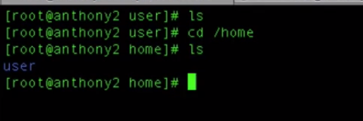

Above Im just verifying whether my node has a admin user bydefault. Lets create a cookbook

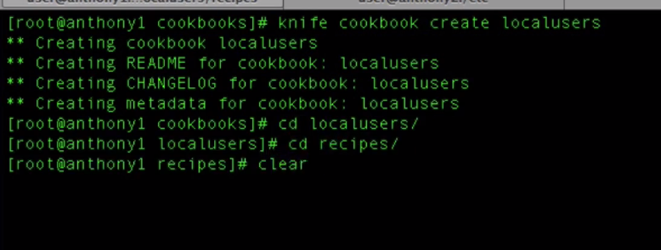

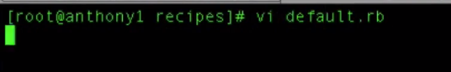

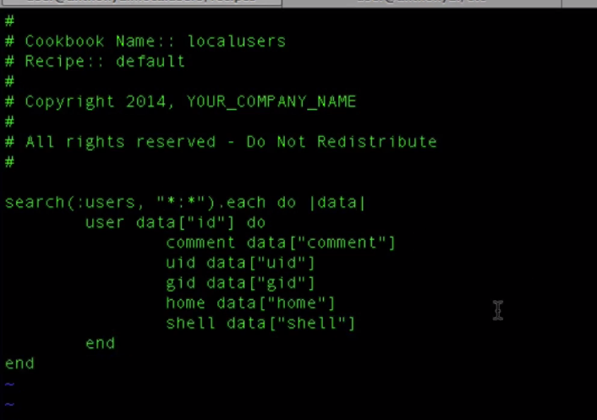

First what we did is user a search ---For each item inside our databag we want to do something i.e we want to create a user. So first we need to solve the problem as how to search for the databag. We do search by using a search function.

So we are searching for the users databag hence we wrote users after the parenthesis inside the search function .



Next we need to define the attribute and value of the attribute we are searching for . so if I want to search for comment having the value of admin and then anything behind it

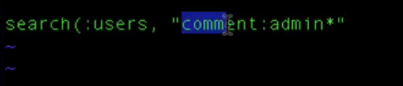

This would return all the databag items that have comment set to admin first and anything behind that . But here we want to list all databags items within our users so we will say for the key * and the wildcard (:)

For each databag so put a .each. So we want all the attributes inside the json databag into a data object hence we did (do |data|). This data object will have all the attributes from the each databag.



Now for each databag returned we want to create a user and that we can do using a **user** resource.

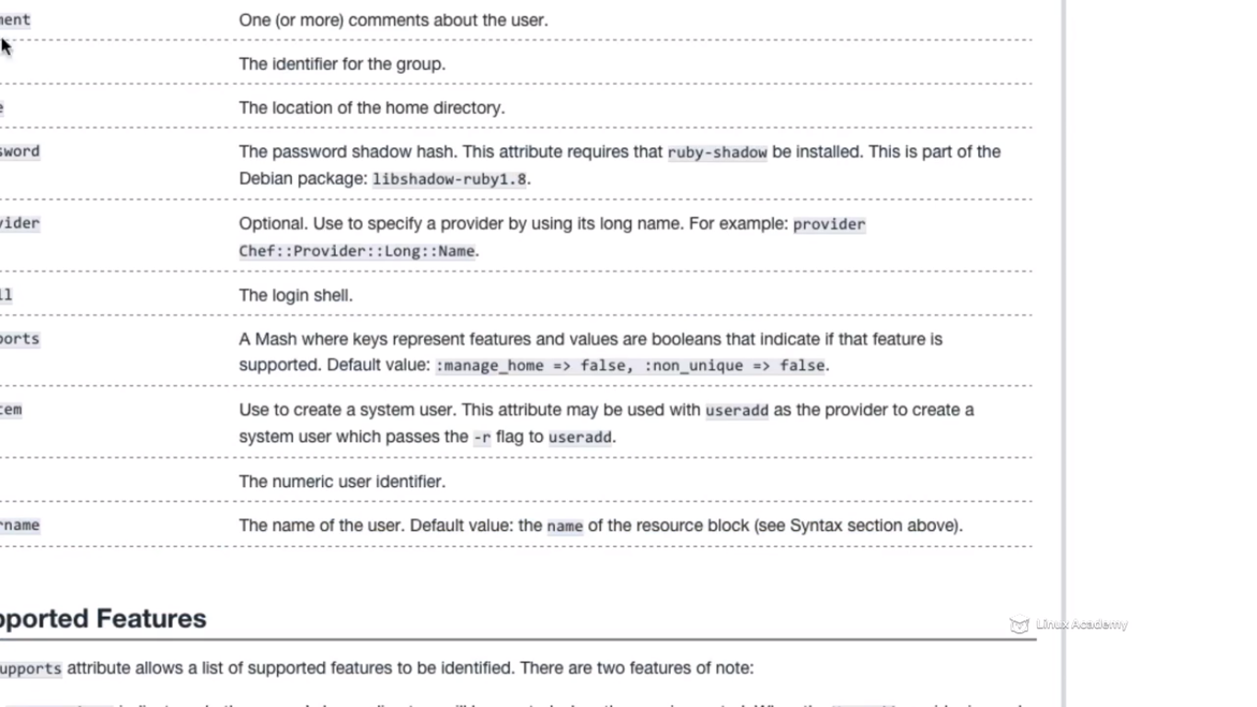

So if we see the chef documentation you will see a lot of attributes available for a user resource.

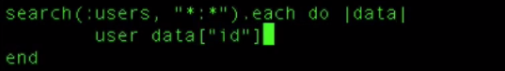

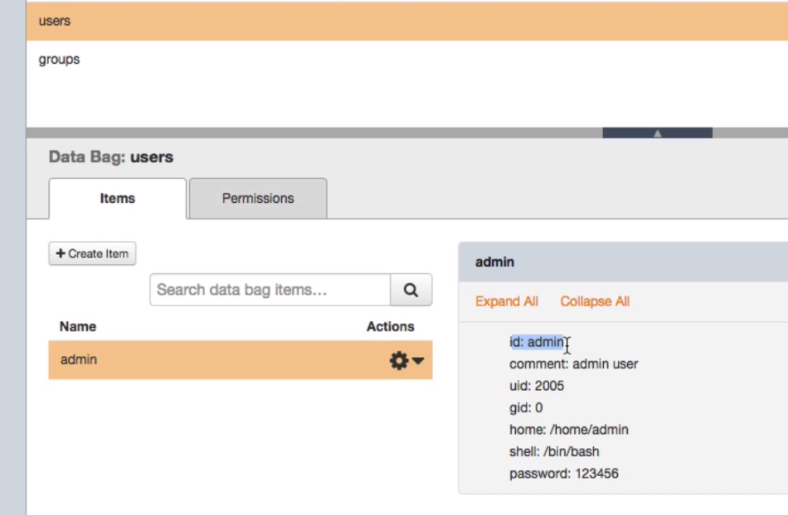

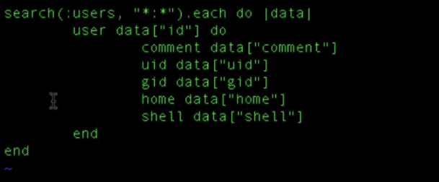

So it loops for all databags and maps for each attributes.

Save and exit

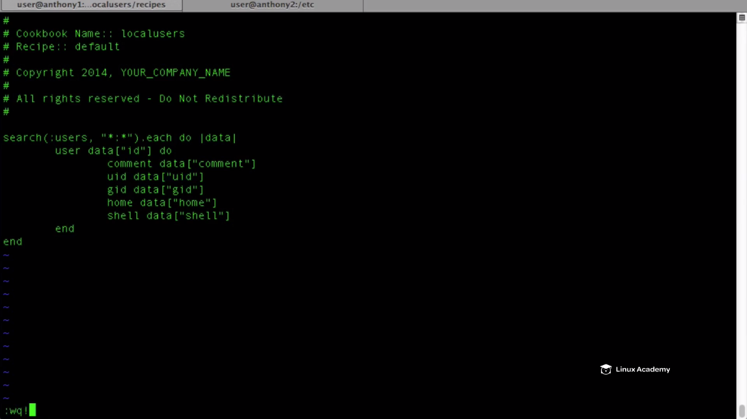

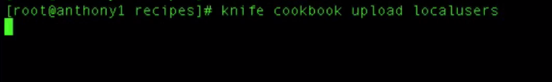

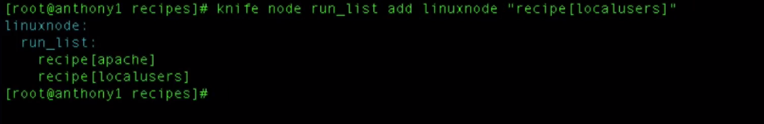

Go to the centos node and do a convergence

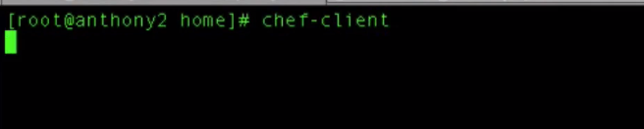



We can see the admin user created as

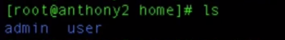

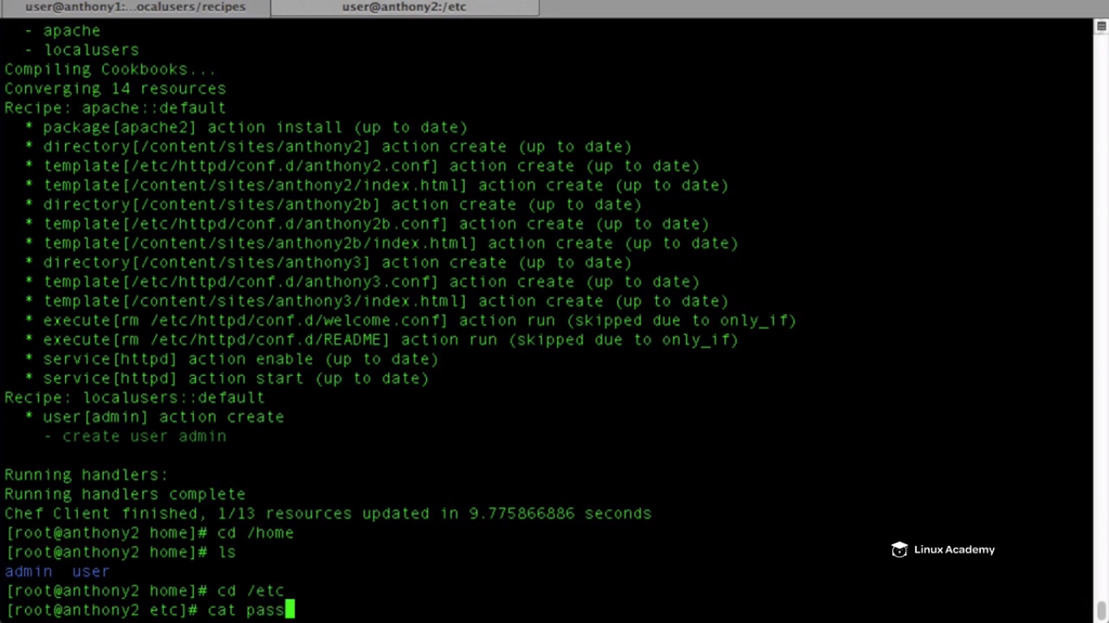

Cat for passwd file

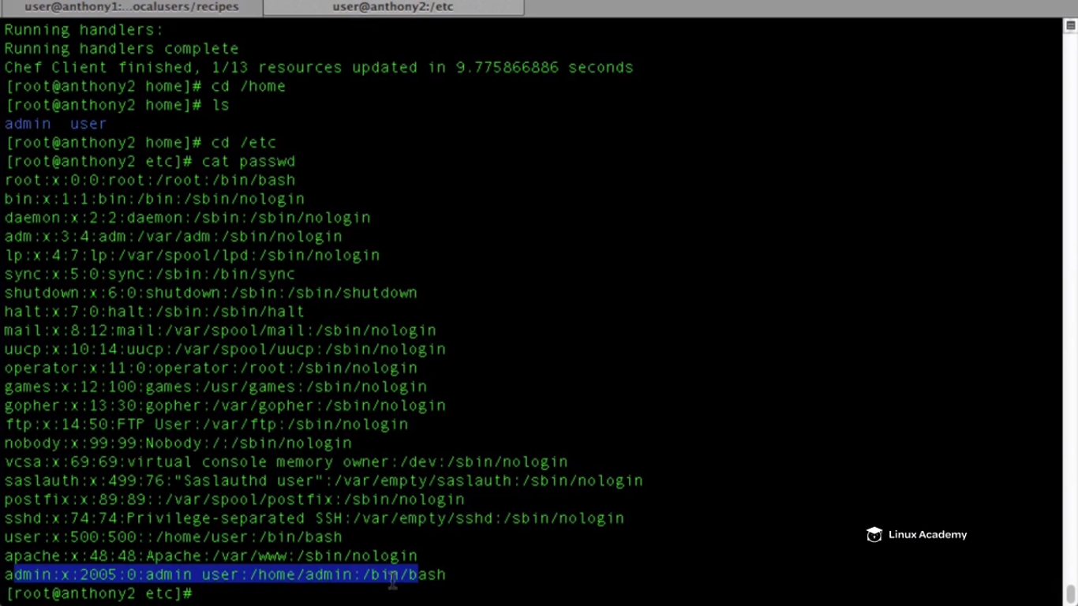

We can see admin user is created .

Now lets go and create a group recipe that creates the group if it doesn’t exist and add the user to the wheel group.

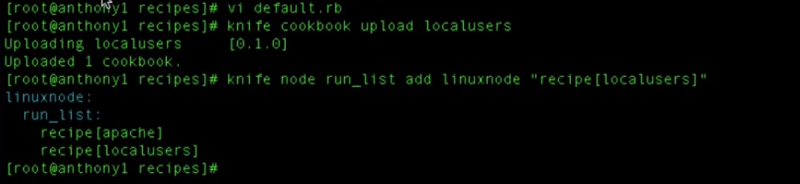

We are creating a recipe inside the same cookbook created earlier

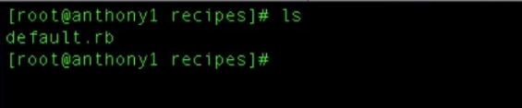

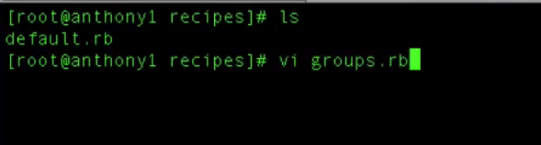

We are going to search for all databag items inside the databag groups and get the attribute inside a data object and will use a group resource. We can go to the chef documentation and look for the attributes we can map for the group resource as

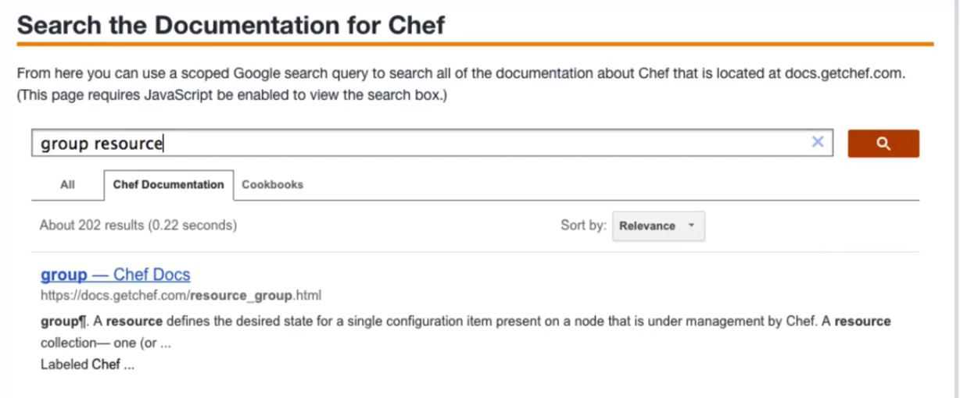

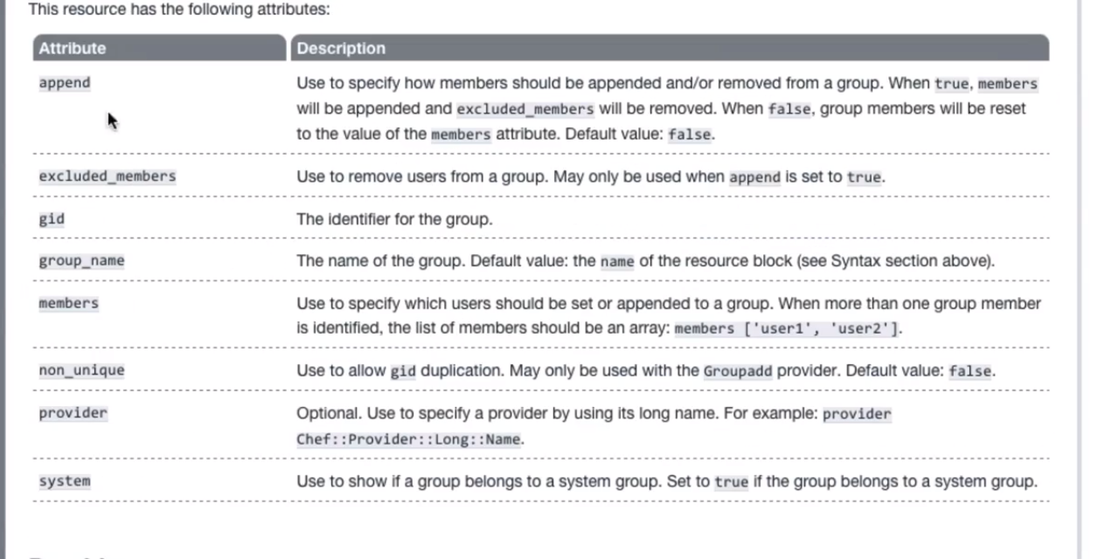

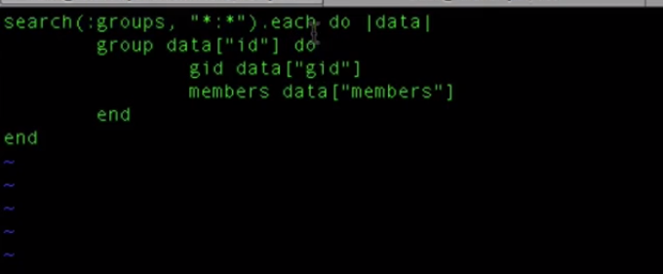

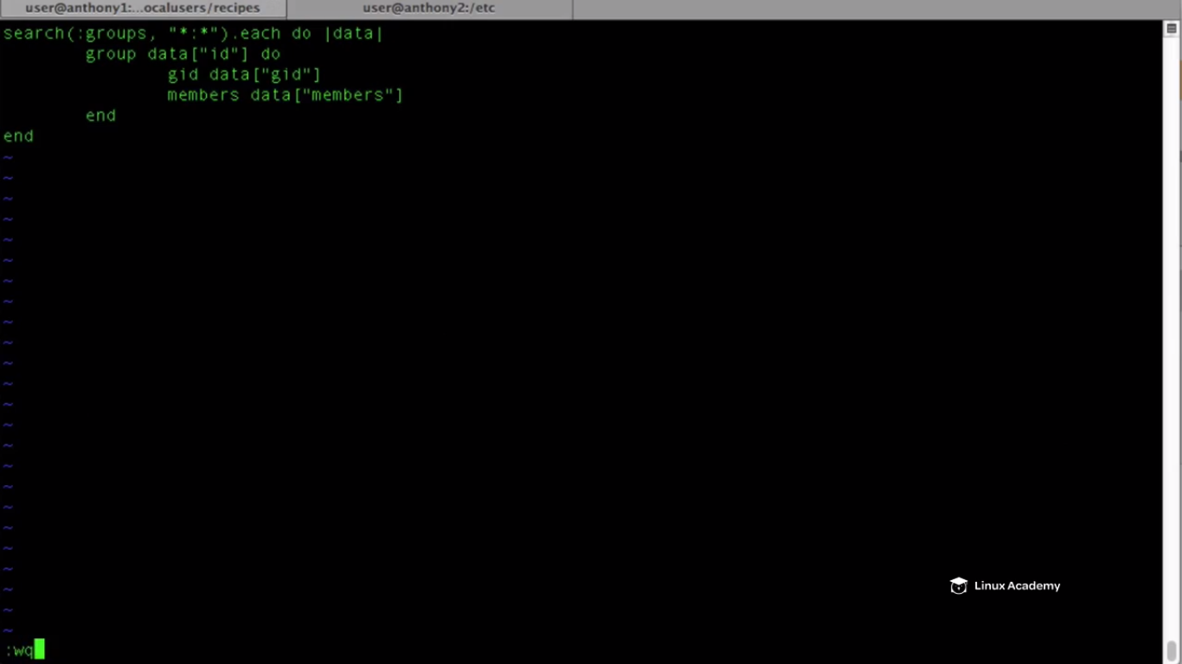

Now we need to add the recipe to the run_list or we can do

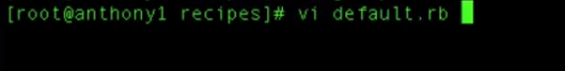

We don’t want that our group recipe to run unless our user has been added to the system. So our group recipe is dependent upon the default recipe which adds in our user, So add the below line to



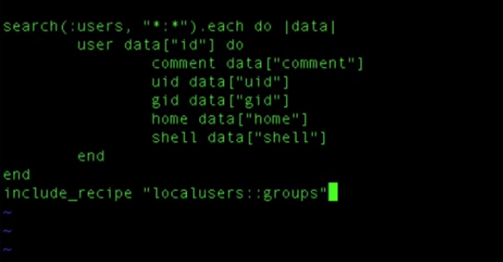

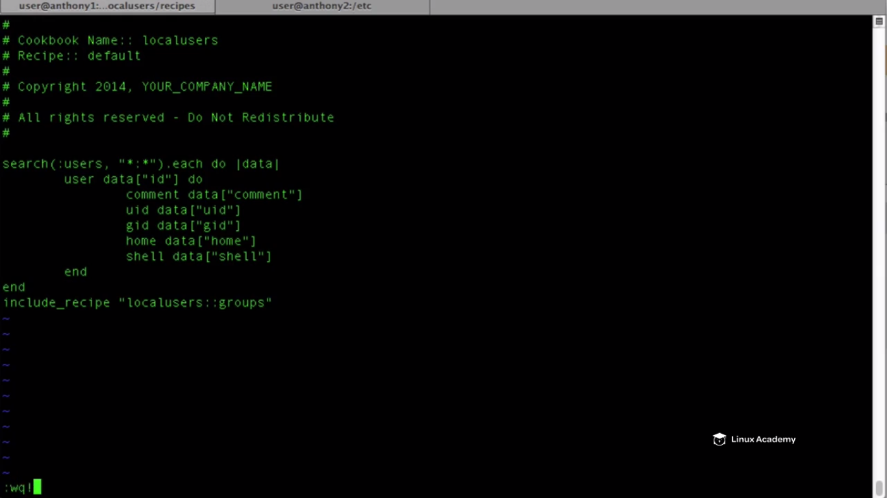

**We don’t require to add the dependency to the metadata file because both recipes are found to be on the same cookbook.**



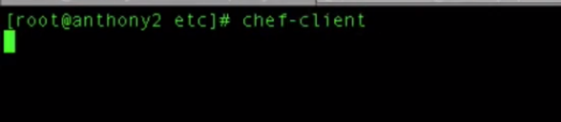



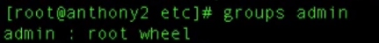

**We can see at the last user admin is added to the wheel group.**

Also we have a user already created in the linuxacademy server and we can see that this user isn’t a part of the wheel group as



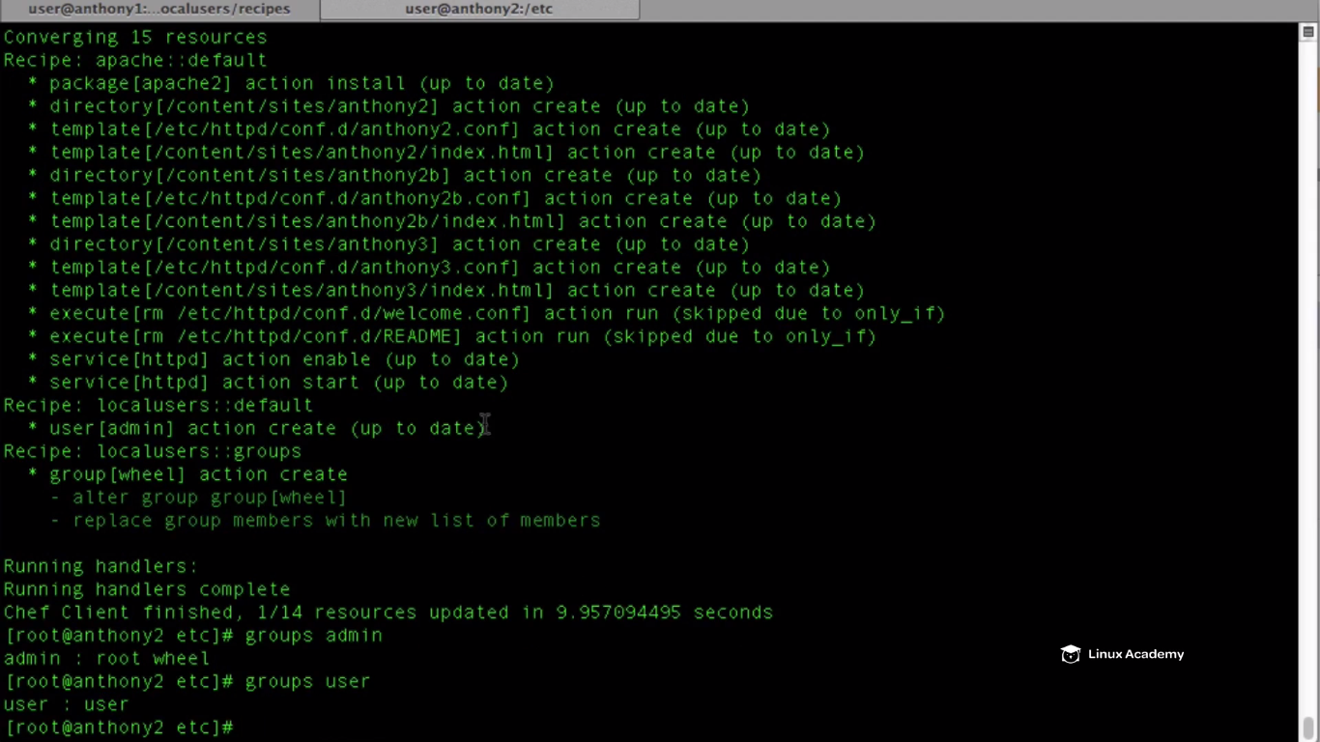

We see the user is not a member of the wheel group.

Lets say we want that user to be a part or member of the wheel group.

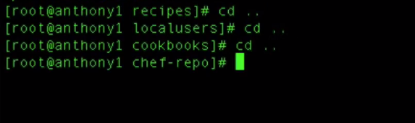

Navigate out to the chef-repo directory

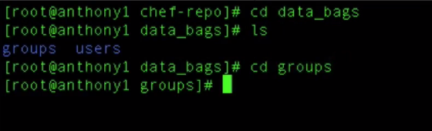

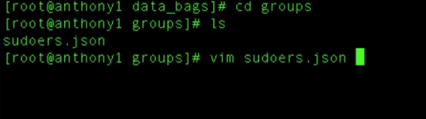

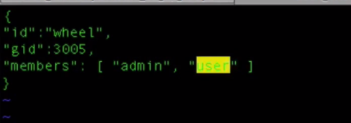

Save and quit.

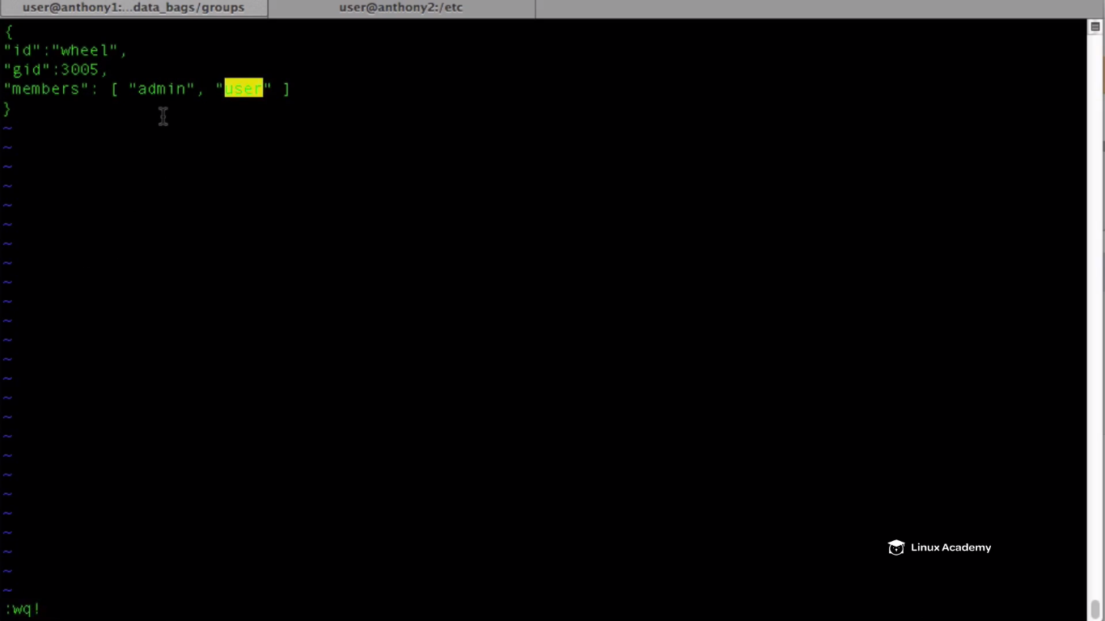

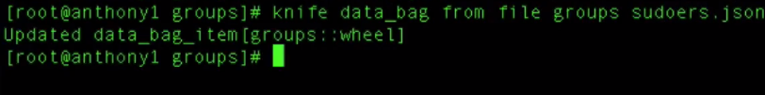

Run a chef-client on centos node

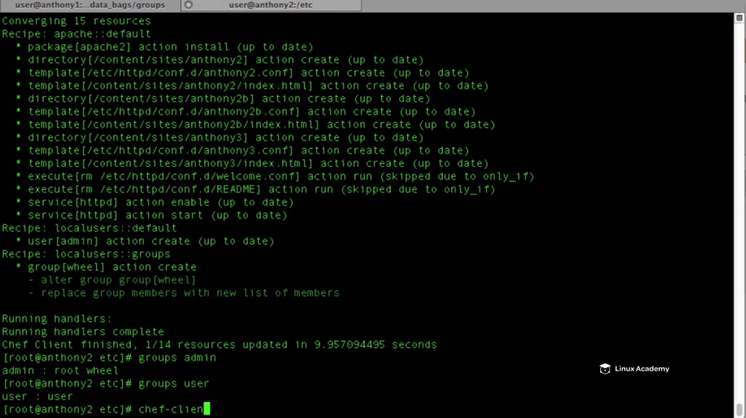



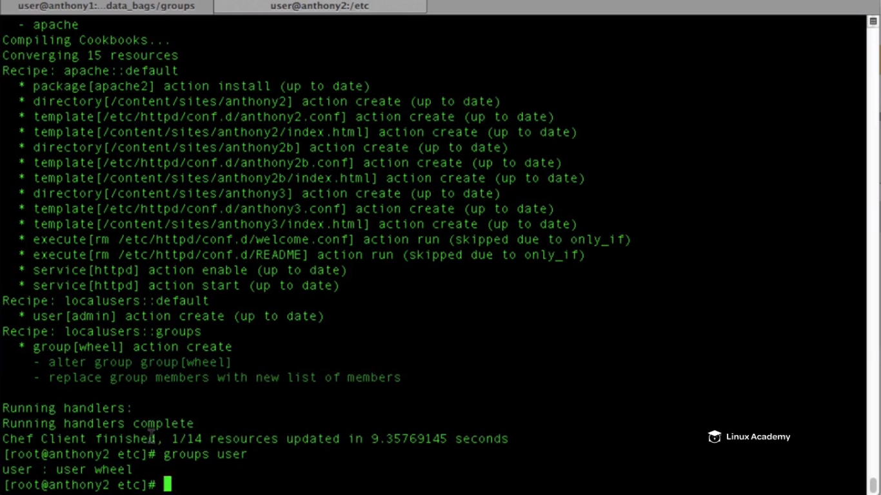

User is a member of the wheel group

**Chef Environments**

**Lecture: What Are Environments And Why Do They Matter?**

In this lesson we are going to learn the basic principles and concepts of environments. We'll discuss how to create them, why they are important, and how to deploy them to our nodes.

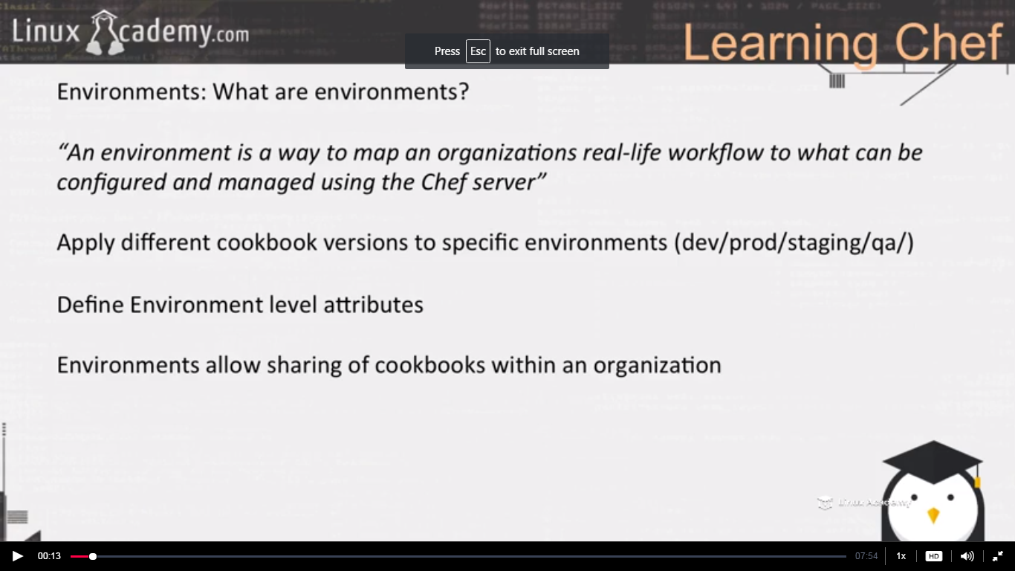

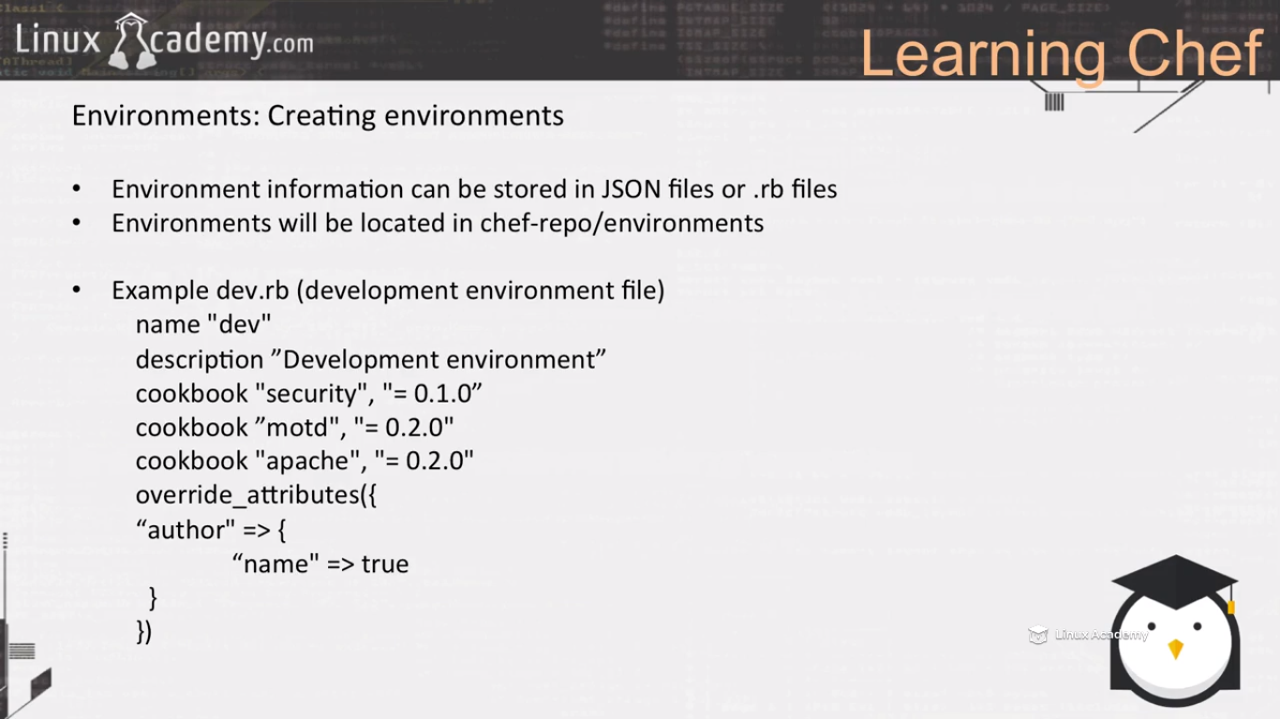

We will define the run_list for the nodes as usual but if we want define which version of cookbook or recipe should run then we can define here inside the .rb environment file.

We can also define the node level attribute lets say you want to set the author of the node etc.

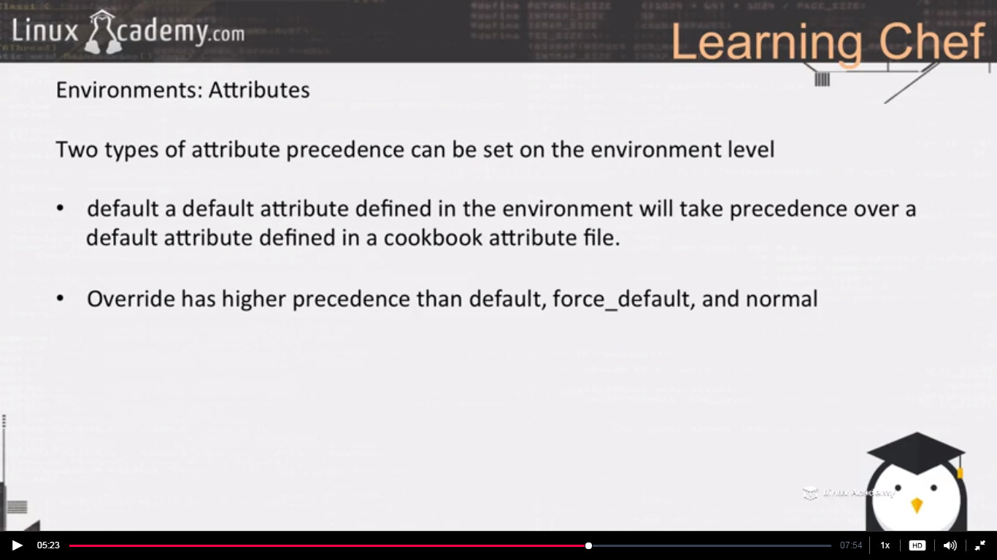

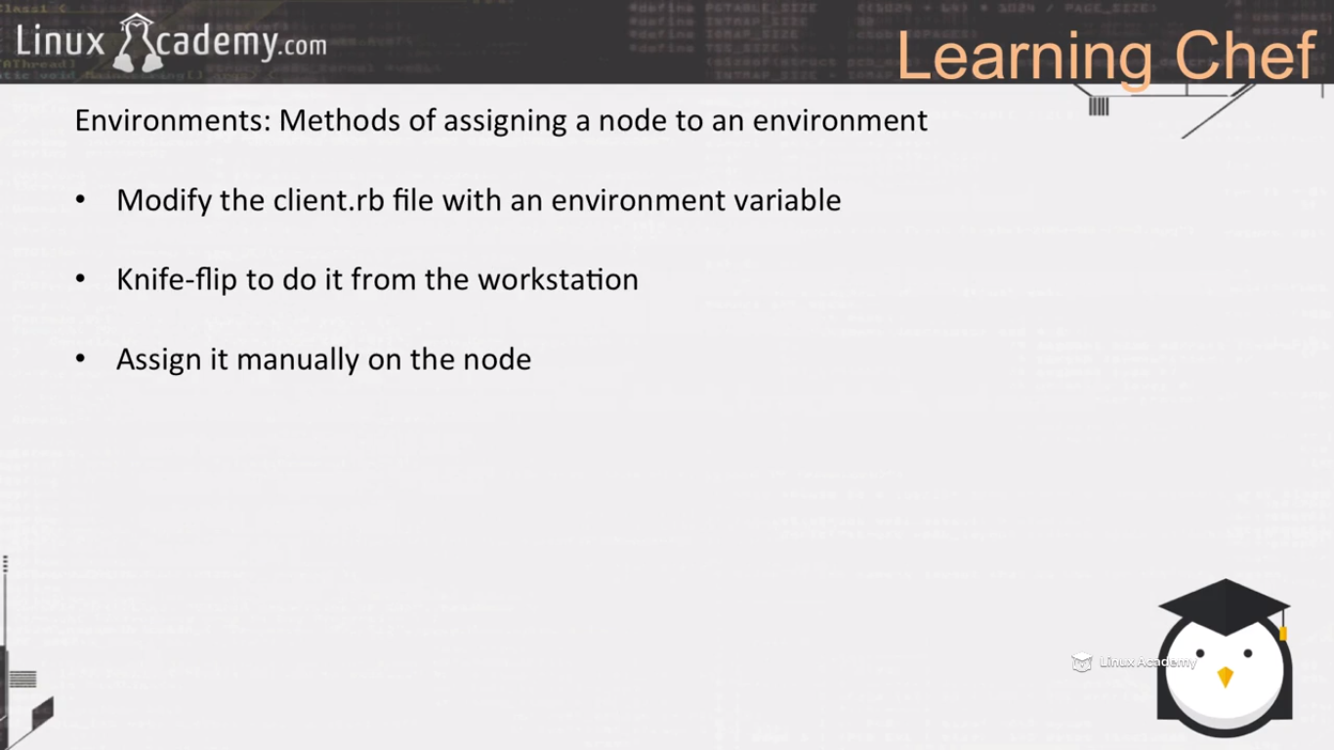

One thing to remember is that once we have an environment a node needs to be assigned to an environment. By default all nodes are added to the _default envirnonment. It must belong to an environment so there is a default one created by chef and its assigned to that by default.

So basically we keep working with our _default environment file. However if we need to configure our node to connect to a new environment there is few different ways we can do that we can assign it manually inside the chef server GUI, we can use a knife plugin called knife flip and we can do it from the workstation . What we are going to do is that we are going to modify the client.erb file located inside the /etc/chef directory on our node and we are going to set the environment variables equal to the environment we want. This way if we wanted we can pass this information to our node at boot time or we can create an image of this node and we can say this is going to be our development image or production image. Whenever this node does a chef convergence it will pull from from the environment defined within the client.rb file. . So our goal for this section is to configure 2 environments dev and prod . We will mdify our apache cookbook to create a new version, we are going to set newer versions to dev 1.5 version and older version 1.0 to production because that will be considered as the stable version.And then we will configure the client.rb file to look at our proper environment.

**Lecture: Creating And Configuring Environments**

In this lesson we are going to walk through how to create and upload environments to the Chef server. We will walk through configuring our node to work with our newly created Dev environment.

Environment is a way to map an organization’s real life workflow to what can be configured and managed using a chef server**.** In todays enterprise world we have different environments as Prod, Staging, QA, DEV etc. We do deploy codes in these environmens. We can have different database for dev environment and production. Our dev environment uses url of its dev database and not of production . So if the code running in dev environment it should point to the url of the dev database and code running inside prod must point to the prod database url. So how can we separate these environments.

So we don’t want to manually change the url of the database for each environment in the code during the deployment. We can do this by using attributes so that the attributes defined for dev points to the url of the dev database and attributes defined for prod must help the code to point to the prod database url.

So lets say we want to test a new version of our web server cookbook , we don’t necessarily want that to deploy it in the prod environment and test it there. May be we want to test it in the dev environment so what we can do is enable versioning of our cookbooks and we can associate a specific version of our cookbook to a specific environment. So lets say our prod environment is using a 1.0 version of the web server cookbook. We want to update that version of the cookbook to 2.0, may be we were developing a newer version of web server cookbook 2.0 and we were testing it in our dev environment, so we can assign the version 2.0 to the dev environment and 1.0 to the prod environment. So the node added to the prod environment would be receiving the cookbook version of 1.0 and the nodes added to dev would receive the cookbook version of 2.0.

Lets see how we can manage the above scenario via chef.

We can run different knife commands here .We can store data in the json format as well as in ruby.rb format. Lets store it here in ruby.rb format.

Lets create a new dev environment as

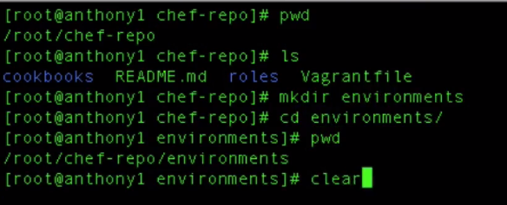

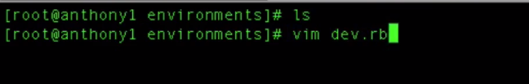

Inside here we are able to provide configuration information to create our environment using our knife tool . So the information about our environment can be

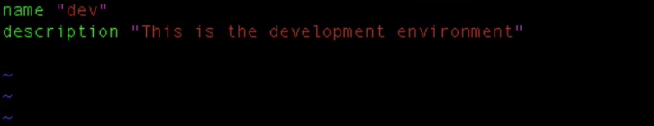

Save and exit

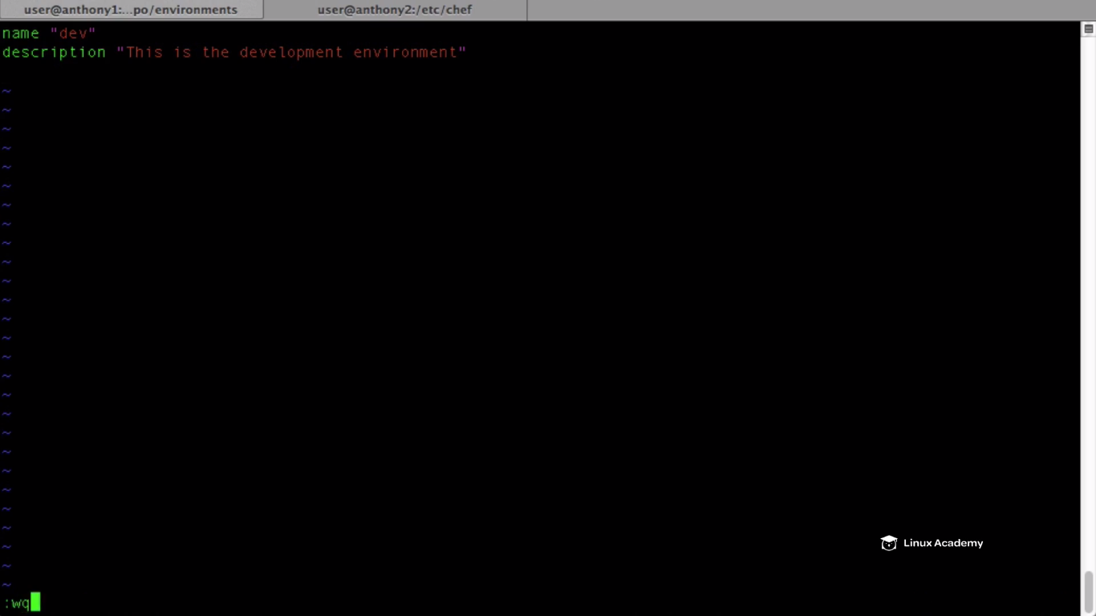

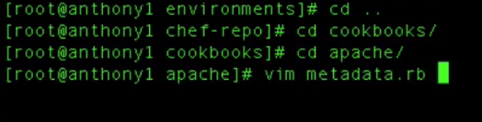

I want to check the version of my apache

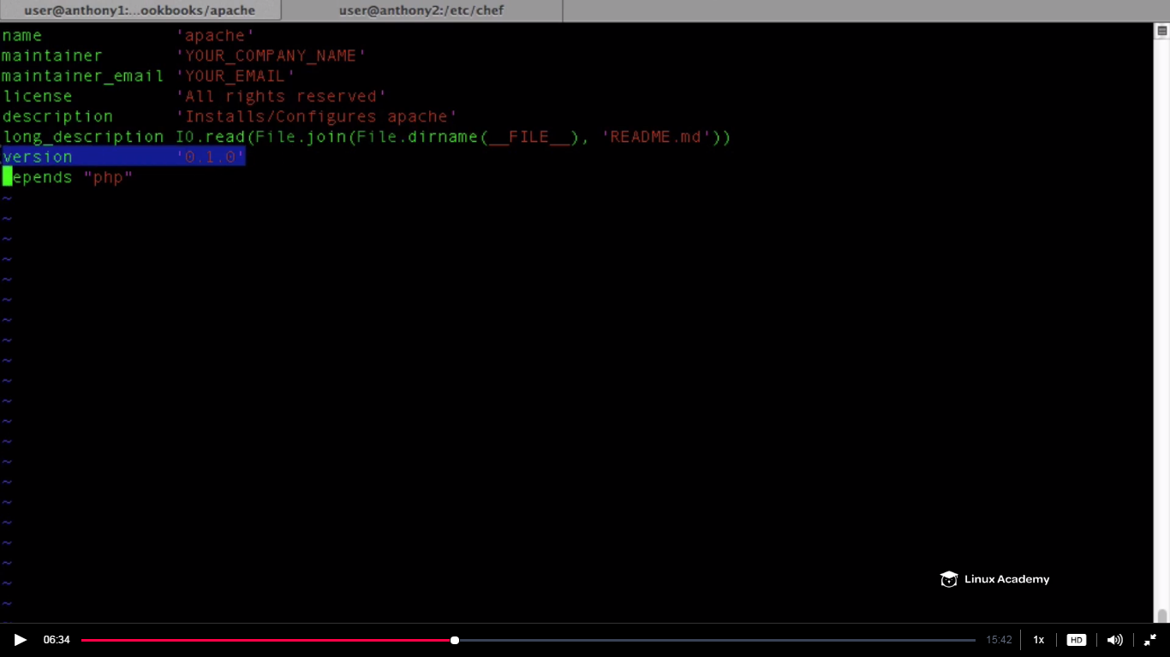

This is the version of our cookbook

So whenever we are ready to create a new version of our cookbook we would change the version here . As soon as we change this version when we upload this to the chef server it creates a new versioned cookbook inside of our chef server . We are not going to modify it here in this lecture however we will modify it our next lecture.

We would just go and configure our environment in this lecture.

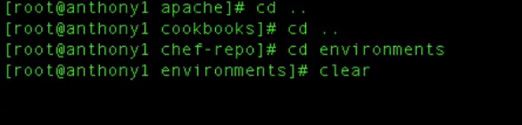

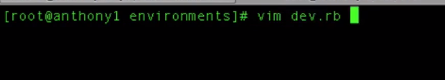

This environment would be using version 0.1.5 as production is using the solid version of 0.1.0.

We know that the default attribute when inside an environment has precedence over our attribute file and our recipe attribute . If we want then this is exactly the place where we want to define our attribute. **So for example we can do override attributes which will give this specific attribute defined in this environment precedence over essentially any other attribute with this name inside our cookbook .**

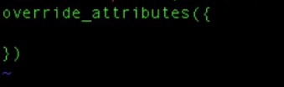

So we have our override attributes this is where we can override or set attributes for our environment.**These attributes have precedence over the attributes with the same name inside of the cookbook.**

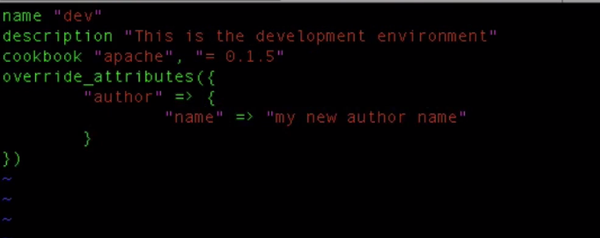

Save and exit.

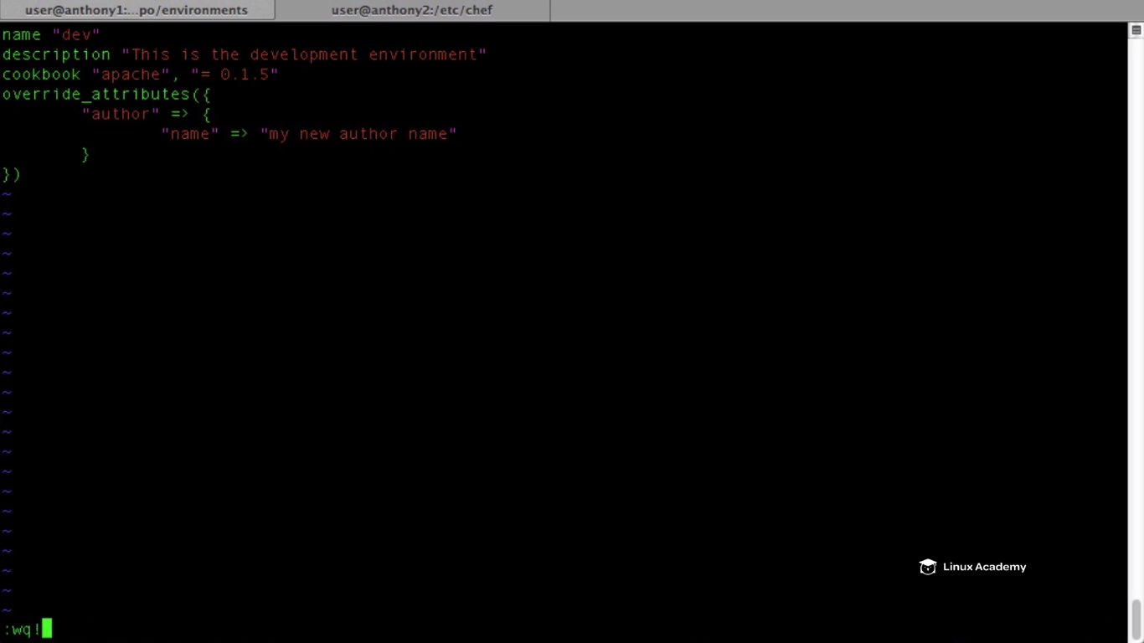

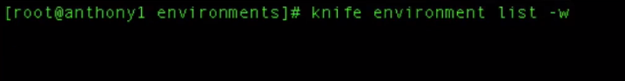

I want to list all available environments. –w will show all the API url for that environment.

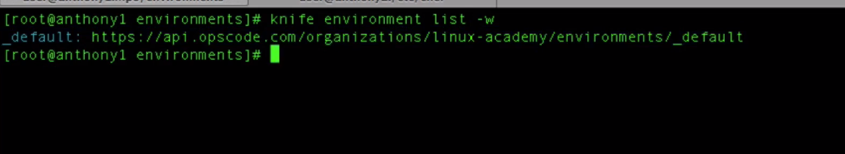

**Currently the environment which we have inside the chef server is the default environment. All nodes must belong to an environment.**

**So bydefault all of our nodes belong to the default environment. So lets create our environment. To do it lets issue a command**

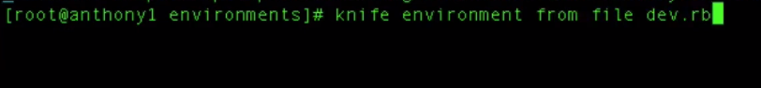

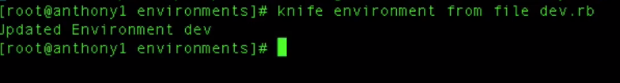

**We defined a ruby file hence we did dev.rb but if we would have used a json file we would have to make sure to user proper json format as instructed inside the chef documentation.**

**Whever we update the changes inside the dev.rb we need to use the above command to upload the changes the same way we do for our cookbook changes.**

**IF we go to the chef interface we can see the environment dev as**

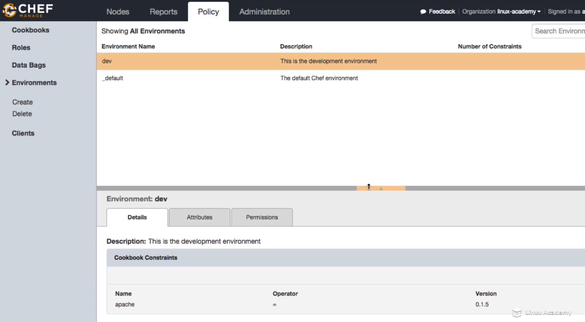

**We have the attributes there though we have a single attribute the author name**

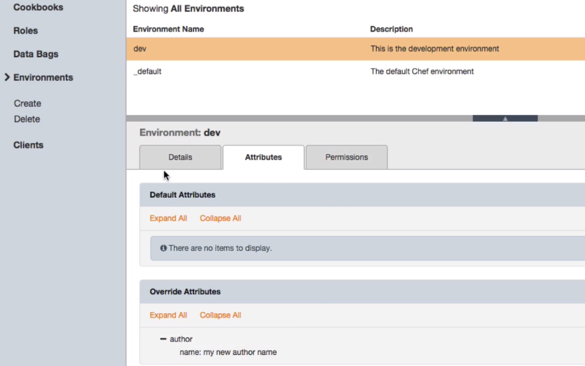

**This attribute “attribute name” would override any attribute of the same name inside of our cookbook.**

**If we browse down to the linuxnode and we see that it is associated to an environment that is the default environment.**

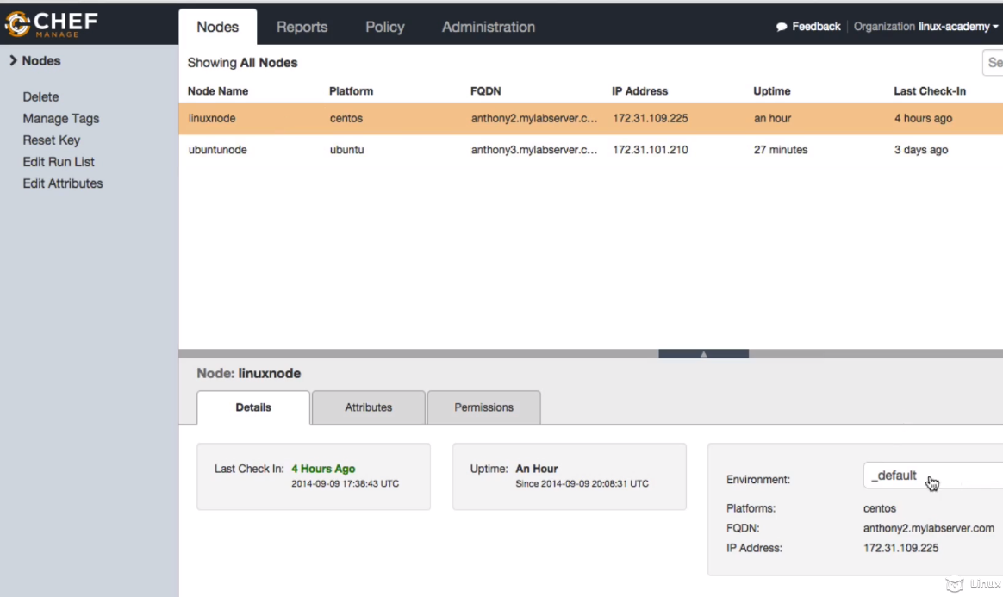

**IF I want I can change the environment right inside here in my chef server to which environment this node belongs to**

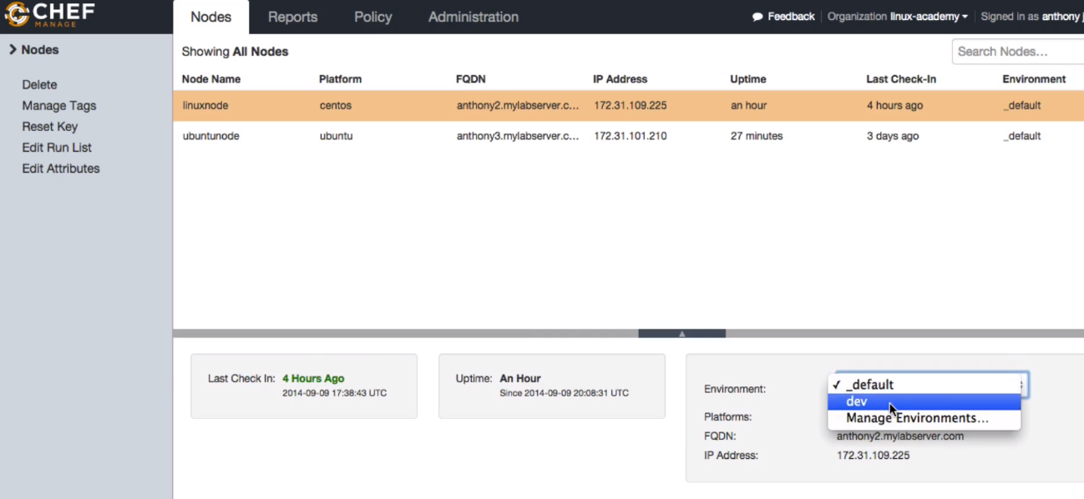

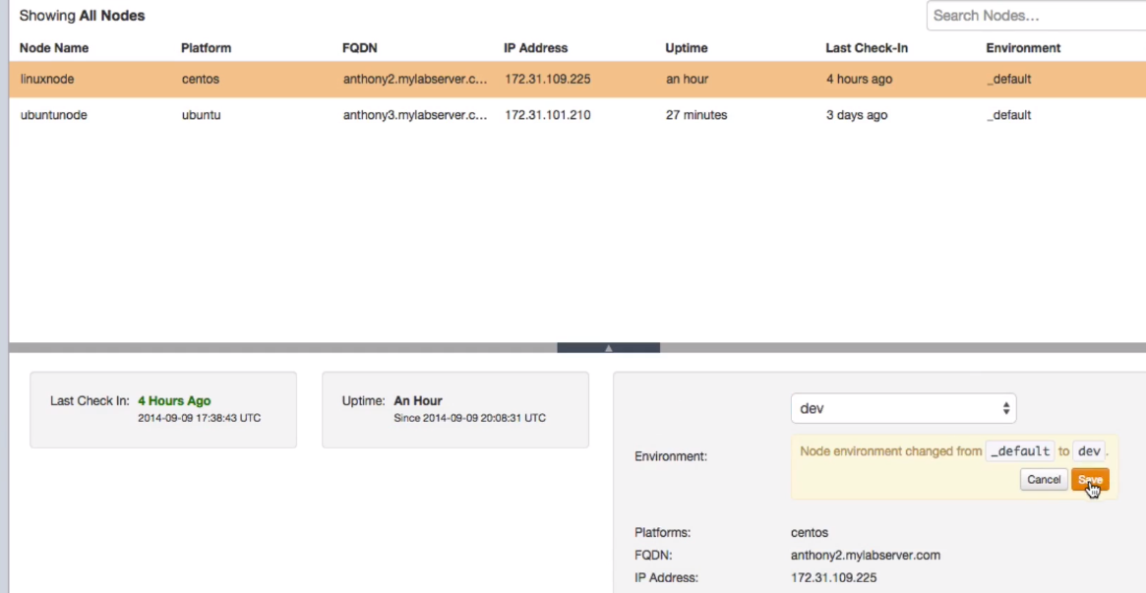

**Save it after selecting dev but don’t save I was giving the example.**

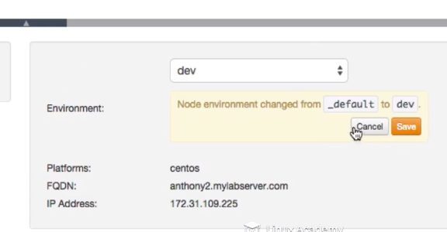

**It should be like this only**

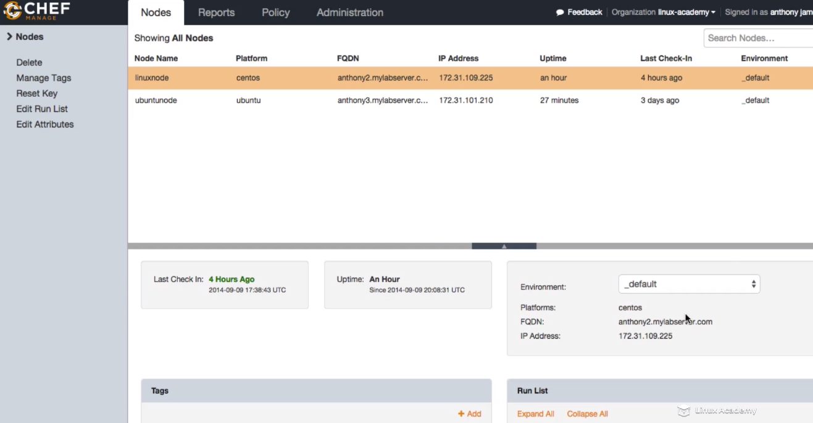

**But the question is how can we do this for large set of servers. Well we can change it here manually or we can also use a knife plugin called knife-flip which allows us to change what environment a node belongs to.**

**Lets say I have a set of dev servers, production servers and I want to configure this on the actual node itself, we can create virtual machine images or bootstrap scripts that automatically updates our configuration files on our nodes to tell the node what environments that node belongs to.**

**Lets go to our node, currently this node is set to our default environment**

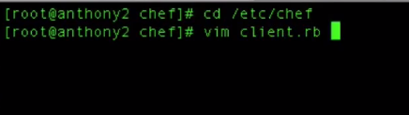

**I would add a line in there**

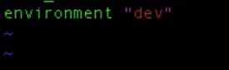

**So this node whenever checks in to our chef server using chef-client running our convergence its gonna look into the dev instructions. Save and exit**

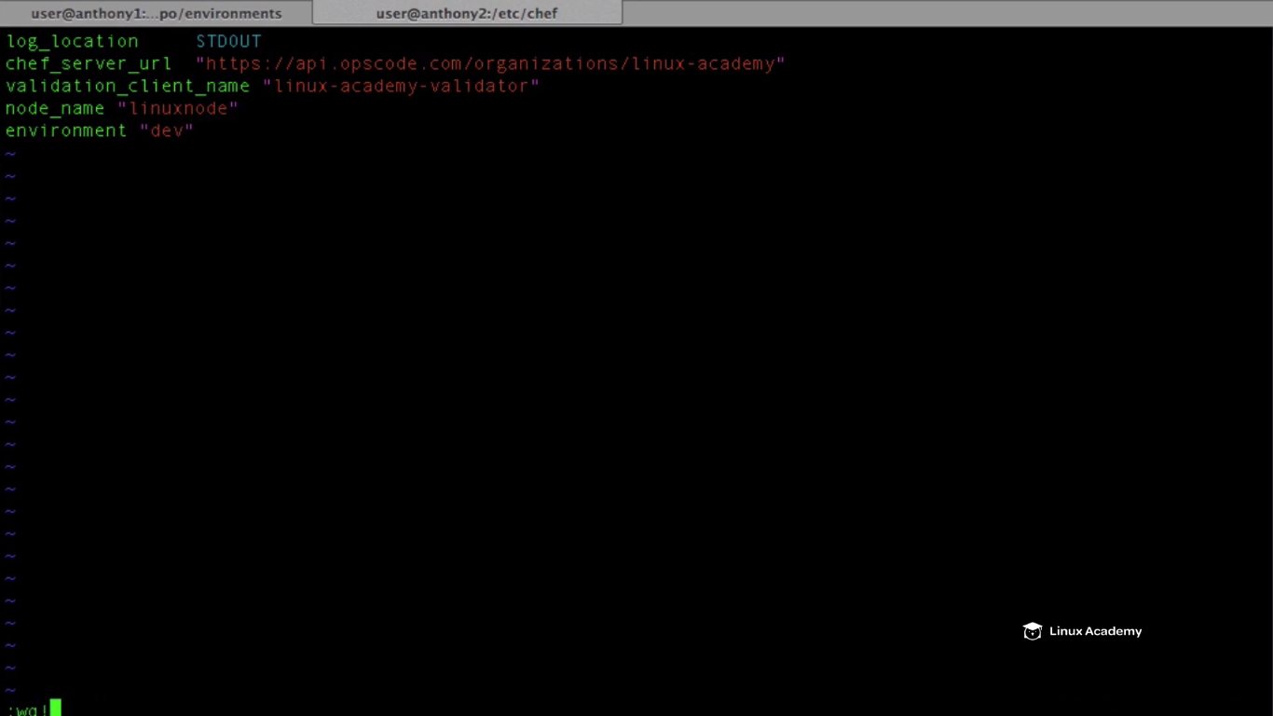

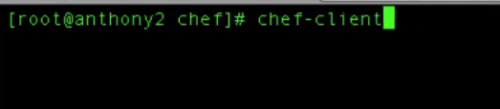

**So we don’t have a apache cookbook for this node because our earlier apache cookbook is 0.1.0 version hence we got the error as**

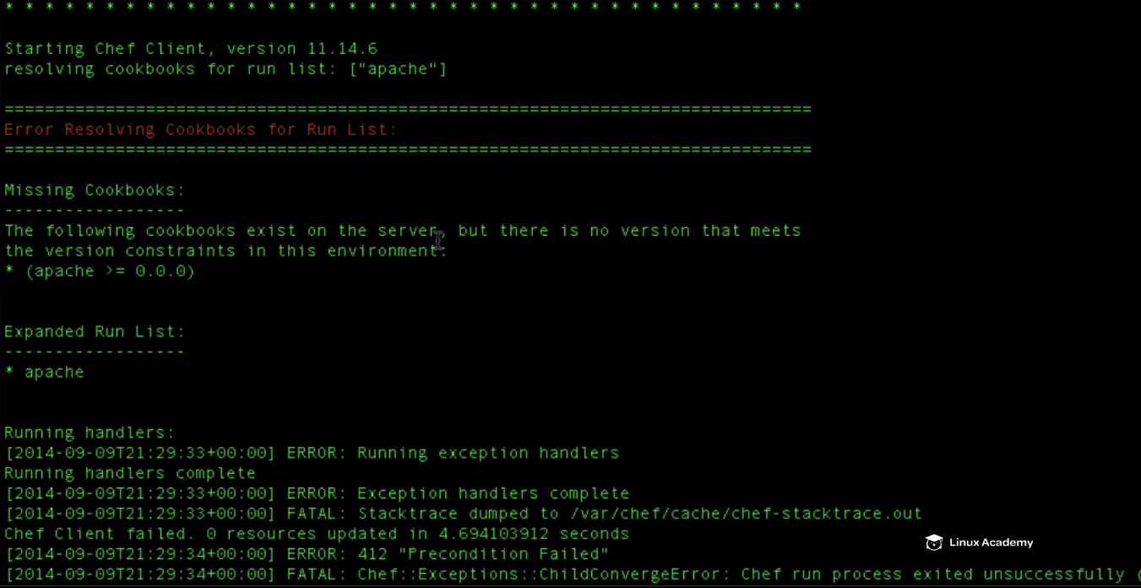

**IT says there is a cookbook which exist but there is no version as our requirement is of version of 0.1.5**

**IF we go to the chef interface and move to the linuxnode we see the environment associated to this node is dev**

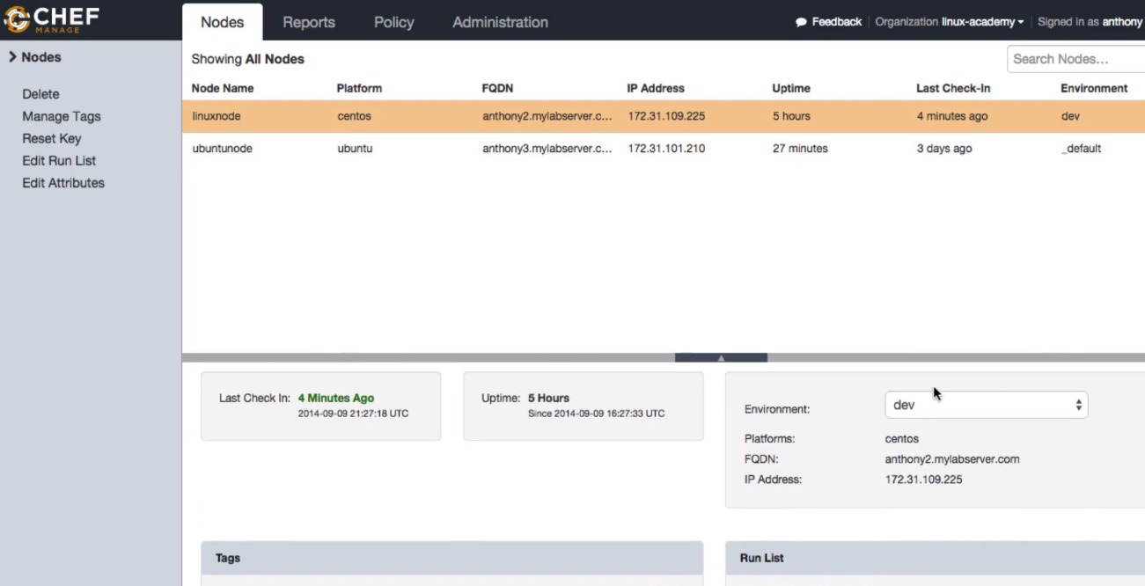

**And if we go to the environment then we can see the dev environment has a requirement of apache version of 0.1.5**

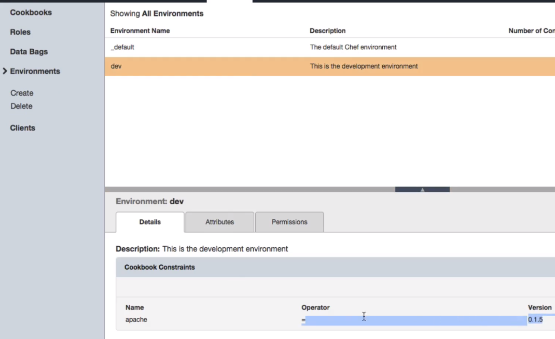

**So we have configured our environment to look for specific cookbook version**

**Lecture: Creating A Second Version Of Our WebServer Cookbook**

In this lesson we are going to create a second version of our Apache web server cookbook in order to demonstrate versioning with Chef environments. We will then demonstrate attribute precedence as it relates to environments and cookbooks as well

We are going to create a new version of Apache cookbook and then will associate this version to the dev environment .

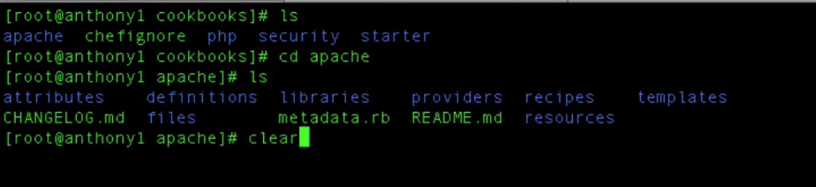

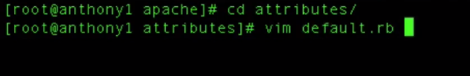

WE will define an attribute of default level precedence on the below location

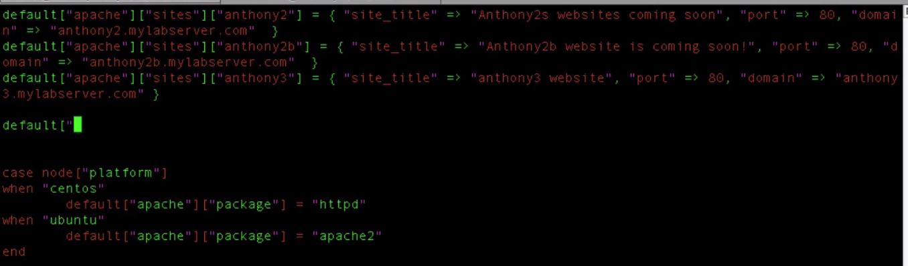

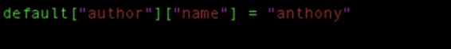

Save and quit after adding above line

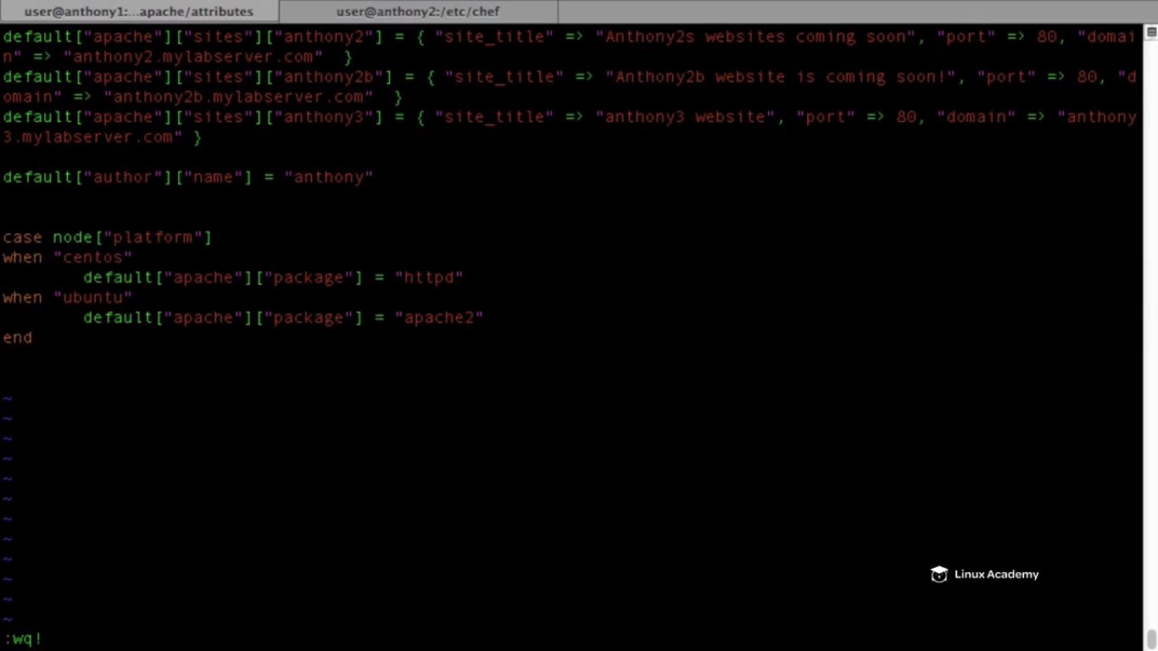

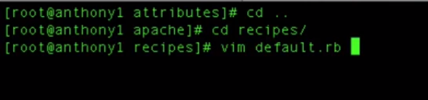

Add the attribute which we added to the attribute files previously to the template inside our apache recipe or say default.rb

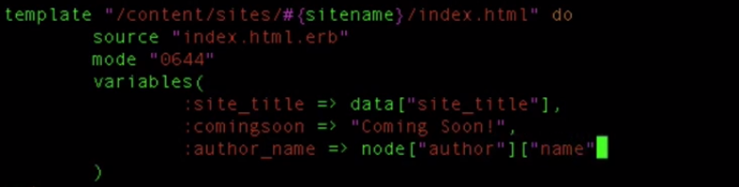

**We used here node not data object which was storing all information because this attribute has already been loaded to the node . We are going to reference that attribute.**

The file should look like this

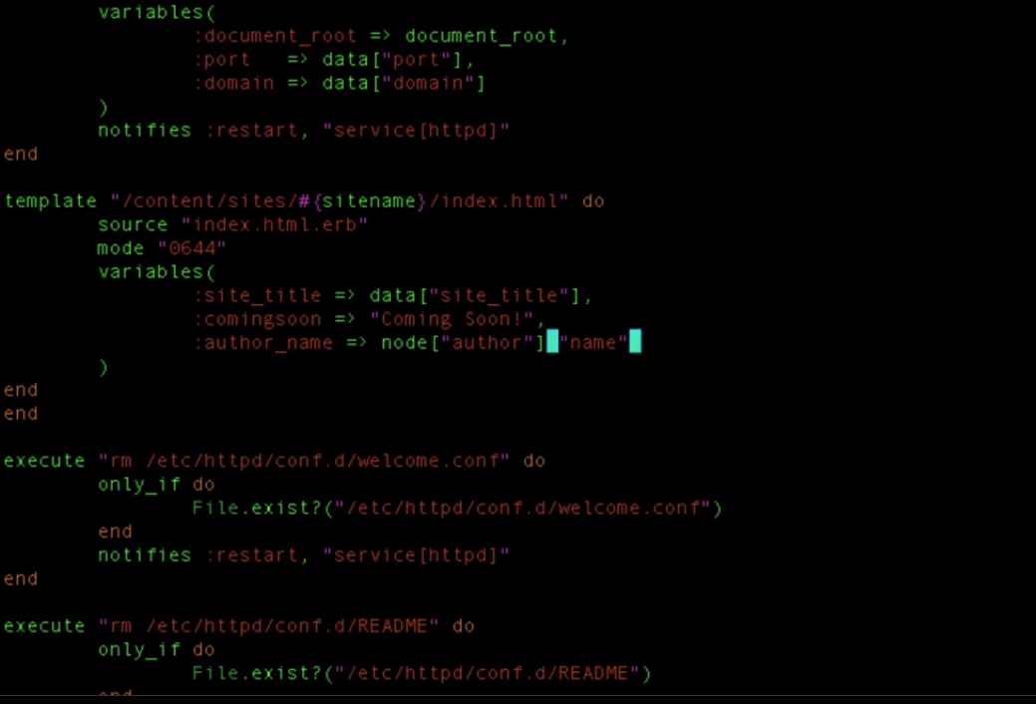

Save and exit.

Now we need to add this to our template section.

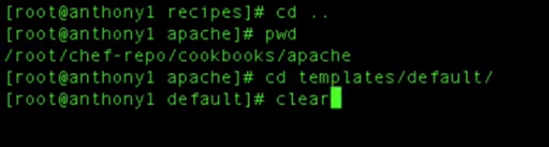

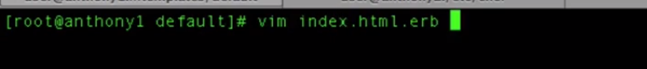

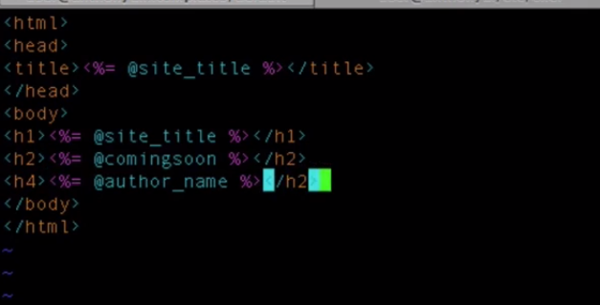

Add the author name to the template. Save and exit.

Don’t go uploading your cookbook yet. IF we were to upload this cookbook it would just be modifying our cookbook 0.1.0 whereas since we are doing it to the dev environment we want to upload a 0.1.5 version of our cookbook because our environment are tied to different version of cookbooks. So to do that navigate to

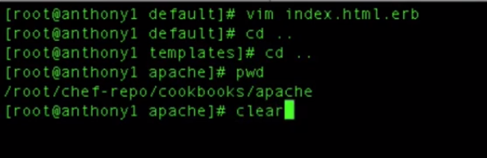

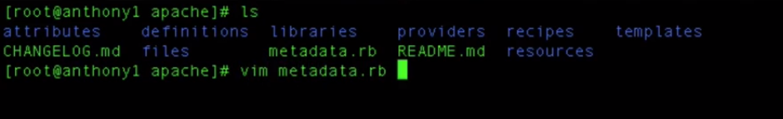

Since our dev environment relies on 0.1.5 version of the cookbook we need to upload a 0.1.5 version of cookbook. So we will just modify it manually becauser versions are modified manually

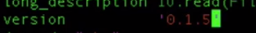

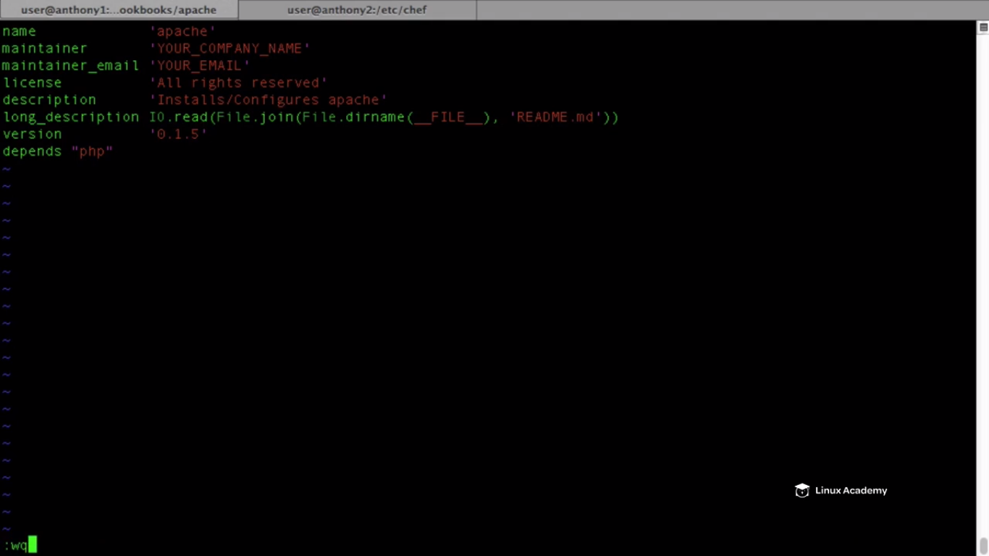

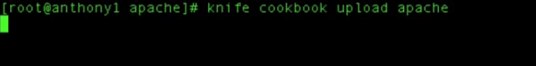

Till it uploads come to the chef interface and refresh it. We can see the current version of apache as 0.1.5

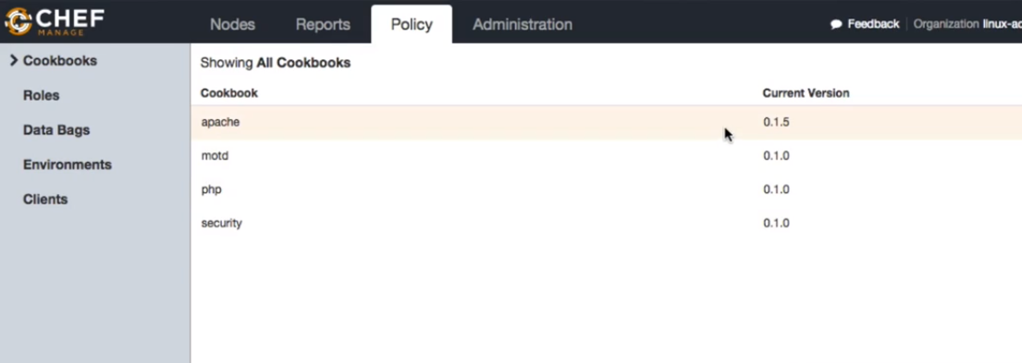

If we were to apply the update to our current chef node, since the version requirement is 0.1.5 it will pull down this 0.1.5. However the current version is also 0.1.5 our production node which doesn’t have any environment assigned to it will also pull down 0.1.5. So in the next lesson we are going to demonstrate our 1.0.0 but what we are doing is that we are doing is creating a requirement inside our dev version for 0.1.5. So lets go and do that . We have our 0.1.5

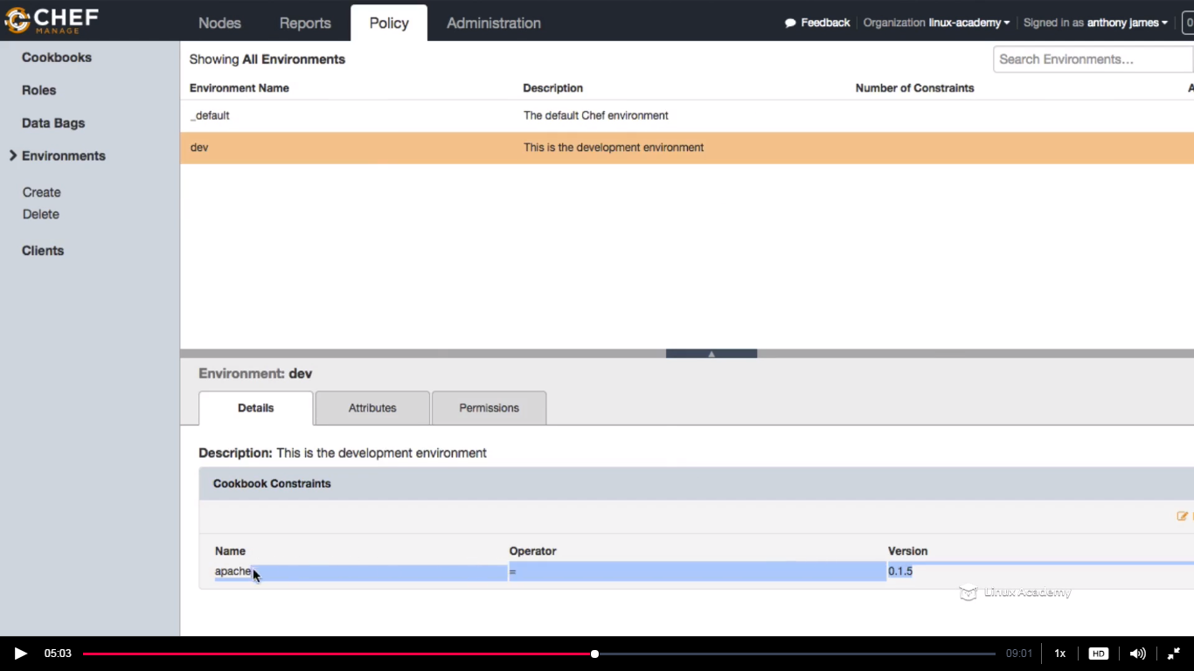

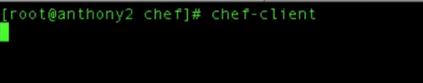

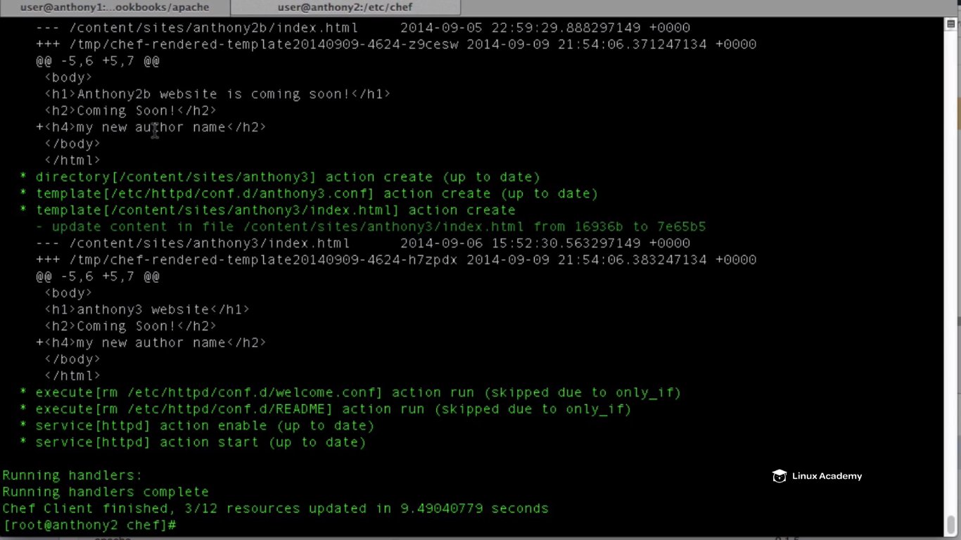

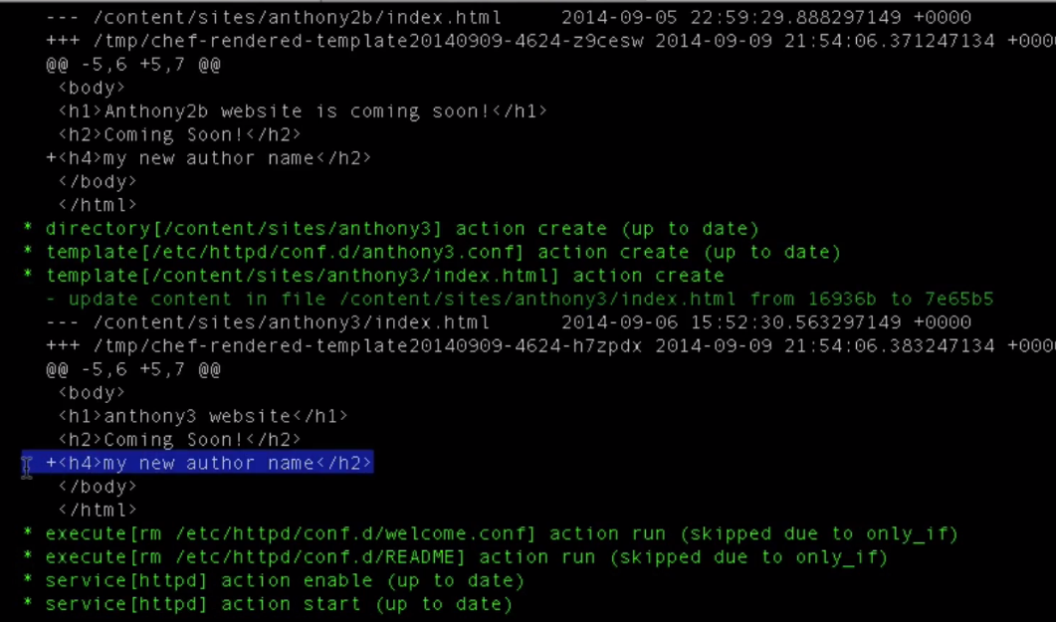

**We see the changes here as we have enabled the advanced log level. We see the author name as “ my new author name” because we have defined this inside our environment attribute which overrides the othere attributes defined inside our cookbook of the same name .**

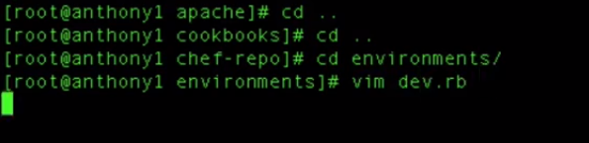

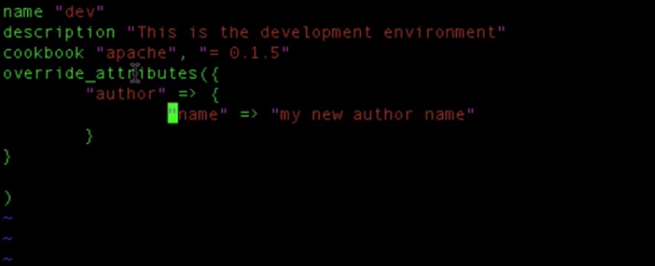

**WE created an attribute override and this overwrote the the attribute because this has a precedence . Because an environment attribute has a precedence over a regular default attribute precedence inside our attribute file in recipes inside our apache cookbook**.

This is the way we can create environment specific attributes such as development URL’s , development credentials, development database access.

If we were to remove this so lets remove the attribute as

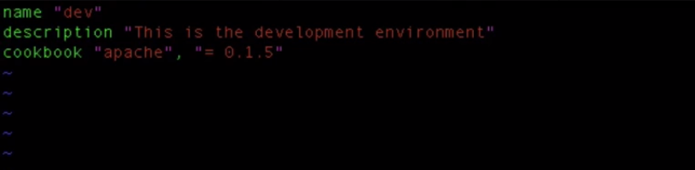

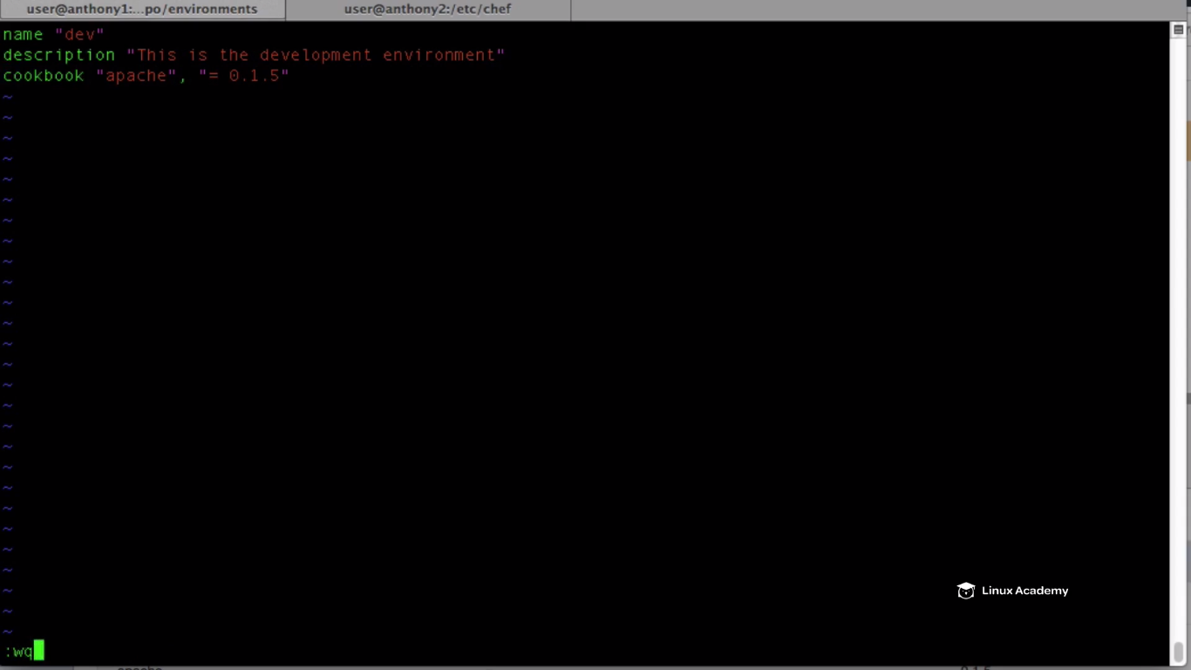

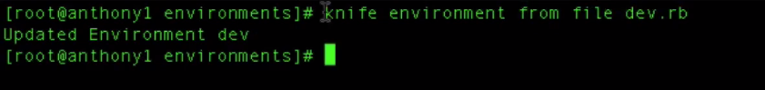

This is going to update our environment.

**Run a chef-clent on the node**

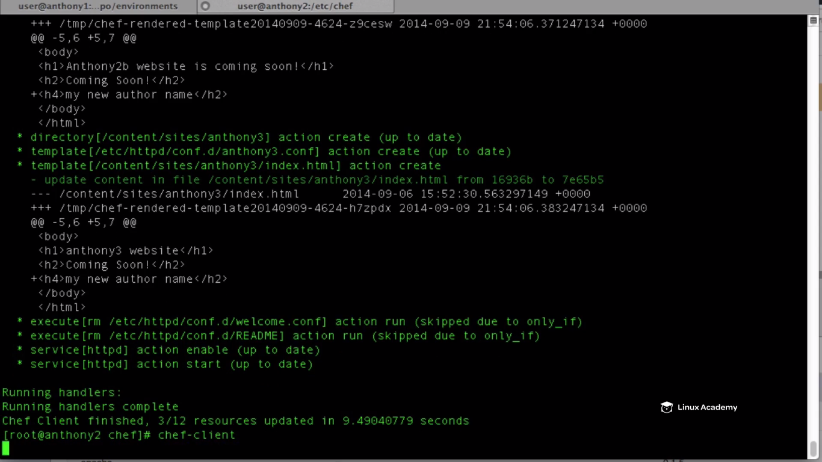

**Come back to the lab server console of linuxacademy and choose a dev environment on the node role from a normal node role as**

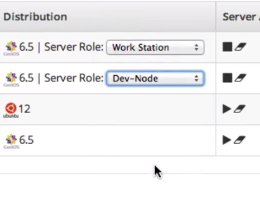

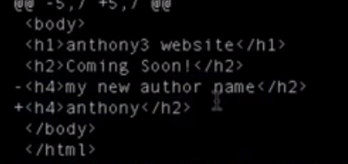

**So we see after the chef client runs that it – out the previous author name and kept the regular default attribute name of the attribute author_name**

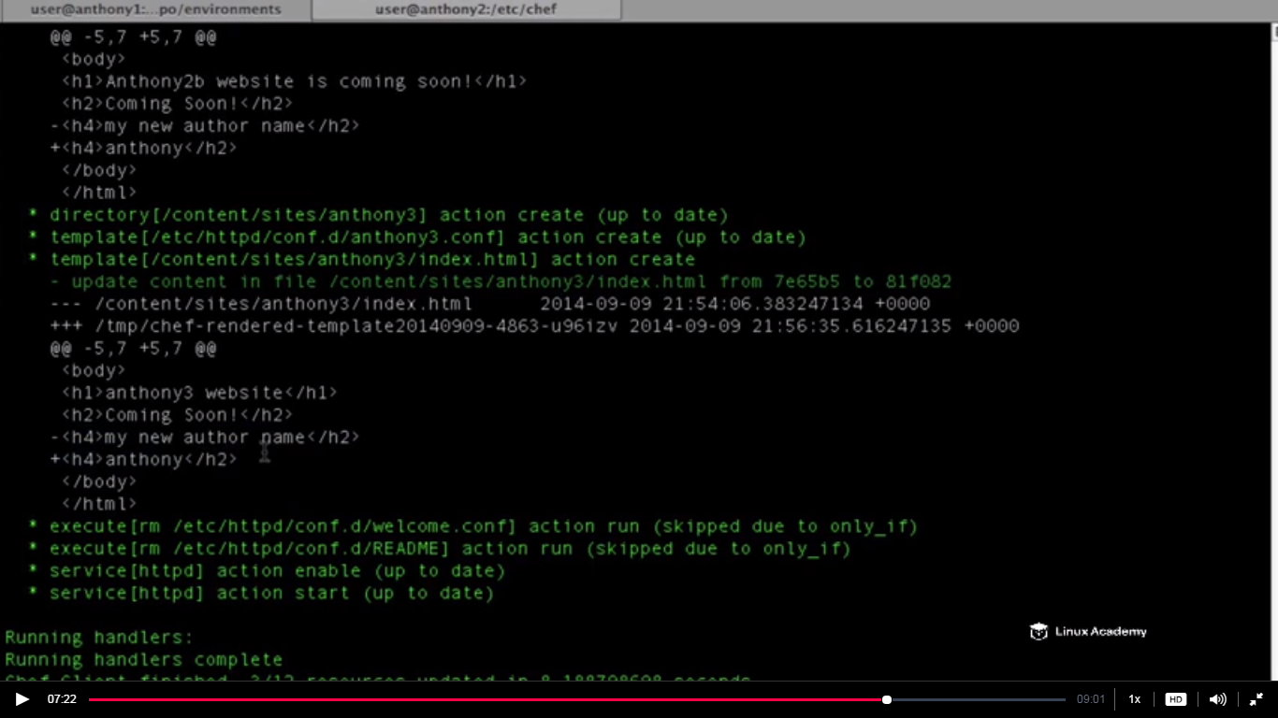

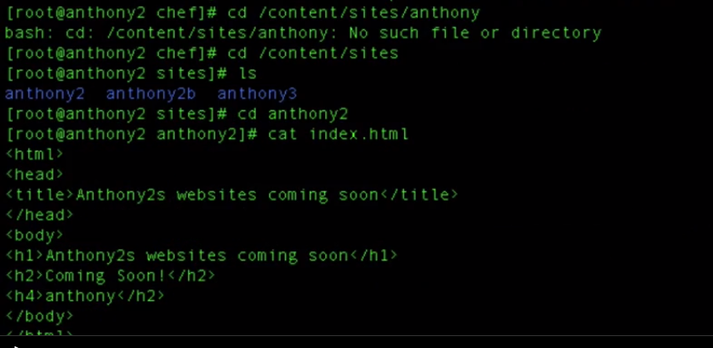

**We see that tribute name as anthony2 which is the regular default attribute name which we defined inside tha /attribute directory inside the default.rb(ccokbook).**

Lets go back and modify the environment back to the previous configuration

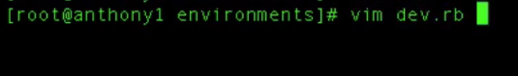

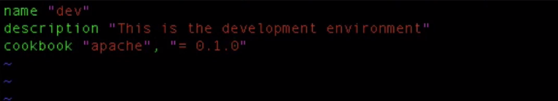

**Save and exit.**





**And we can expect that the index.html not to have the h4 tag as its now the older version or say the stable version of apache we are running.**

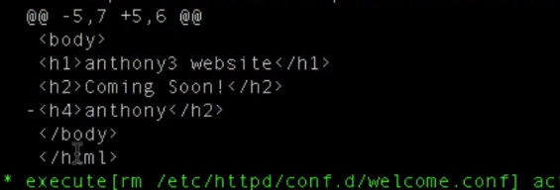

**IT says here remove the line <h4> . (- sign signifies remove )**

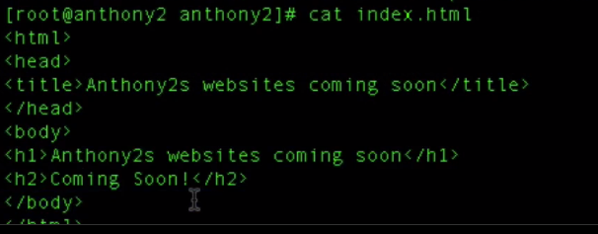

**H4 is no longer available.**

**We learnt how to configure cookbook for specific environments.**

**Lecture: Deploying To Different Environments**

In this lesson we are going to take our two webserver cookbook versions and deploy them to different environments. We will deploy one to our dev environment and the other out to the prod environment.

Go to linuxacademy server console and start the Ubuntu server.

We want the 0.1.0 version of the apache to be applied to the production server i.e here its Ubuntu and the new version that is 0.1.5 to the centos node that we have named now as the dev-node.

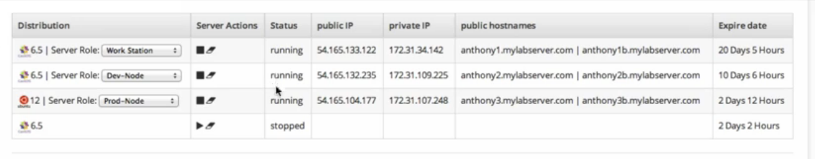

Go to the workstation,

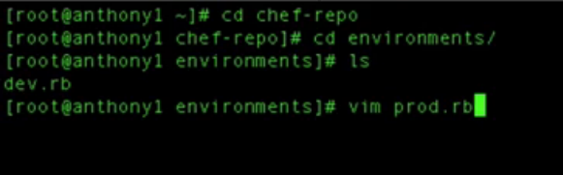

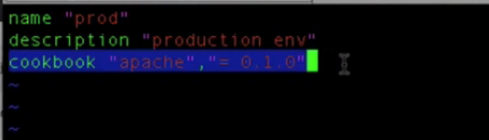

**We have defined here that the cookbook version has to be 0.1.0. This is a dependency and here only we can define the cookbook. We know that we have defined the recipes in the runlist and node will run those runlist for them but if we want to specify the cookversion version which has be on a particular environment we have to define it here only.**

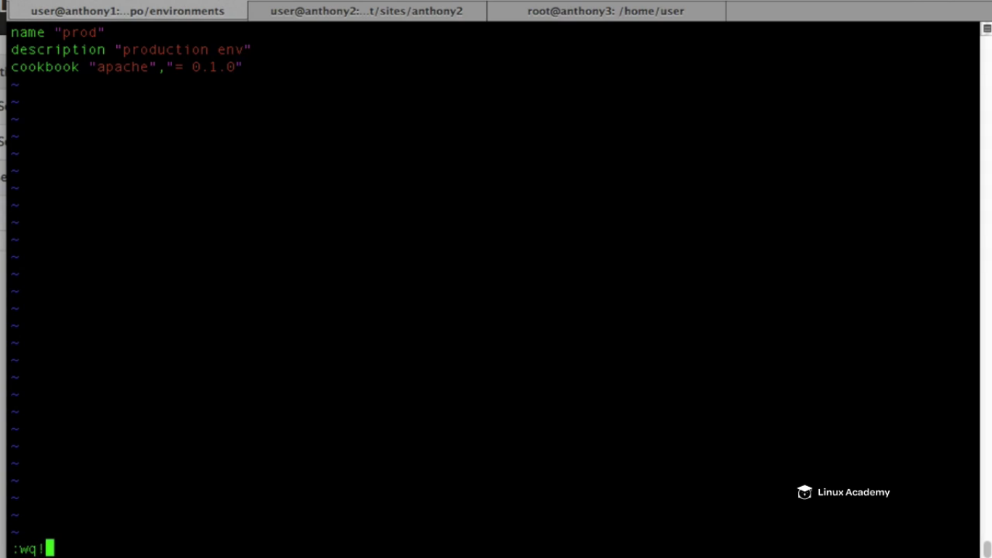

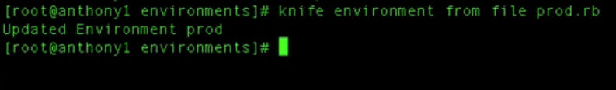

**We also need to update our dev environment ,hence do a**

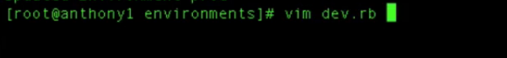

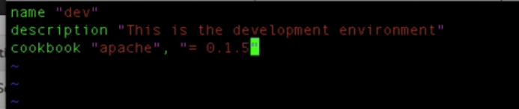

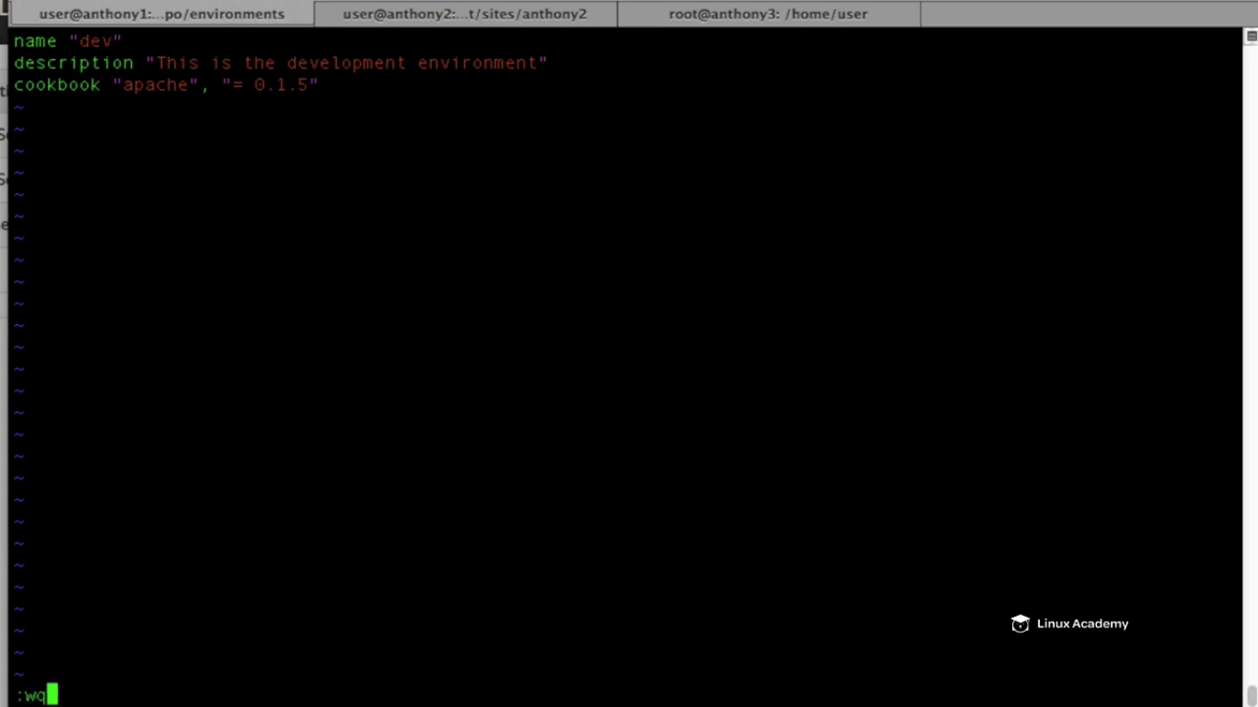

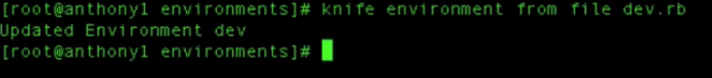

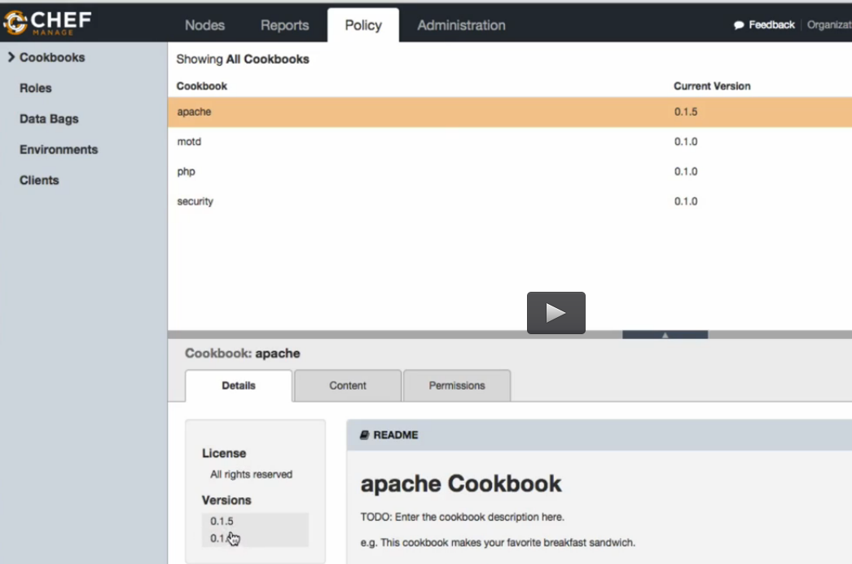

**WE see two versions of apache above .Also if we want to see tha attribute move to the content section on the console**

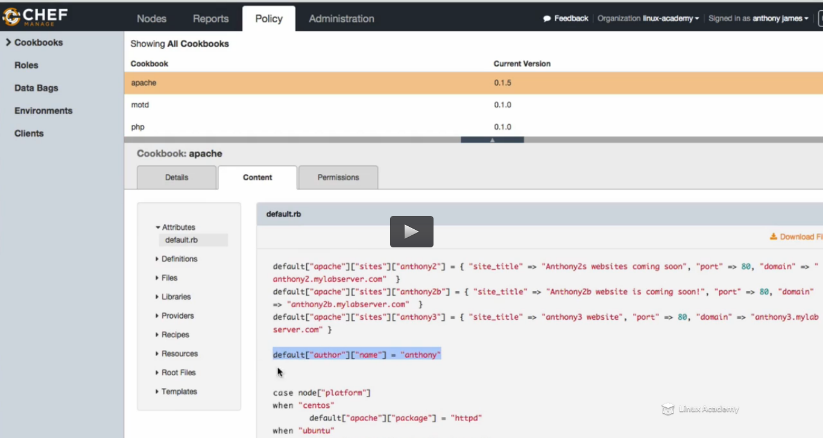

**We see the default version of the attribute which we have assigned the value Anthony is visible because it’s the dev environment and we have defined the precedence attribute for this which override the default attribute. Also we go to the template section we see the h4 there and the author name there as the value.**

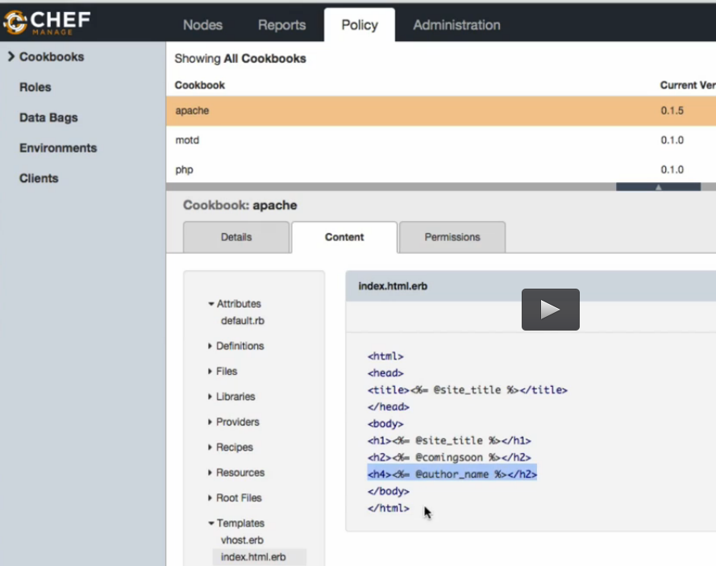

**We see the dev environment is printing the attribute author name as its running version 0.1.5 and we want the production environment to run apache .0.1.0 version where there is no attribute we defined as author name so it shouldn’t display that in the index.html file .so lets have a look from the console for tha apache version 0.1.0 attribute as**

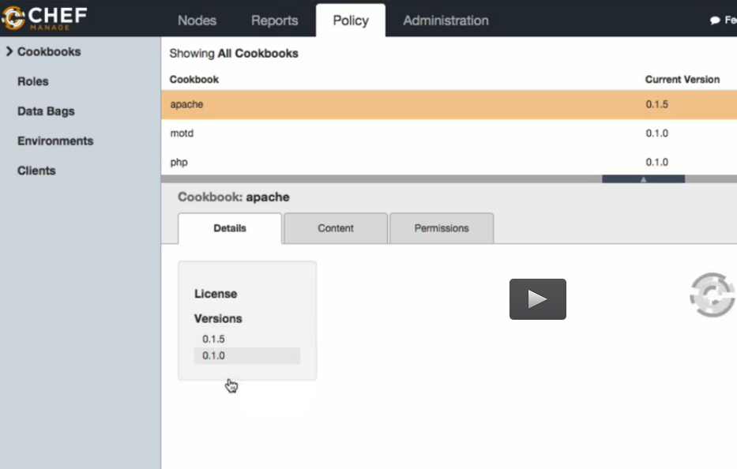

**Go to contents after selecting the version 0.1.0 and go to templates and index.html.erb**

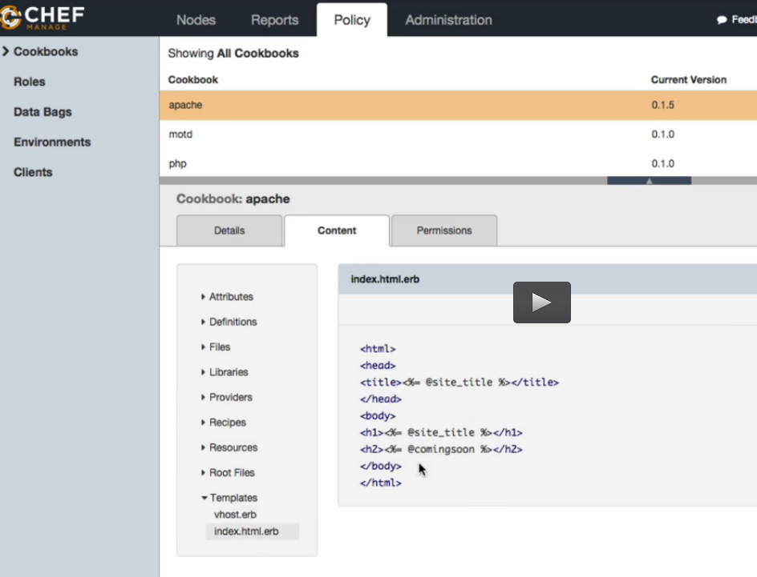

**Lets go to our new production node that is the Ubuntu node.**

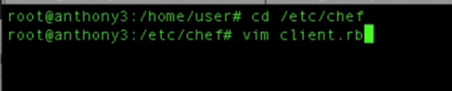

**We need to tell this node that this belongs to the production environment because it default belongs to the _default environment.**

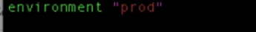

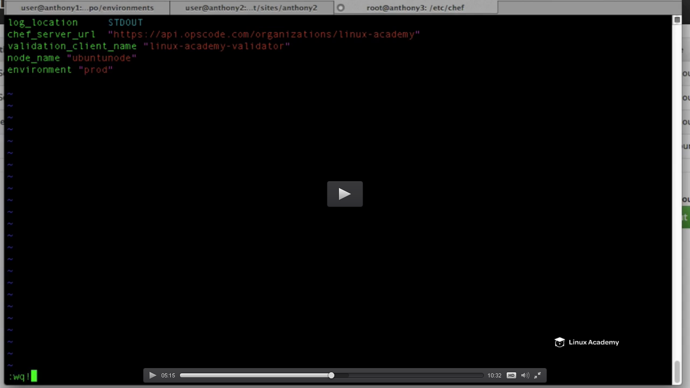

We can create an image of this instance and can built any number of servers which would belong to the production environment.

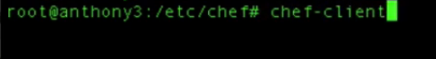

Also run the chef-client on the dev environment which is our centos node..

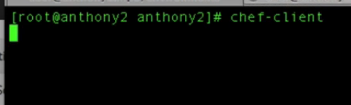

Then go to our production server’s content directory and cat index.html to see

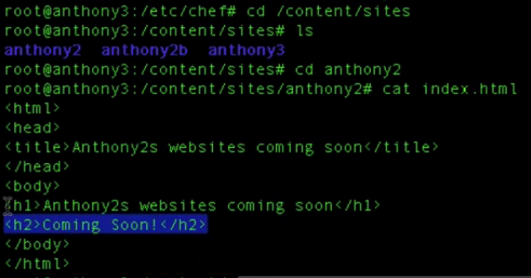

So we see that the attribute we added(.ie author name <h4> tag is not here) is not getiing displayed. So its confirm its running the stable version of apache which is 0.1.0

So if we go to the dev environment content site and cat index.html as

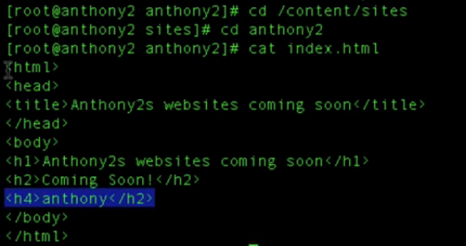

**So we have successfully created two environments I.e dev and prod and have also created a cookbook dependency for both of those for our apache cookbook.**

**If we want to define attribute based on the environment we will do that on the attribute file.**

**Lets discuss attribute precedence a bit more. Lets say we have different credentials for prod and dev environment.**

**We have defined the author name attribute in the attribute file inside the cookbook for the dev environment .**

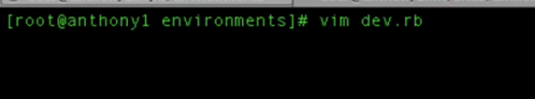

**Lets create an environment variable here.**

**Let me create the name attribute here which we have created inside the attribute file of the cookbook. What we want to demonstrate here is that the default precedence environment attributes overrides both default precedence attributes inside our cookbook attributes file as well default precedence attribute inside our recipes file inside our cookbooks.**

IF we go the chef interface we see the default attribute value as anthony which was defined inside the cookbook and this value would be override by the attribure defined inside the environment file i.e default.rb because the default precedence enviornment attribute has higher precedence than the default attributes defined inside the attribute file or recipe file of the cookbook.

**Go to the chef console and see that the apache version 0.1.5 which would be for the dev environment has the author attribute value as Anthony currently as**

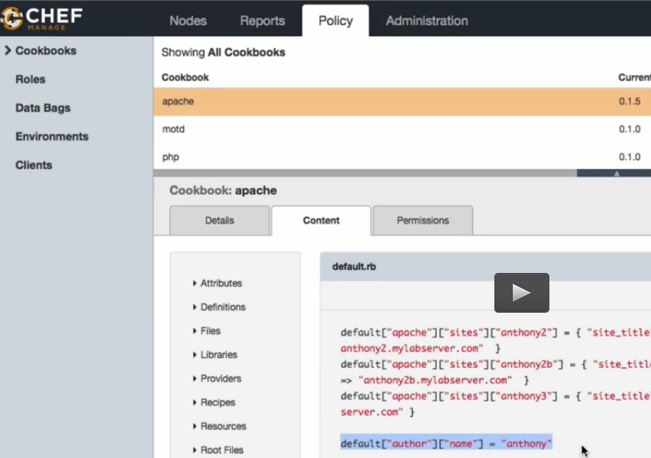

**WE have defined a attribute inside the dev.rb file as**

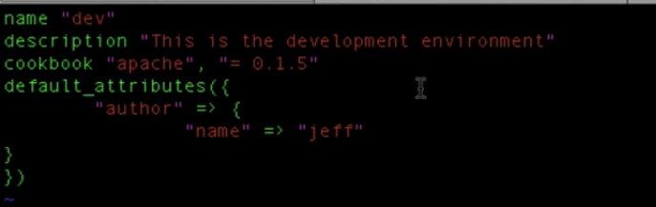

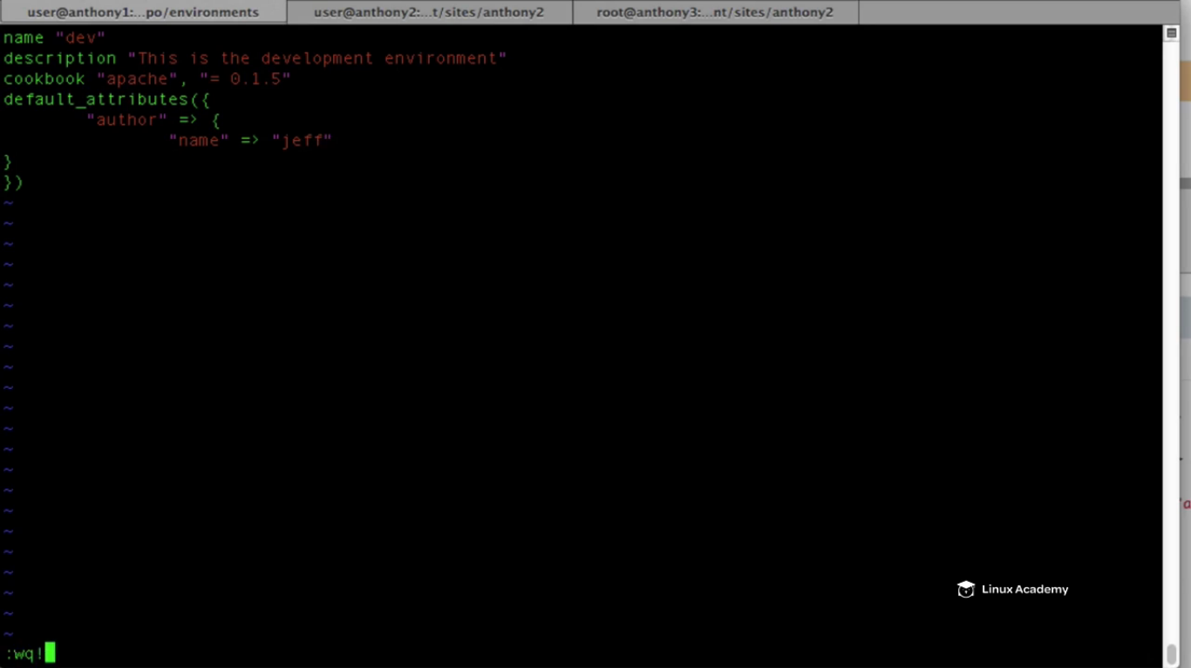

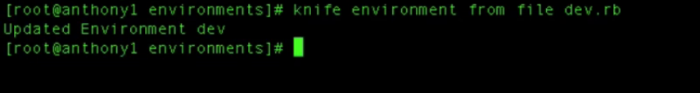

**Run the chef-client on the node which is running the dev environment i.e centos**

**And then go to the index.html and cat it**

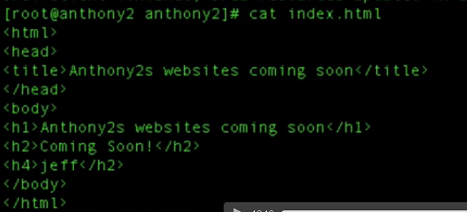

**So the attribute value here is now jeff not Anthony.**

**Lecture: Viewing And Deleting Environments With Knife**

In this lesson we are going to learn a few knife commands and how we can use them to manage our Chef environments.

So how we can know on which environment we are onto our system



List all the environments.

Now if I want to compare two environment that is our dev and prod environment.

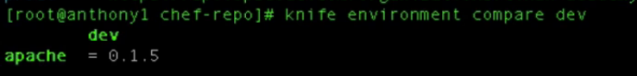

This would list the cookbook inside our dev environment.

This can do for many environment at the same time as

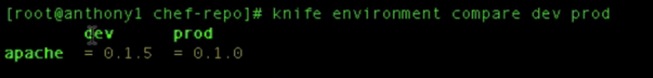

Lets compare all cookbooks for all environments

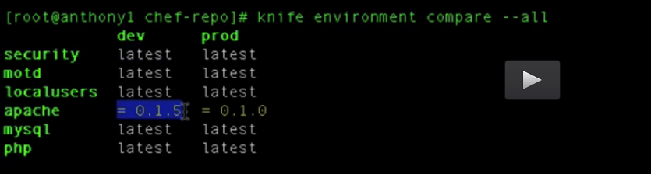

If we want to delete some environment from the system then

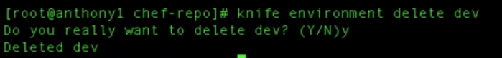

IF we go the to the chef console and inside polies do a refresh, we see only 2 environment left and there is no dev environment.

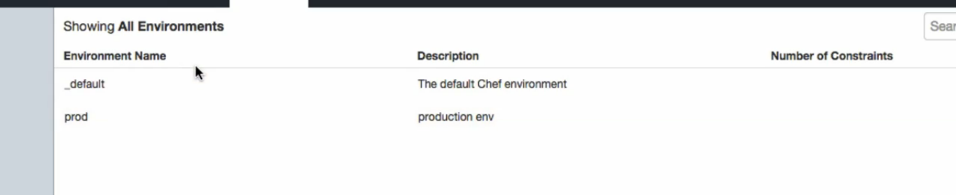

However if I go to the environment directory we still have the configuration file because that is located on our workstation as

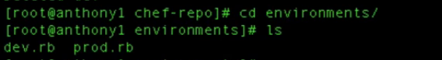

So lets add this back to our chef server



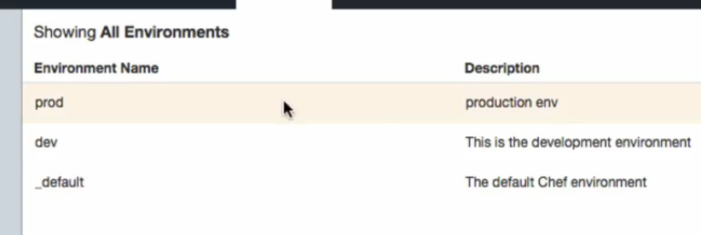

Lets say we want to see the information about the environment.

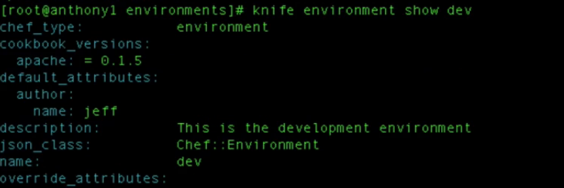

**Roles**

**Lecture: What Are Roles?**

In this lesson we are going to be introduced to Chef roles. We are going to learn what they are and how they are used within our infrastructure.

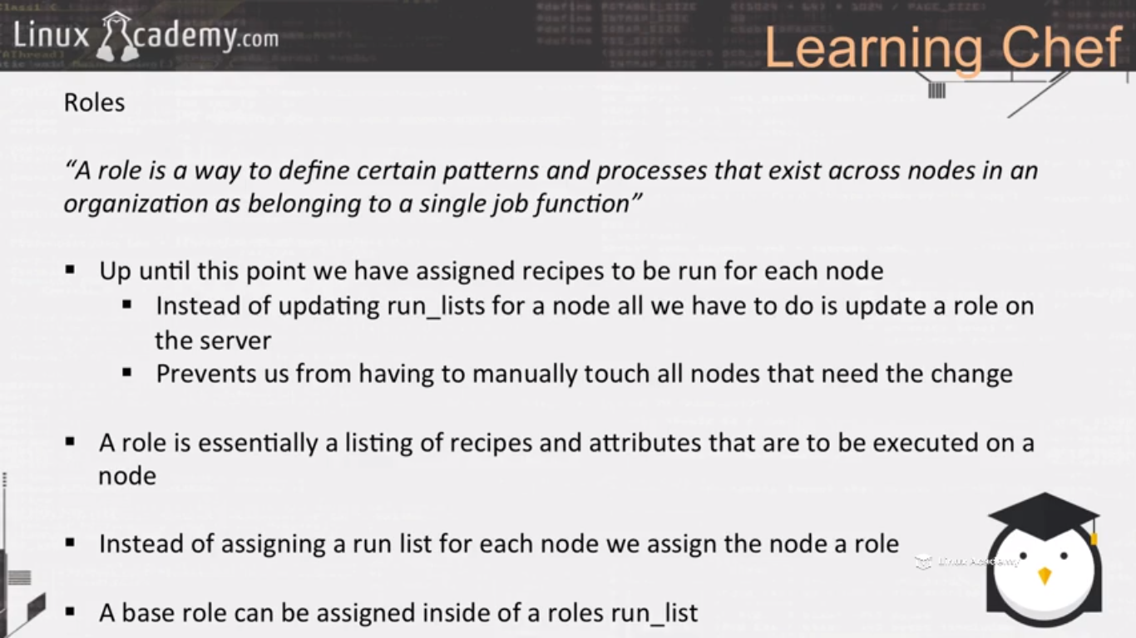

**Till now we have assigned recipes to the runlist for each node. Now roles would come into picture.**

**IF we want to add a single recipe to a runlist and apply it to all the nodes with our system then the best way to do this is to create a role. So instead of updating a runlist for a single node all we have really to do is update a role in the server.**

**The role contains attributes as well as a runlist of recipes to be run. We also know that because we can add attributes to our roles those attributes have their own level of precedence as well.**

**Lets say we are running a load balancer that has 10 webserver underneath it. So if we need to add a since recipe to each node runlist underneath it then we have to make 10 changes . What instead we can do is that create a role that inside of a role has the recipe runlist and all we have to do is that assign that role to our nodes or our webserver nodes and then whenever we need to make any change we just update the role on the chef server and during the next client convergence it will apply the additional recipe defined within a role.**

**So we can have different type of servers in our production environment like database servers, web servers, nfs servers etc. so what we are doing is telling the node to ask what role am I, what role do I play in this infrastructure. Im a web server, so because I’m a webserver I need to run the apache recipe, the motd recipe and may be the ngnx recipe depending the type of the web server we are running, so that is what the role does.**

**Lets say we have a recipes that has to be run on every node regardless of the node’s role. For e.g our security recipe that removes the validator.pem file what we would do is we would create a role, we will call it a base role and then inside each roles configuration file we would just add that role to the other roles runlist.**

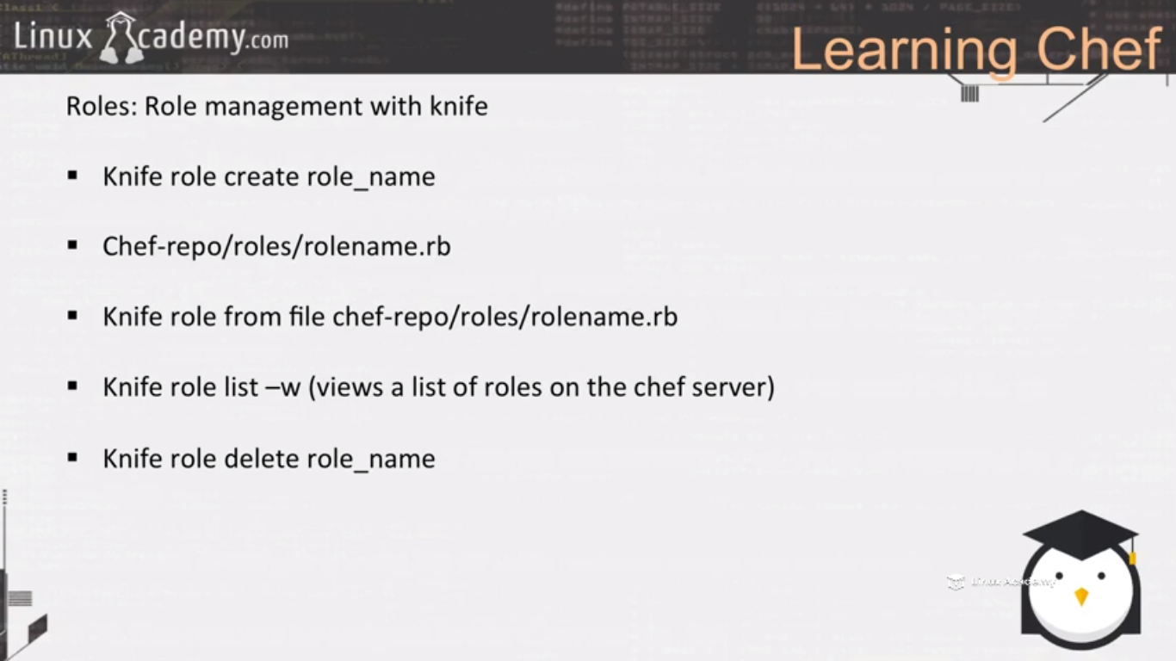

**Lecture: Creating A Web Server Role**

In this lesson we are going to create our first role. This role is going to install the security recipe and Apache recipe on our node. We will create our first role and then assign that role to the run list on our node.

We are going to create our first role which would be going to know as web server role, then we are going to assign it to our centos linux node so that then our linux node would act like as if we it would be a web server. And inside our web server role which is stored inside our chef server we are going to have a runlist of recipes that are to be run. We just have to assign a single item to a chef node in its runlist. We assign it a role and then inside of that we will just update the role on the server rather than to have to touch each node .

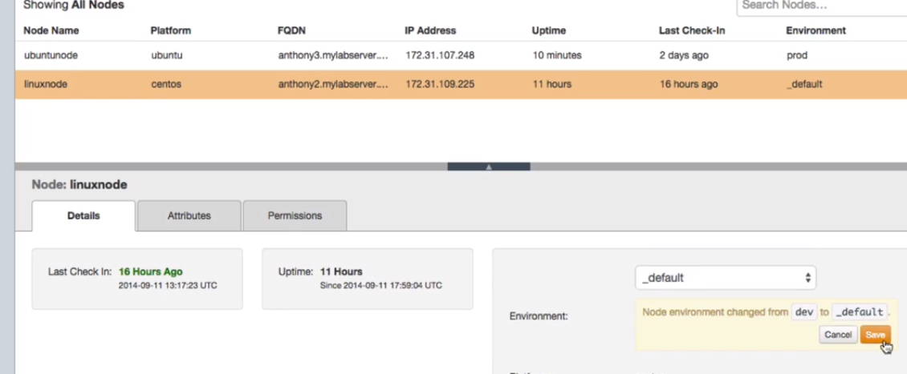

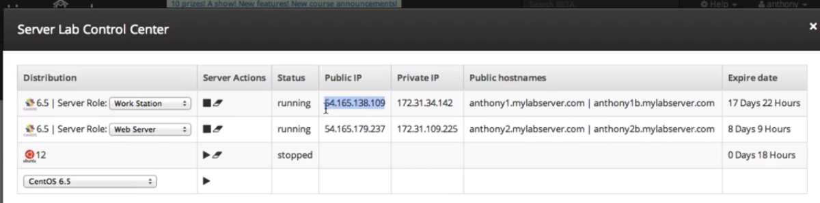

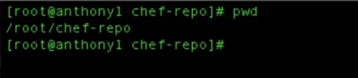

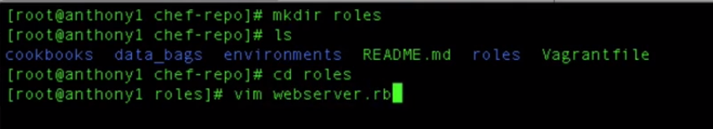

This is the files that we are gonna be creating the roles from

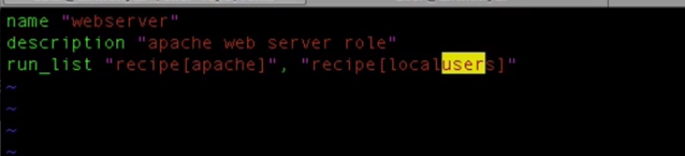

Save and quit.

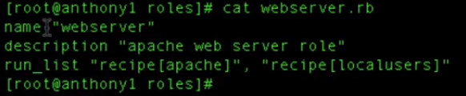

Upload the role to the webserver.



We are in the roles directory that is we just used the webserver.rb if we wouldn’t been in the /roles directory then we have to give the full path of the webserve.rrb

I just want to remove the current list item so just drag the current items and put them in the available recipes as

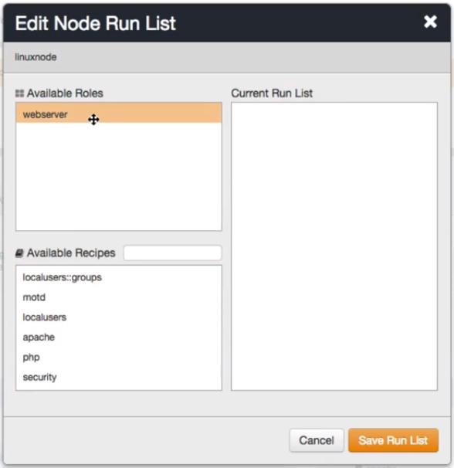

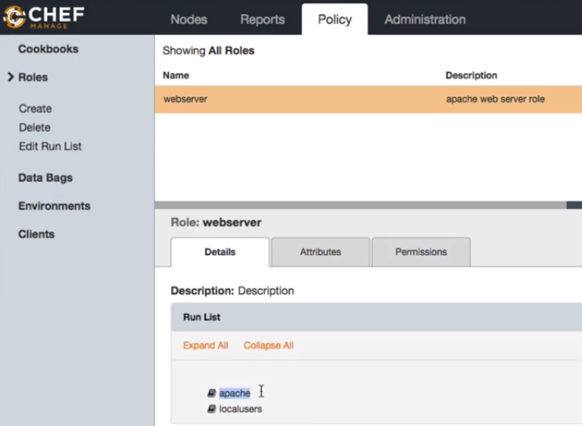

We see the apache and localusers recipes inside the webserver role. So we have to somehow add this role to the node which we want to act as a webserver.

So our node can check in with the chef server and say my role is a webserver give me all the recipes im supposed to run based off our roles runlist. We have to do this one time, we needn’t have to update this everytime we have a new recipe.

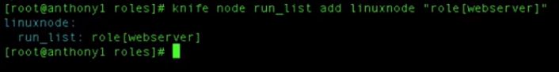

Till then we were in our workstation now head over to the node.



Lets say we want to add one more item

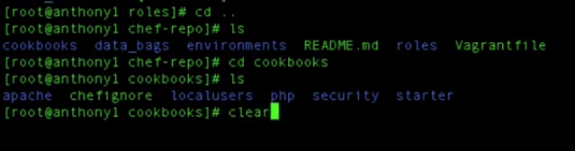

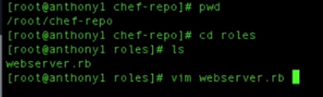

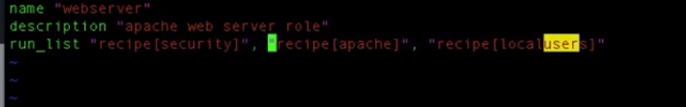

Save and exit

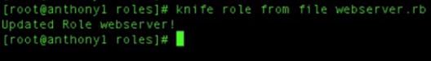

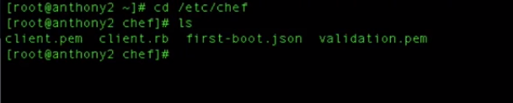

We see the validation.pem file is still there and we know that our security recipe removes our validator.pem file so let see if it removes it or not as we have added this recipe to our webserver role.



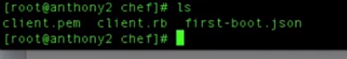\\

We see there is no longer the validation.pem file.

**Lecture: Building A Simple MySQL Cookbook For A Role**

In this lesson we are going to build our lab environment to prepare for another node. This node will act as a database server and our goal will be to have the database role deploy to this node.

Since we are creating a mysql cookbook lets launch a new instance for it.

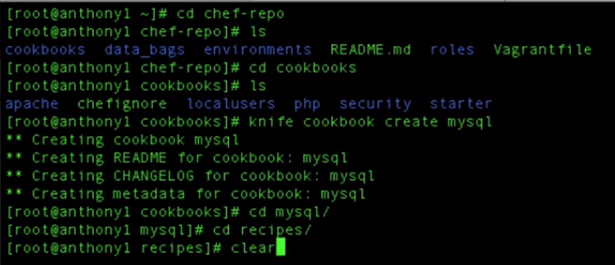

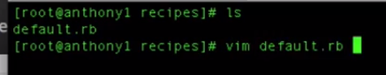

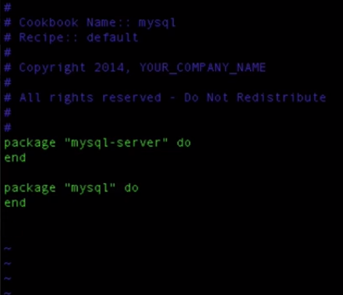

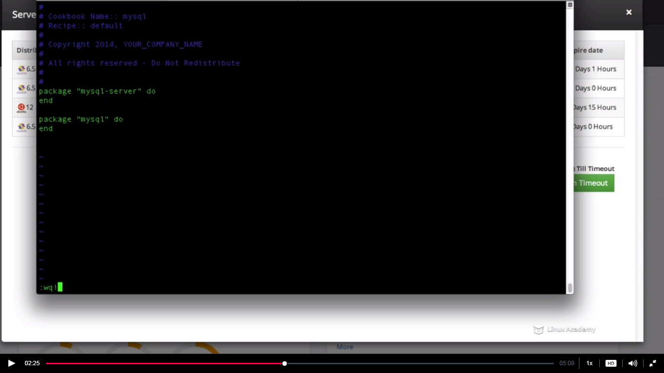

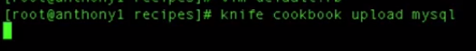

Now lets connect to the new server we created



In order to bootstrap a node we should have the rootlogin enabled as

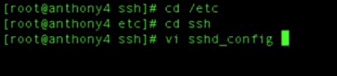

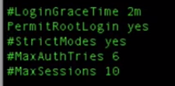

Save and quit.

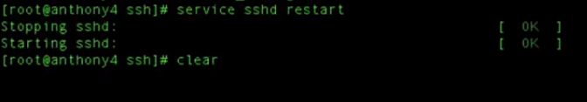

Go to the workstation and bootstrap the node

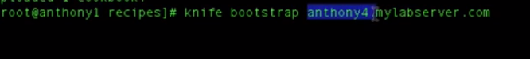

This needs to be your public domain



We have followed the best practises by not giving this node its name. Now during bootstrap it will bootstrap with its FQDNS because each node has to be unique in our environment

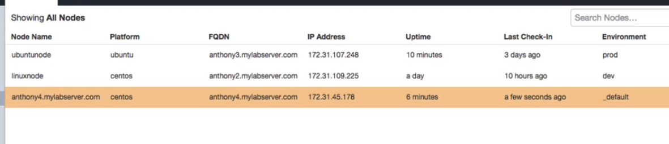

We now see above our newly bootstrapped node .

**Lecture: Creating A DB Server Role**

In this lesson we are going to create our database role and assign it to one of our nodes. From this role all nodes that have the role of database will run the MySQL recipe and install the MySQL server on the node.

This is just a bootstrapped node and we need to give this node a database role.

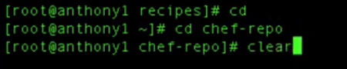

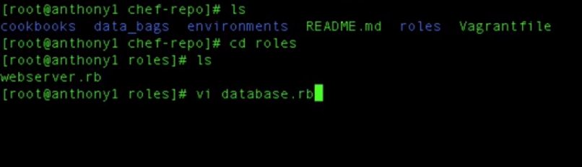

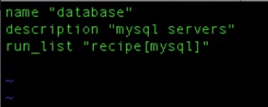

IF we have attributes for this specific role we can define them inside here but since we don’t have we will just save and quit.

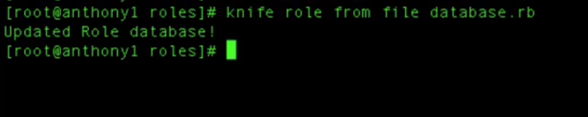

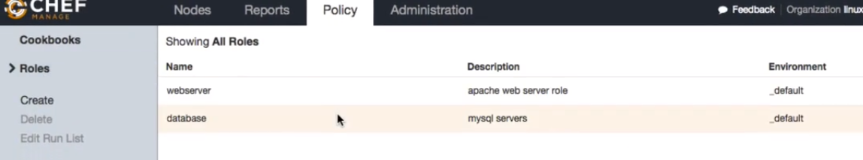

WE see two roles here.

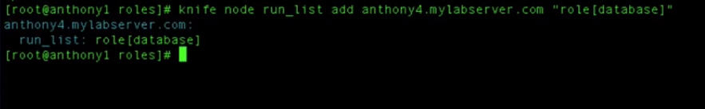

This node is having a database role

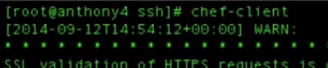

So if we want to verify if mysql is installed or not just do a

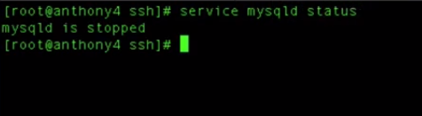

It is stopped because we haven’t added a service resource inside our recipe that starts this service.

**Lecture: Creating A Base Role**

In this lesson we are going to learn how to create a base role. The base role is going to contain the run_list of recipes that we want to run on ALL our nodes. This way all you have to do is include the base role in your other roles in the environment.

Now we have two nodes running two different role one database and one webserver role.

So now what needs to be done if there are recipes that are to be run in both the nodes.

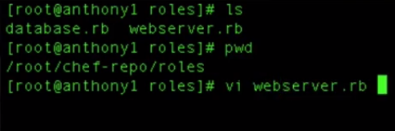

Here we want to say that the security recipe and the localusers recipe whould be there inside every environment.

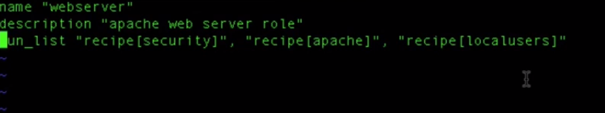

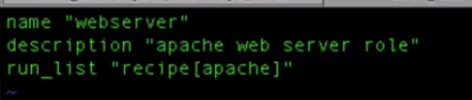

Save and quit after removing the recipes

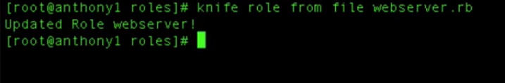

Create a new role

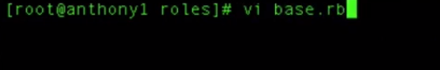

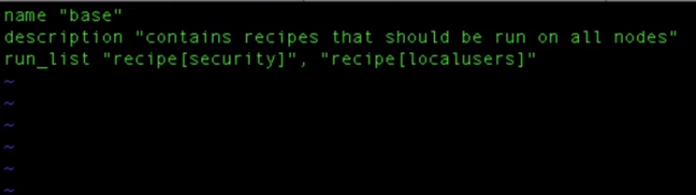

Save and exit

We will add this role to both roles we already have. We have already mentioned this base role has to be run for the nodes in the environment so we have two roles and we want the base role to be run for the both nodes

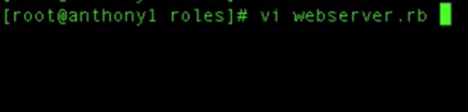

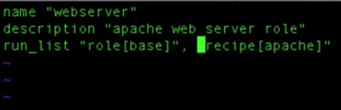

Save ane exit

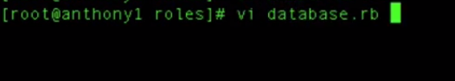

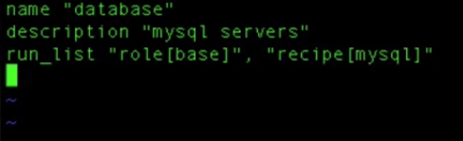

Save and quit

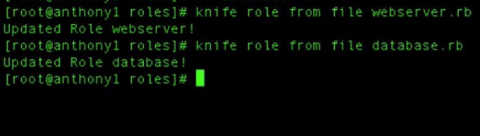

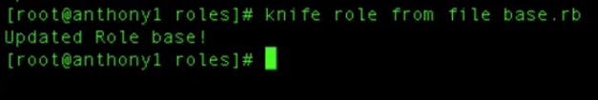

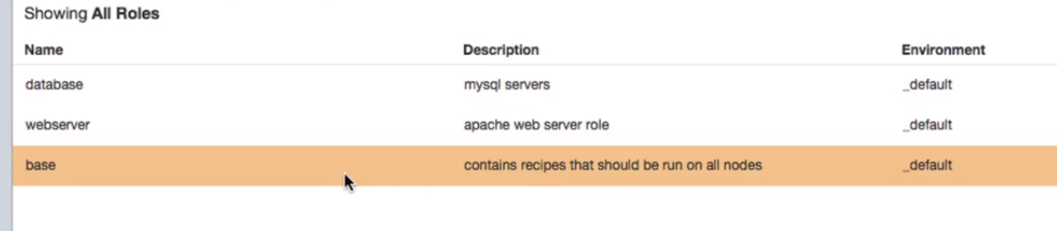

Lets head to our database node

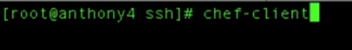

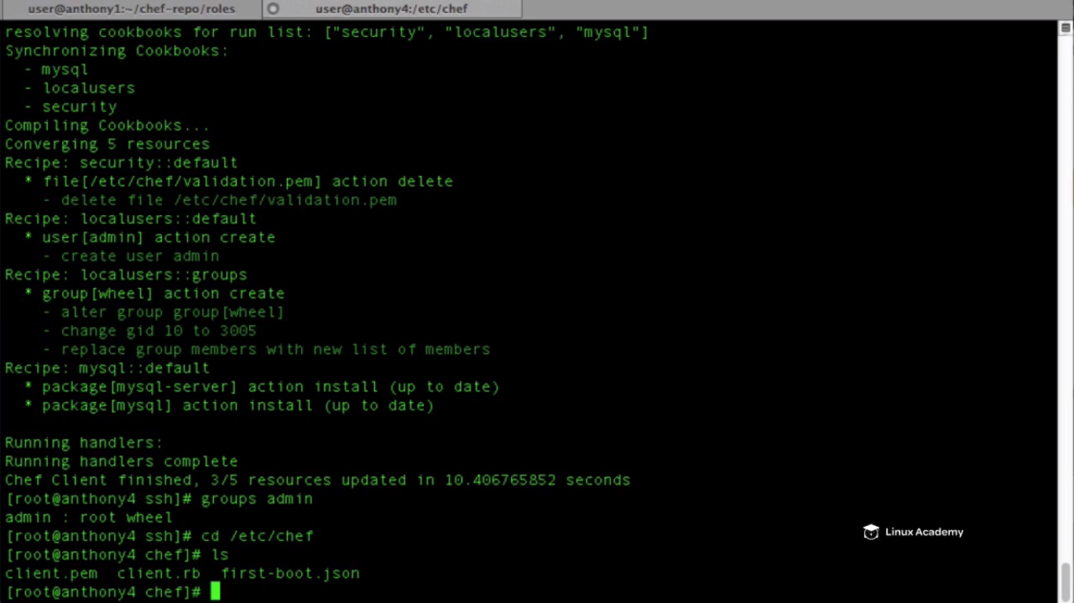

**Extending Chef**

**Lecture: Knife Plugins**

In this lesson we are going to talk about a few of the Knife command line tool plugins available to us as DevOps administrators.

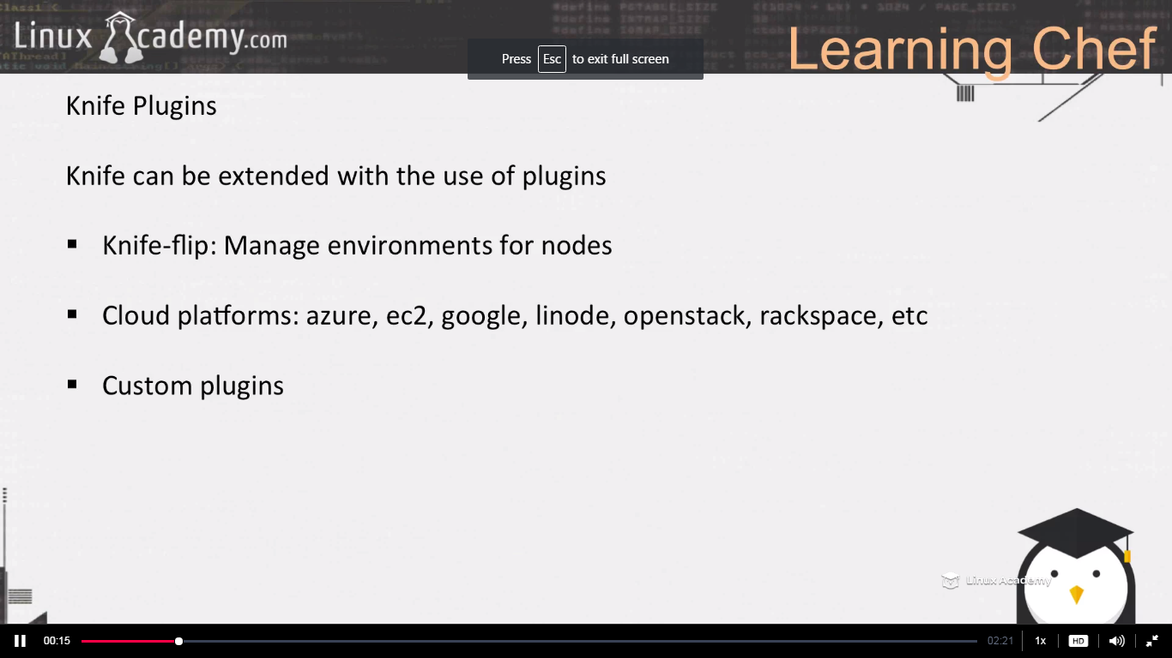

**Lecture: Chef Supermarket And Chef-Client Cookbook**

In this lesson we are going to look at pre-built cookbooks already available on the Chef supermarket

Chef provides us with a library of prebuilt chef recipes . There are lamp server recipes, mysql recipes,ngnx recipes etc One of the cookbook is chef client . This cookbook already allows us to configure automated runs of chef clients on our nodes so this cookbook will download and install a base role for all of our node

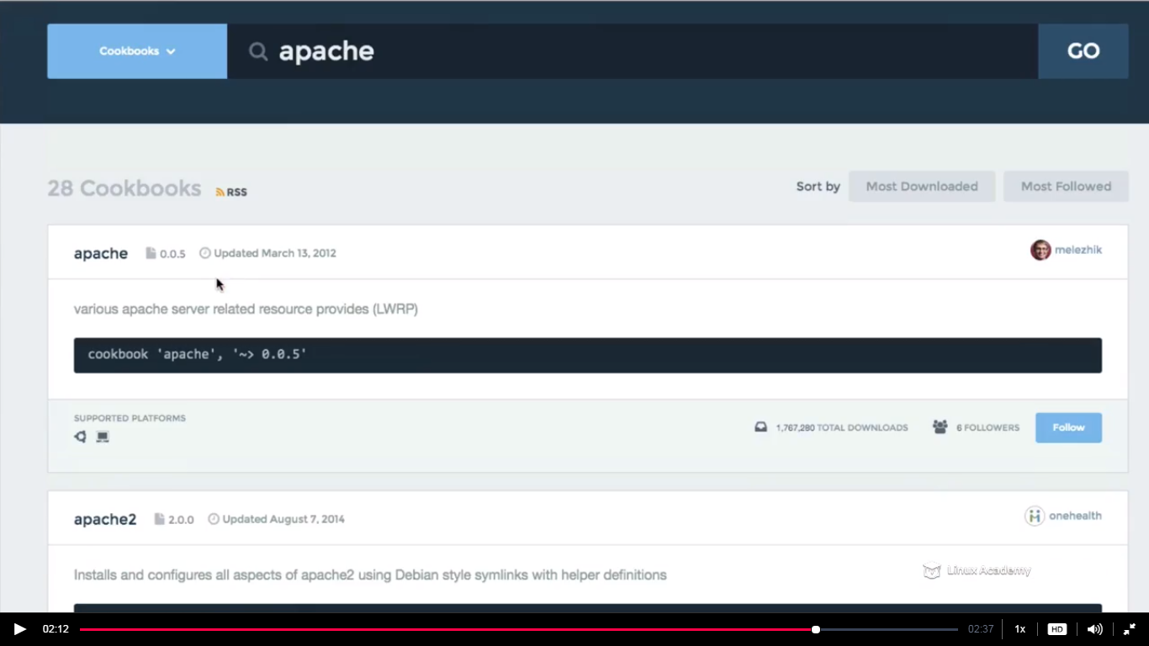

**IF we go and search for apache cookbook or any another cookbook you just have to search in the community for that cookbook**

**Deploying Nodes In Production**

**Lecture: UnAttended Node Bootstrapping**

In this lesson we are going to talk about the production workflow as well as how to configure unattended bootstrapping. We use unattended bootstrapping for services such as AWS EC2 Auto Scaling.

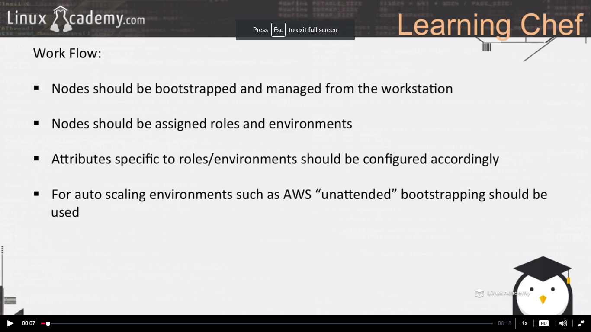

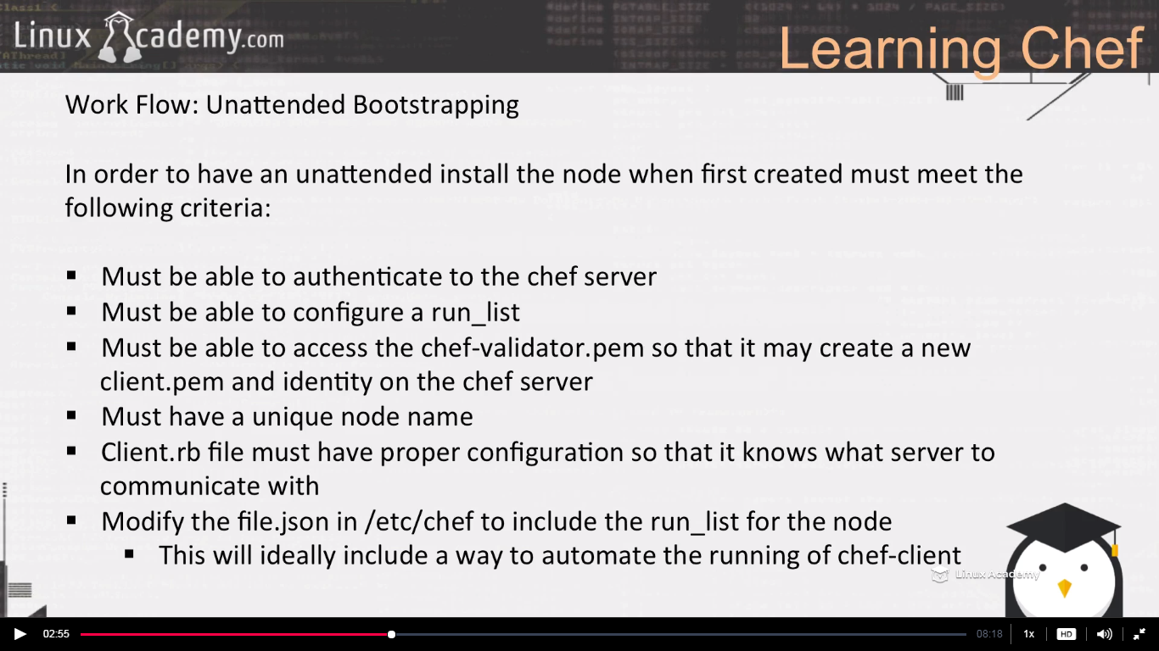

If you are familiar with the amazon user data then we can pass the bash script in the user data which download the validator.pem or client.pem from S3(if we have kept it there) and the chef-client and install it. So in this case we don’t have to do the above mentioned things manually. The instance during boot will get the validator.pem and the chef-client,ruby, file.json(or say all the things mentioned above during the unattended bootstrap) installed.

**Lecture: Chef-Client Cookbook (Security And Automated Runs)**

In this lesson we are going to learn how to use the chef-client supermarket cookbook to automate the chef-client runs on our nodes. Automating the convergence (chef-client) runs is very important for automation in our infrastructure.

So the chef-client cookbook runs bydefault every 30 minutes.

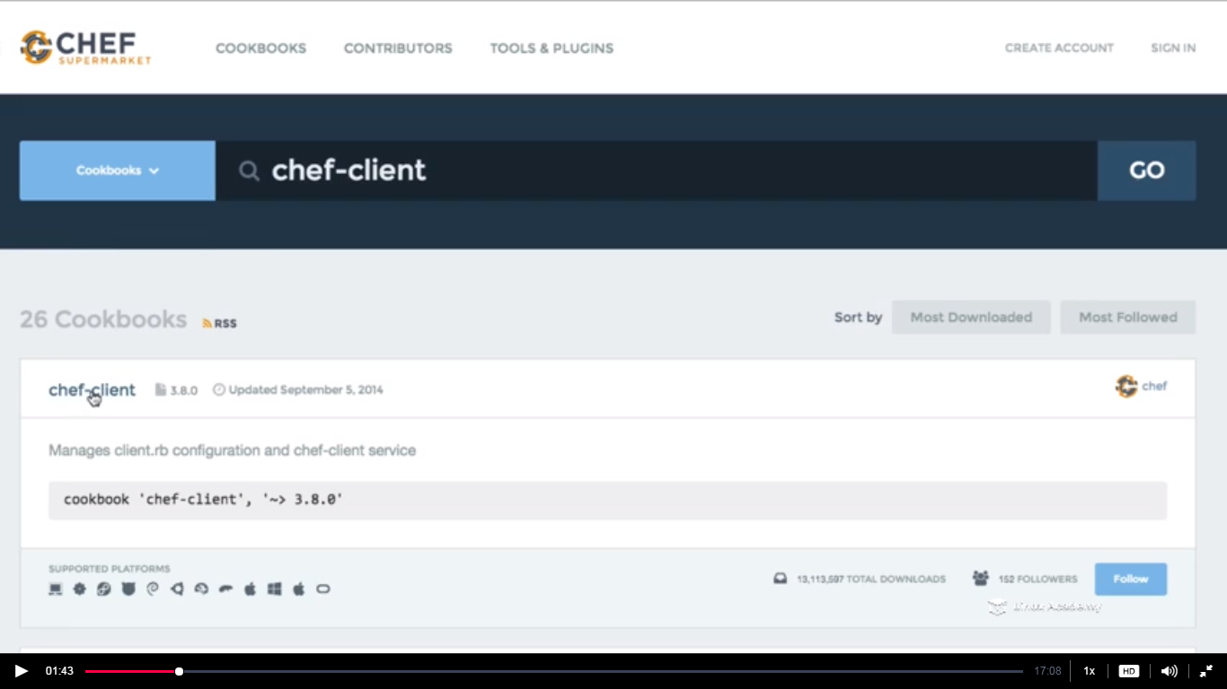

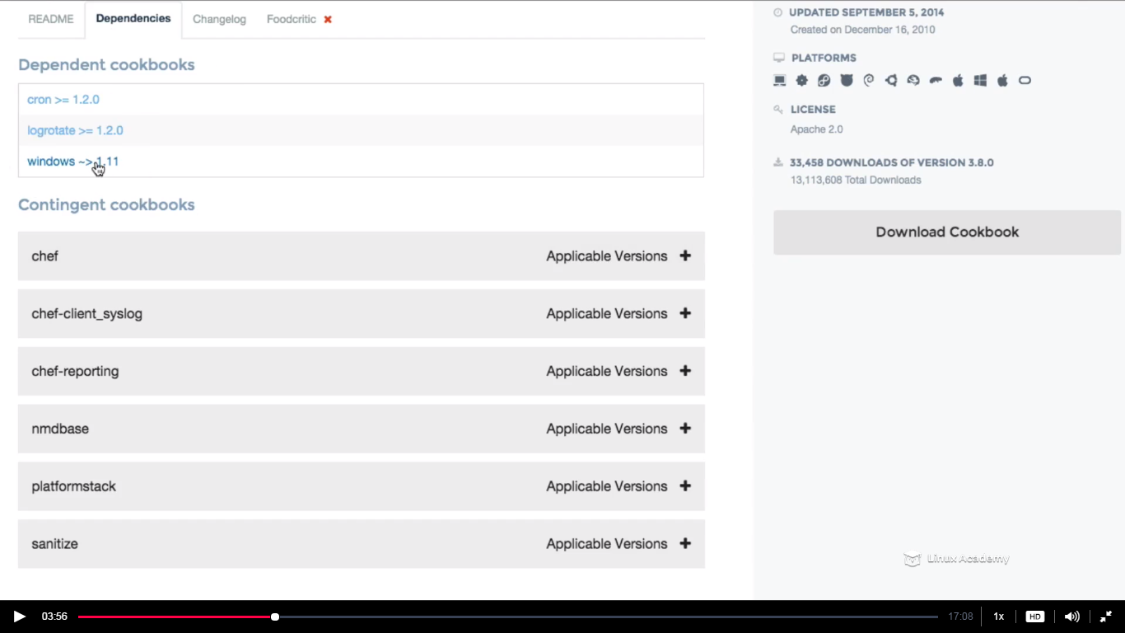

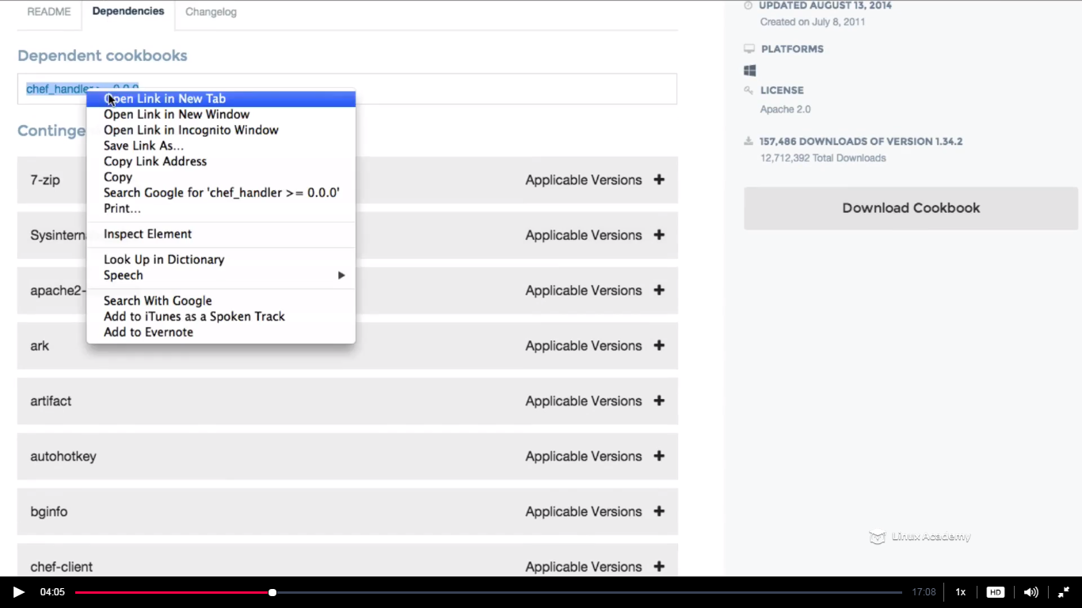

Download all the dependencies for this cookbook(4 dependencies are there like logrotate,windows,cron and there is a dependency for the windows itself.

Since we have downloaded these we need to upload these to our workstation inside our chef-repo directory.

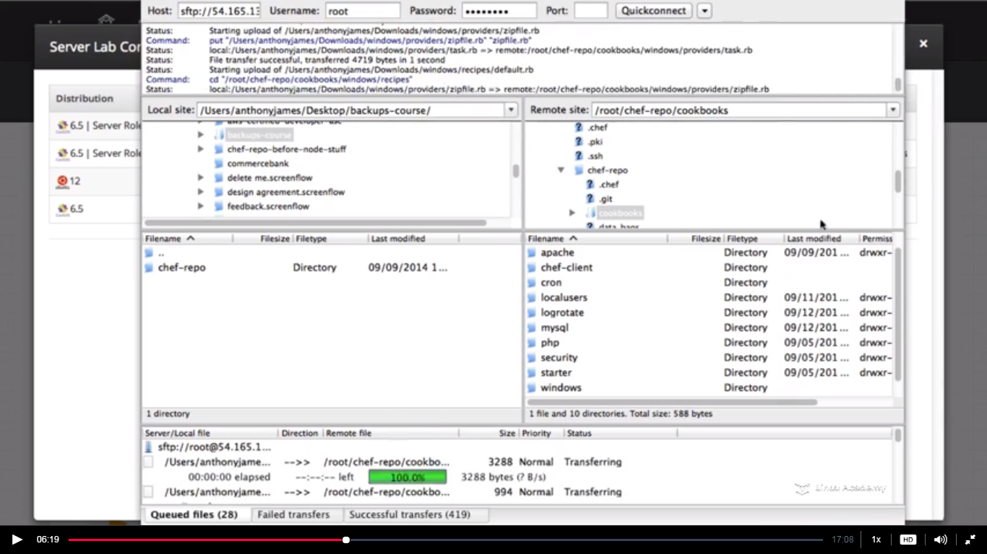

Uploading the downloaded cookbook to workstation by firezilla

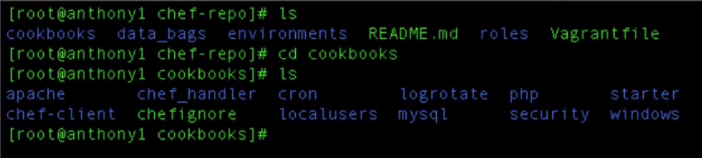

Now we need to upload these cookbooks to the chef server.

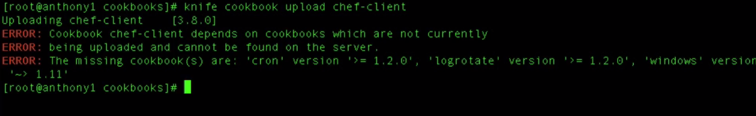

Error because chef-client has dependencies on logrotate and cron and windows cookbook which hasn’t been uploaded to the chef server. So the cookbook on which chef-client reliazes need to be uploaded first. Also we know that the windows cookbook has a dependency on the chef handler cookbook. So the order in which I should upload the cookbook is chef-handler then windows, logrotate,cron and chef-client.

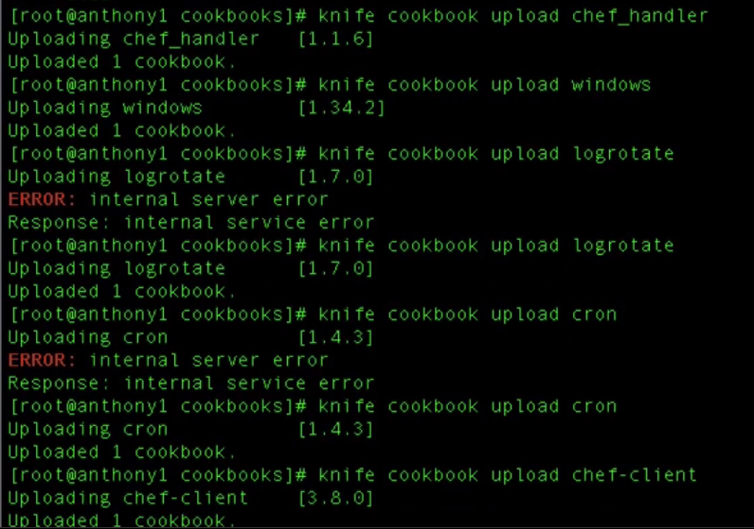

Since our cookbooks are uploaded what we need to do is somehow get the recipes and configurtions to run on every single node. So our goal here is to remove the validator.pem file from every node and also configure our chef-client convergence to automatically run every 13 minutes on every single node

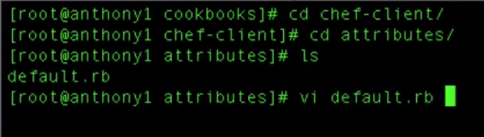

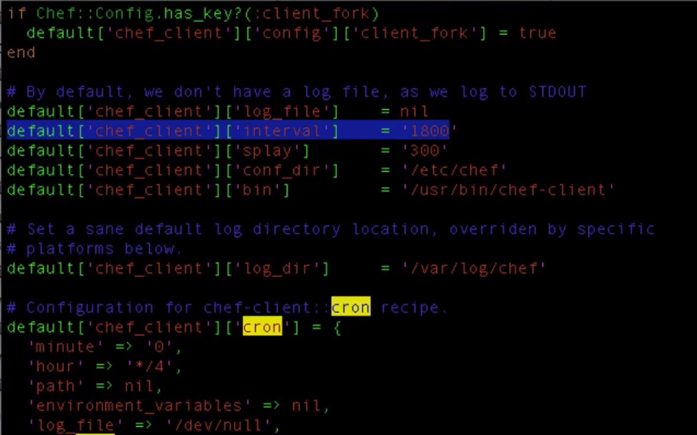

So we wont be doing anything here we will just exit.

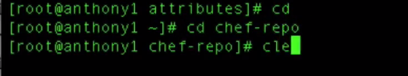

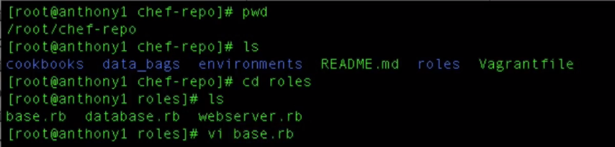

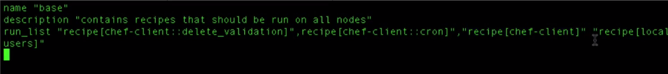

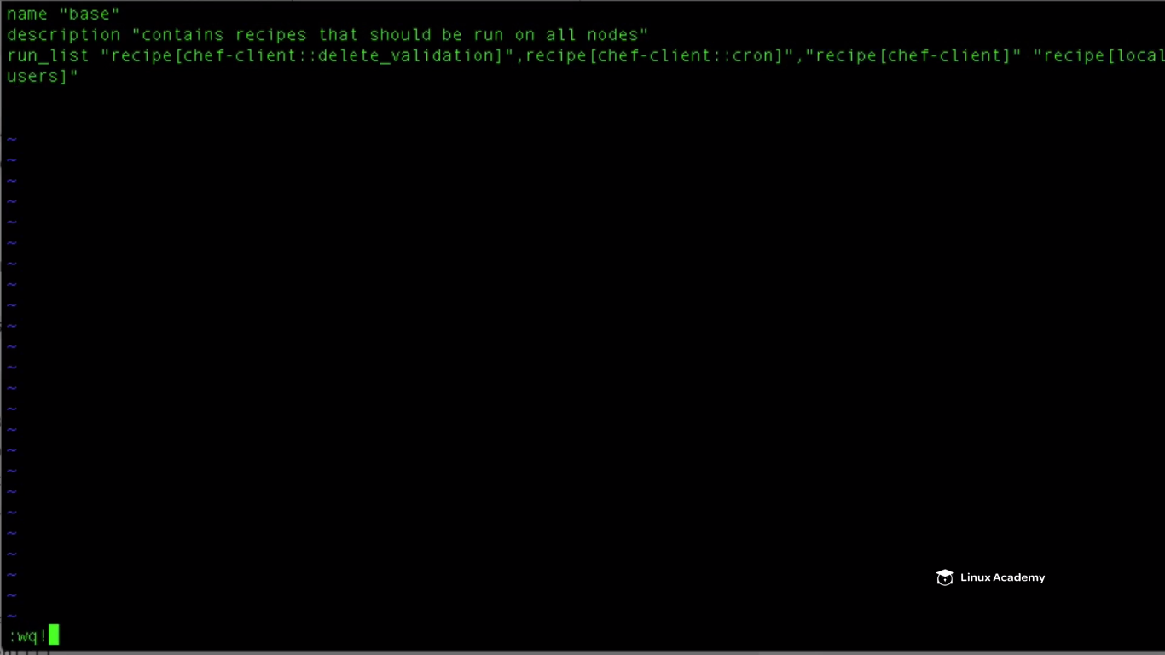

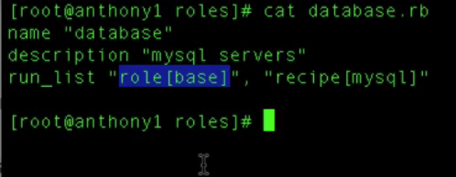

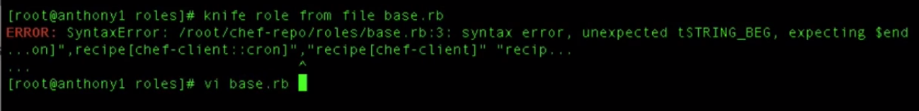

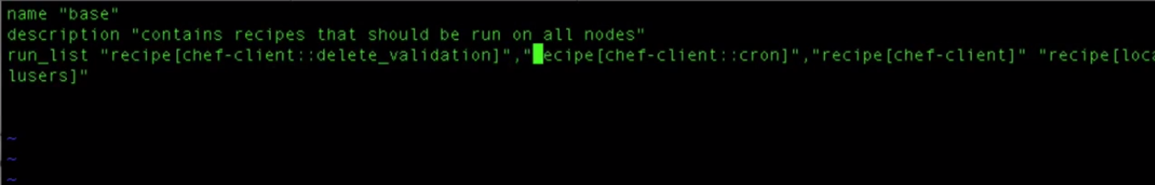

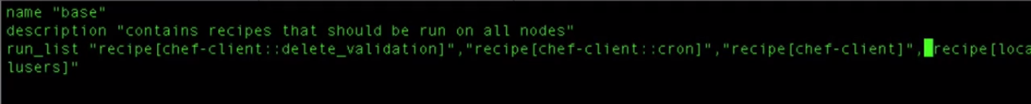

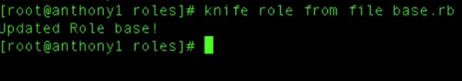

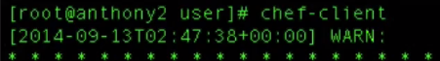

Running chef- lient on centos node.

Do a **crontab –e**

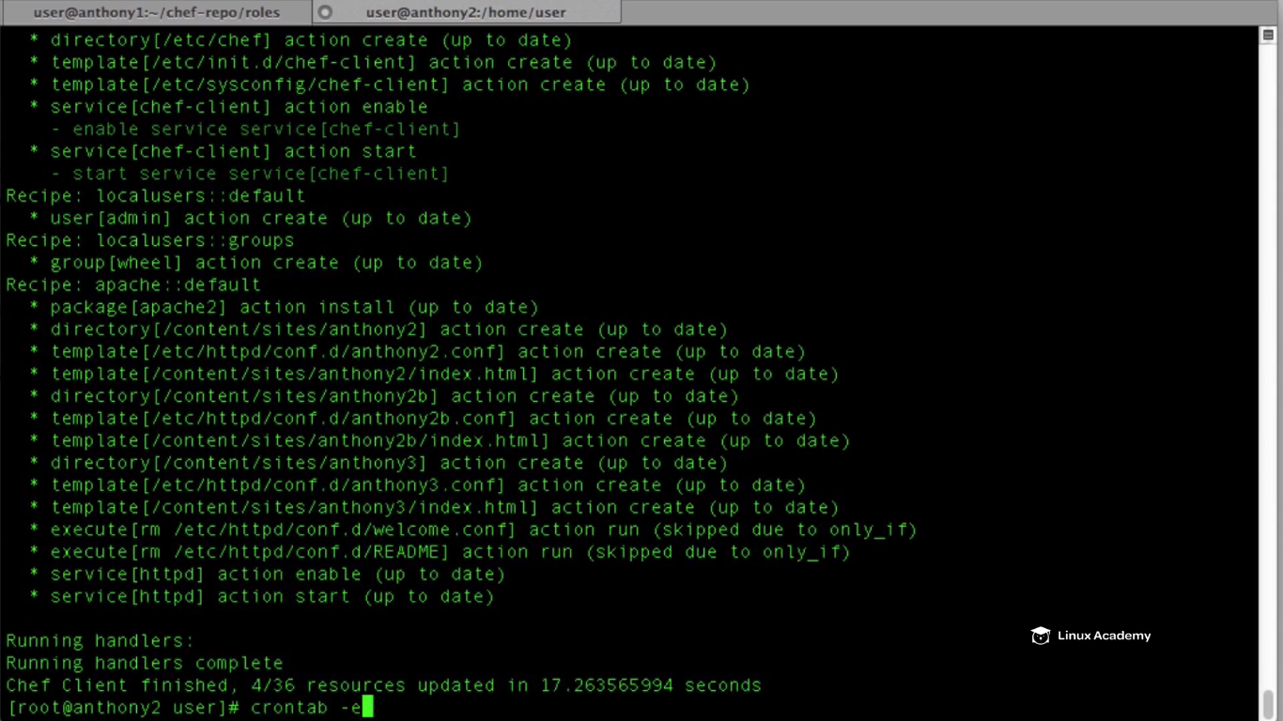

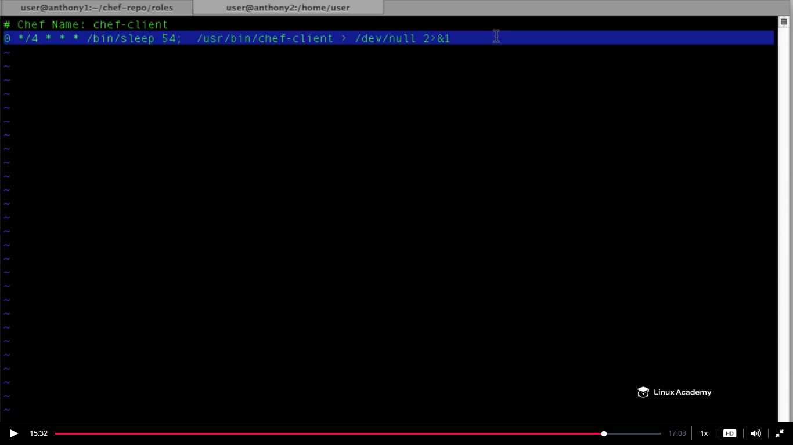

WE see our chef-client will run on the designated time on the attribute.



We see there is no validation.pem file

In production we set the node to run automatically not to run chef-client manually.

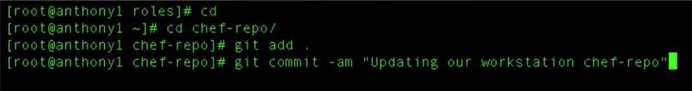

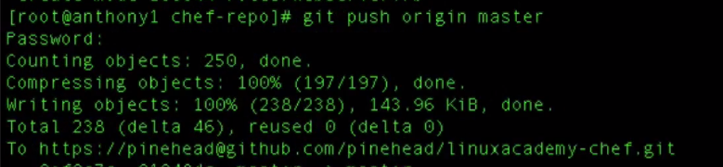

Now anyone can pull the configuration from the GIT whenever he wants.

**Using OpenSource Chef Server**

**Lecture: OpenSource Chef**

In this lesson we are going to take a look at starting our LinuxAcademy OpenSource Chef server and configuring it to work. We will login for the first time and look around our Chef server.

We know there is two versions of chef-server enterprise version and open source chef server. Now the enterprise chef server has a hosted chef version which we have been working on during our this chef course. They also have a self hosted version that we will host in our environment.There is a free version of chef which is called open source . In this case of open chef server its not that scalable and we don’t have organization within our environments. So if we want our cookbooks completely separate from other organizations like we do in chef enterprise then we need to fire up different chef servers for different organizations.

We have to host our open source chef server in our own environment . Not only that configuring our workstation and downloading our starter kit is substantial different when working with our open source chef server.

IF you are using your own version of server then go the chef website and download the rpm version of the open version of chef server.

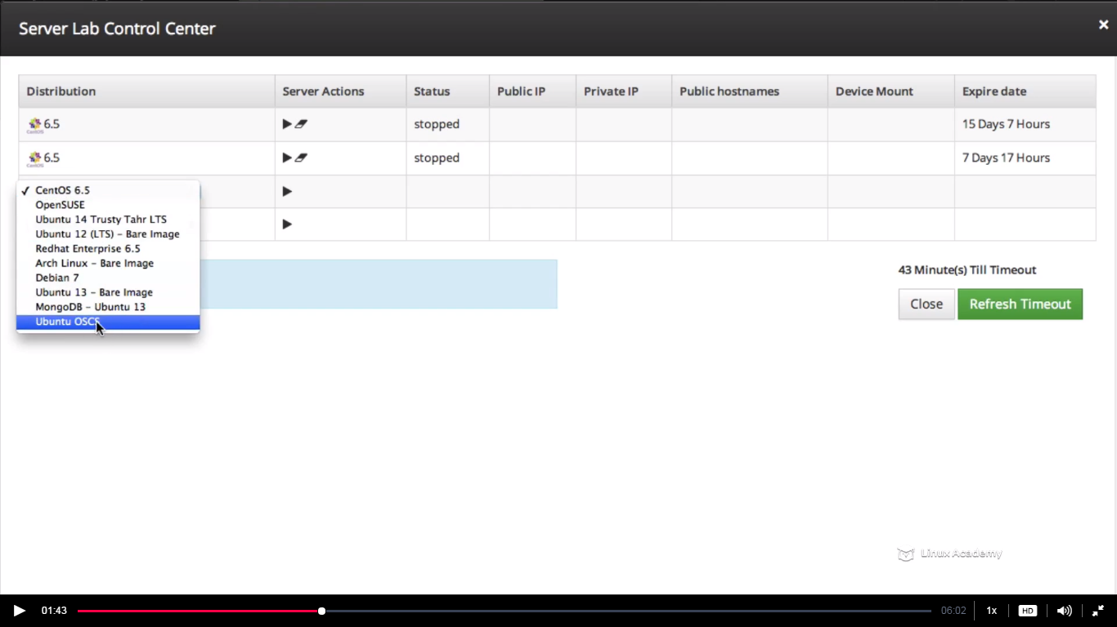

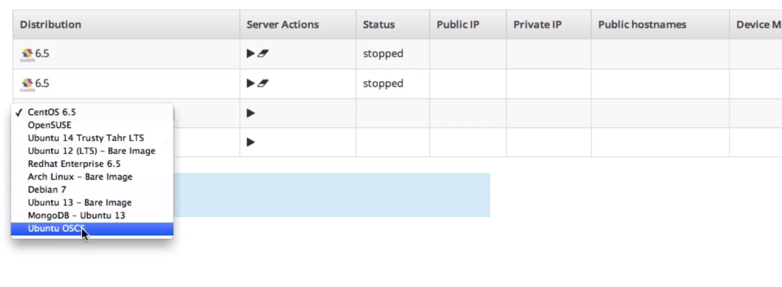

Hit start after selecting this and then connect to this server.

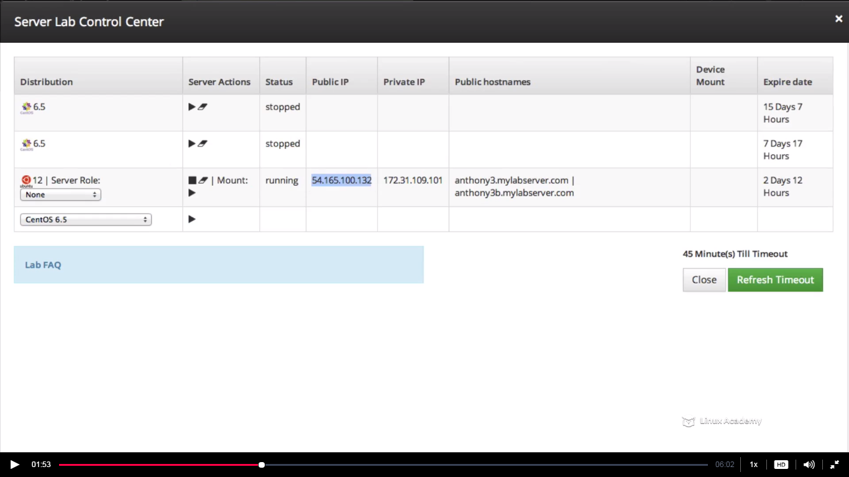

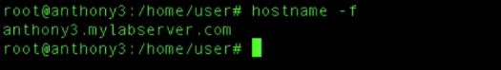

To run a open source you need to have FQDN and you can verify that by the above step.

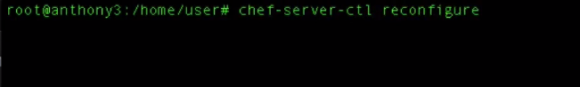

To test if the server is running fine after reconfiguring do

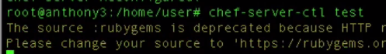

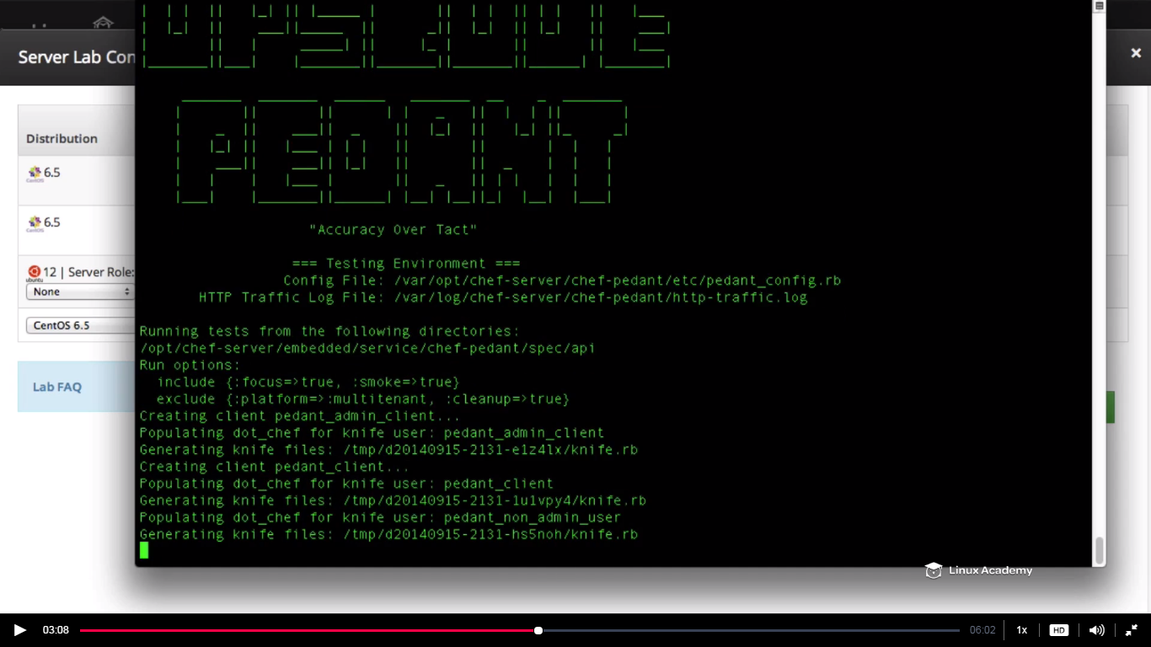

Since we are getting the ASCI code this is first symbol that our chef server is running fine after the reconfigure.

If there are errors then there is a reason that you don’t have a FQDN.to resolve that.

Go to browser and use the public ip or the FQDN

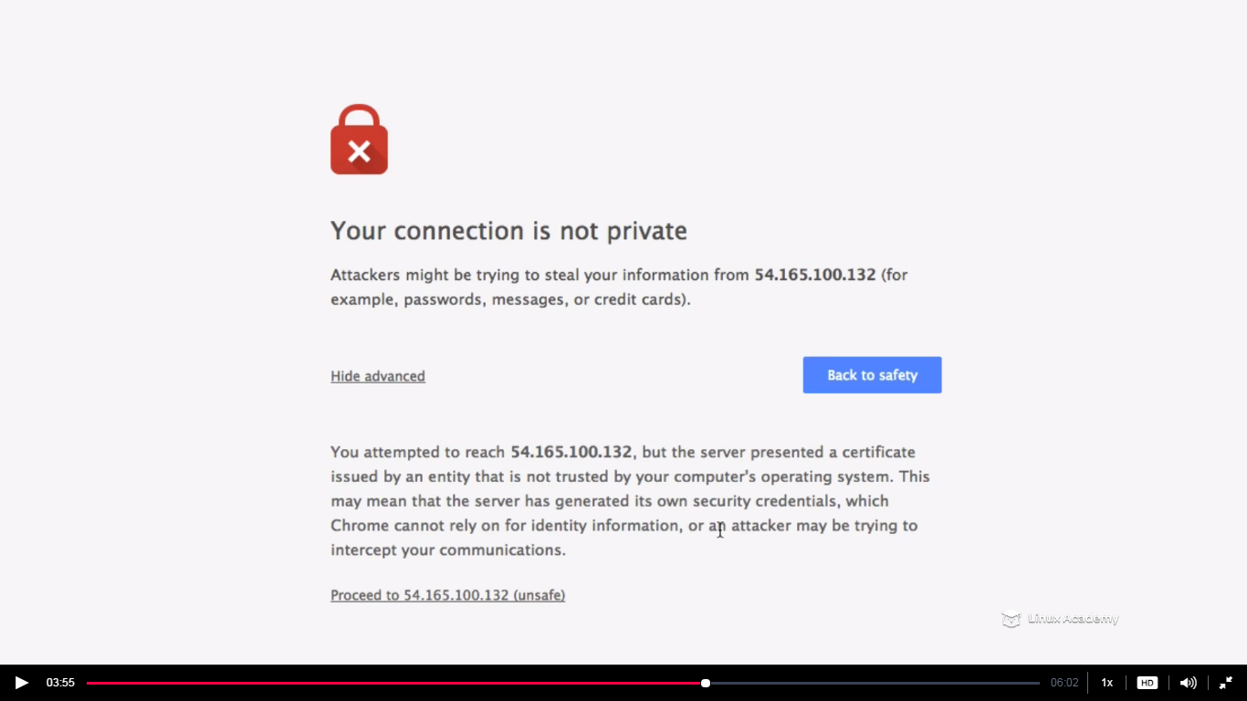

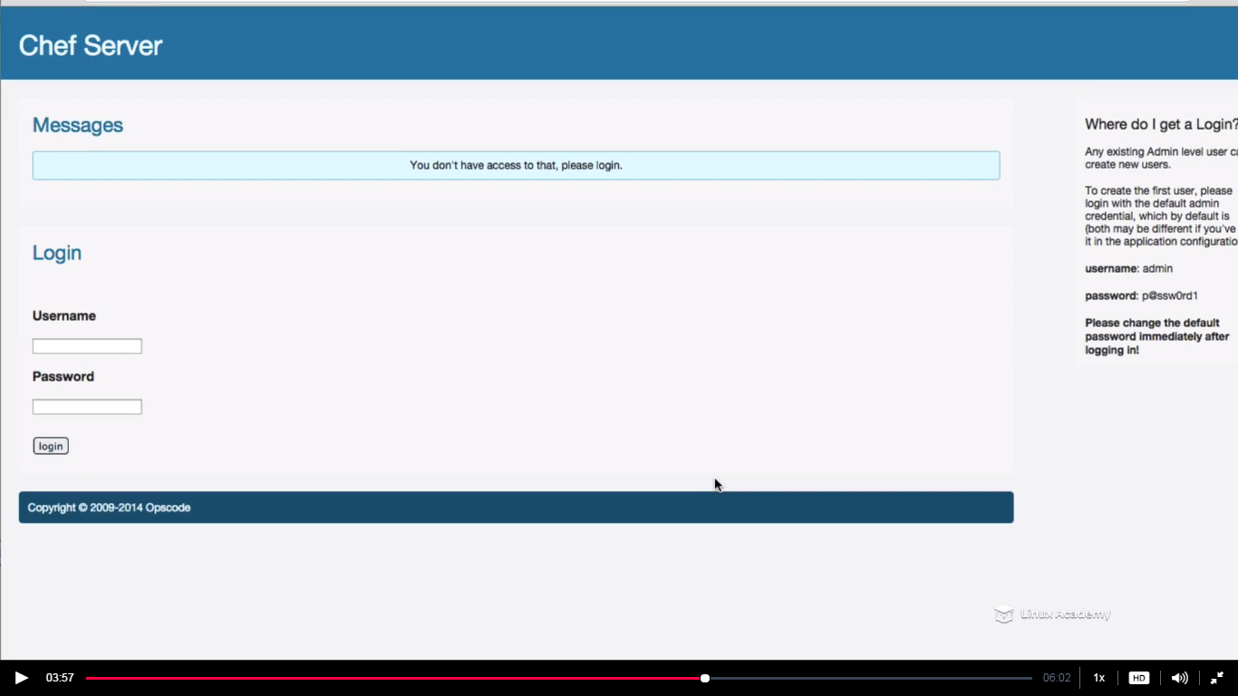

On right hand there is a default username and password and we can use this to login

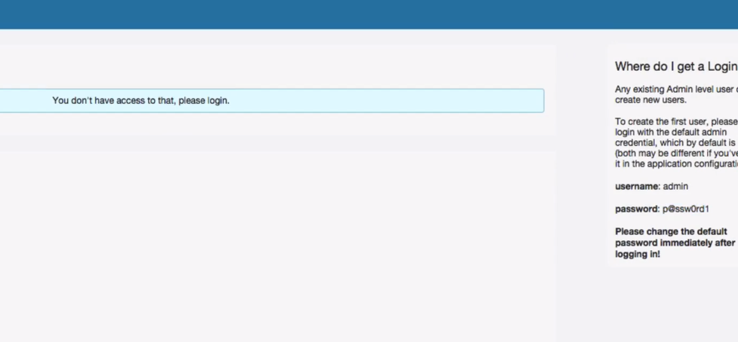

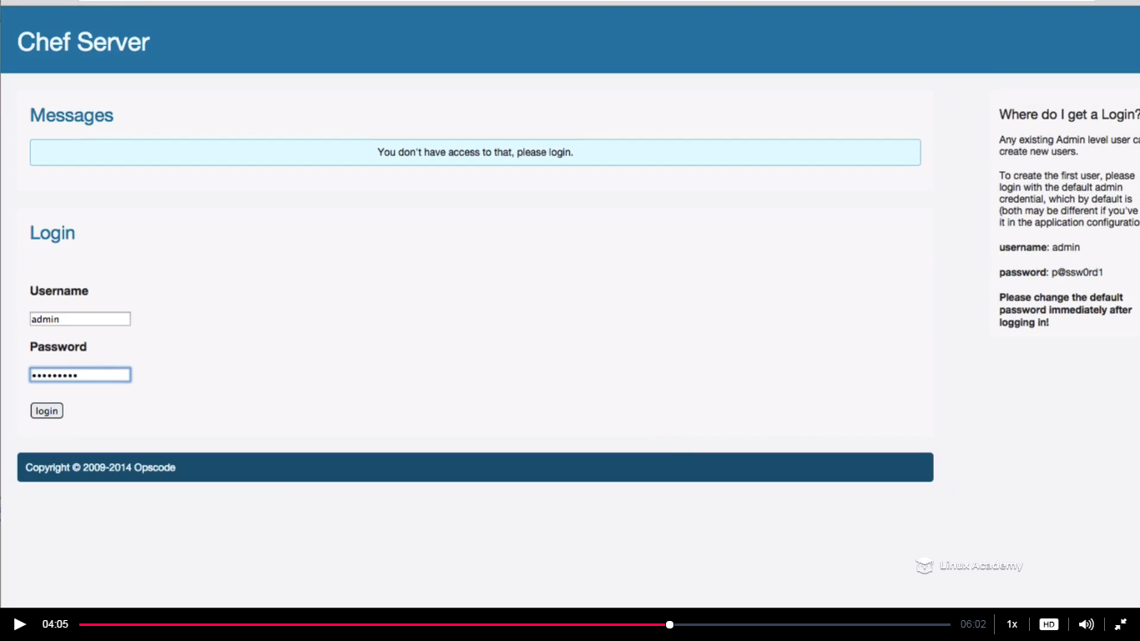

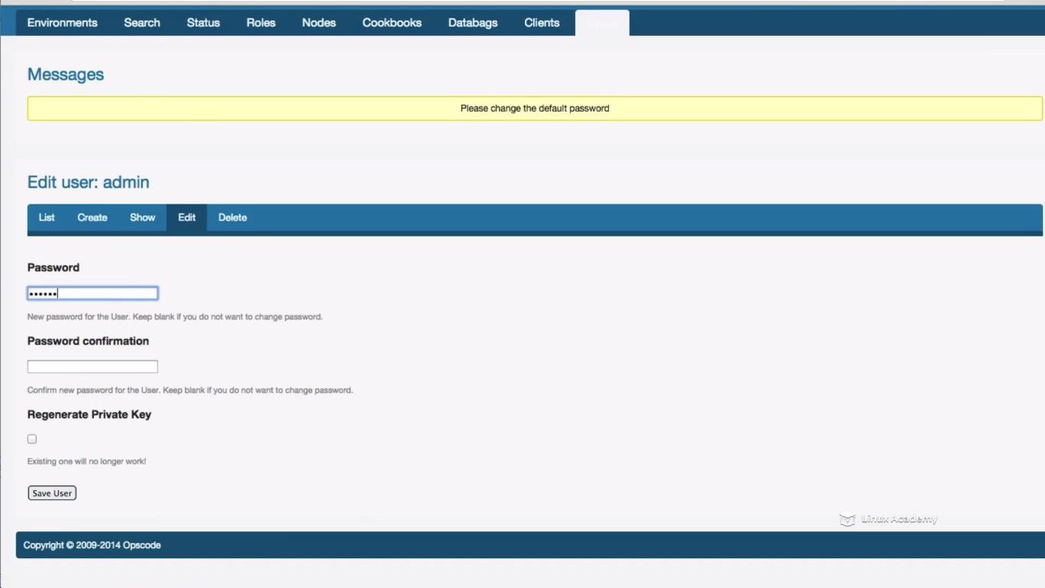

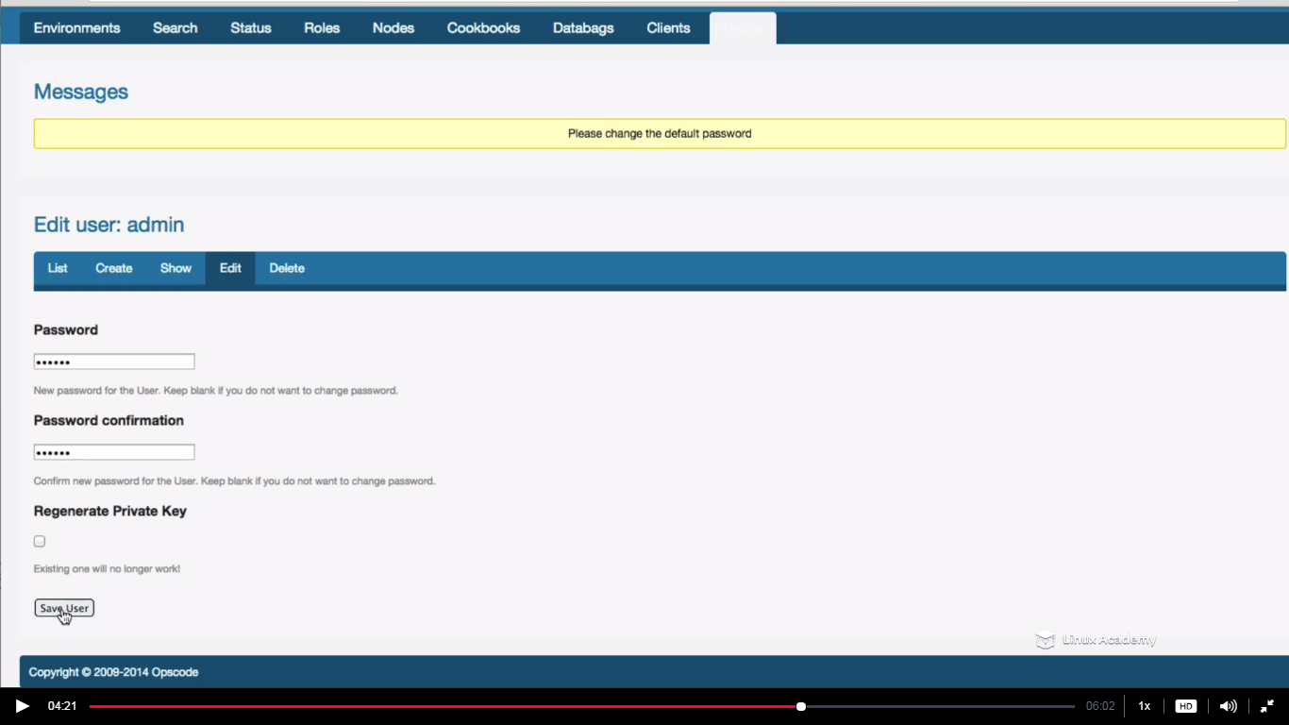

**Lecture: Configuring The Workstation And Bootstrapping A Node**

In this lesson we are going to learn how to configure the certificate credentials that allows our workstation to communicate with the opensource chef server as well as bootstrap nodes. We are also going to configure knife manually as well as download the chef-repo from github.

This is a fresh instance which im using as a workstation.



It downloads chef and knife for us.

We will now download the chef repo. We don t have organization here to download the starter kit so what we have to do is to download the chef repo from github and then configure our keys manually.



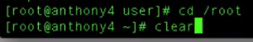

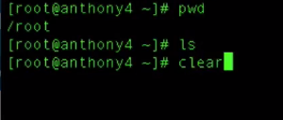

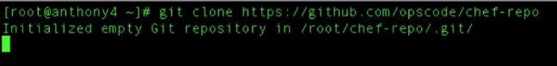

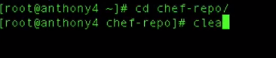

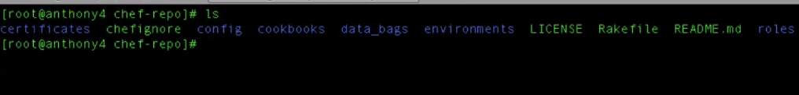

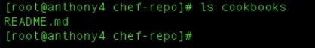

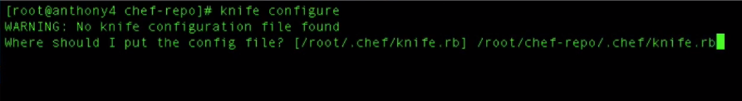

Give the open source chef server url





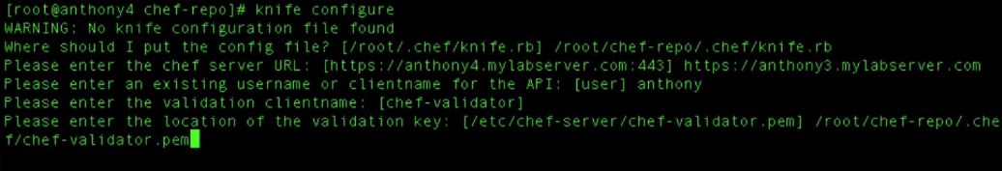

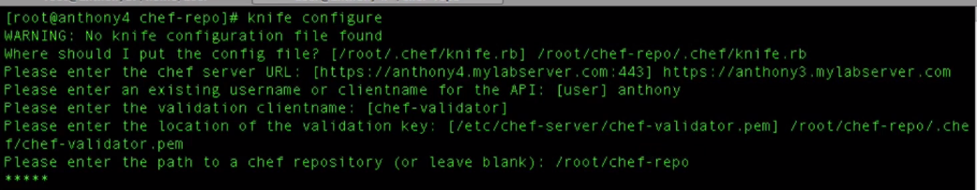

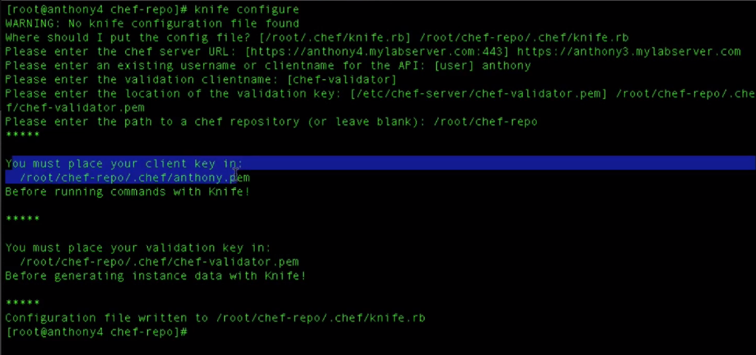

WE need to generate these these and for these go to the chef server

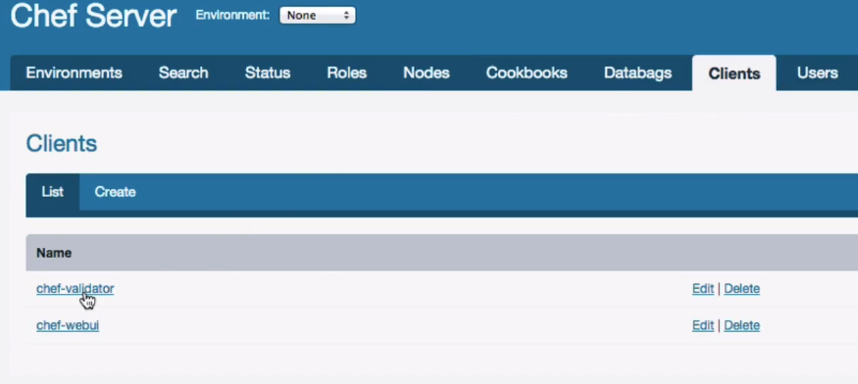

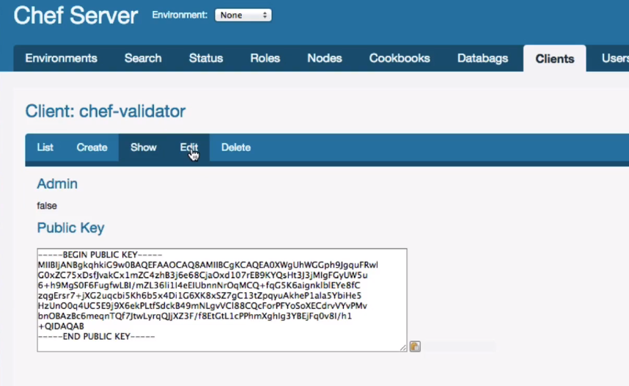

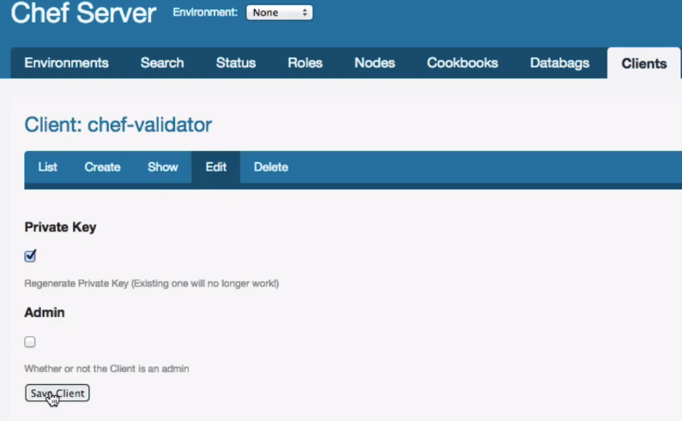

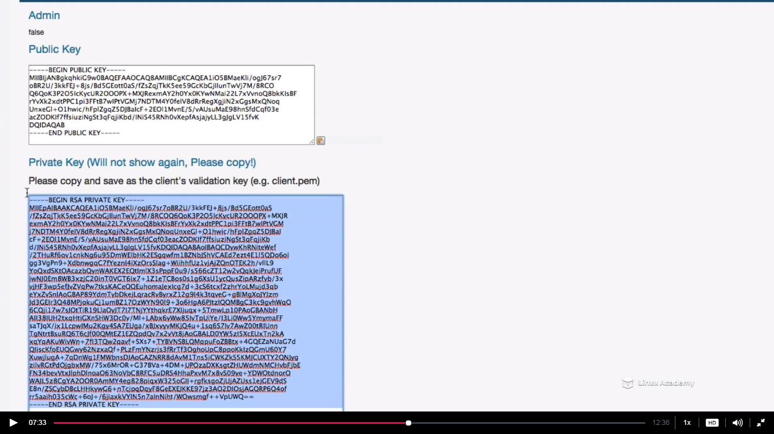

This is the new RSA key generated. This key will only be available right now. That’s why we need to copy it

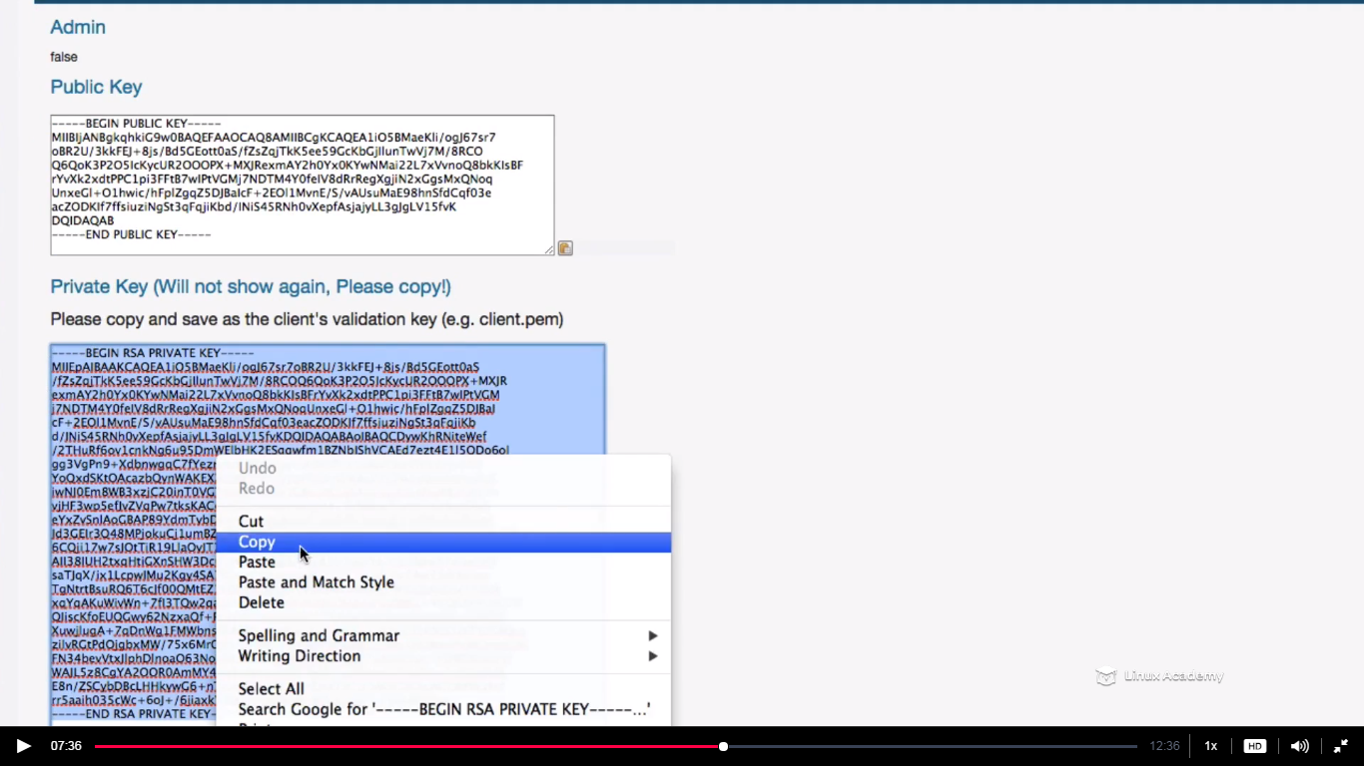

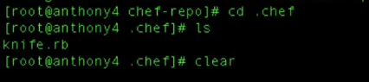

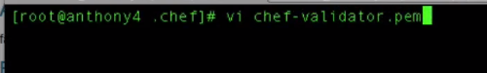

We need to paste the contents which we copied earlier.

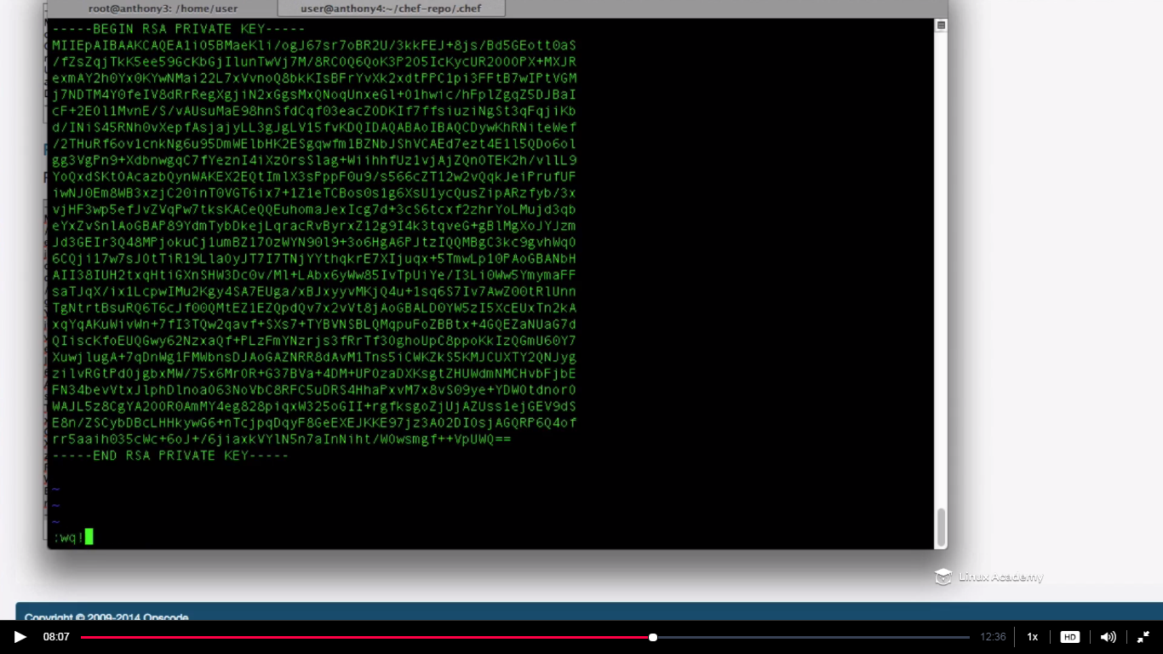

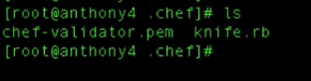

Next we need to create a key for the user.

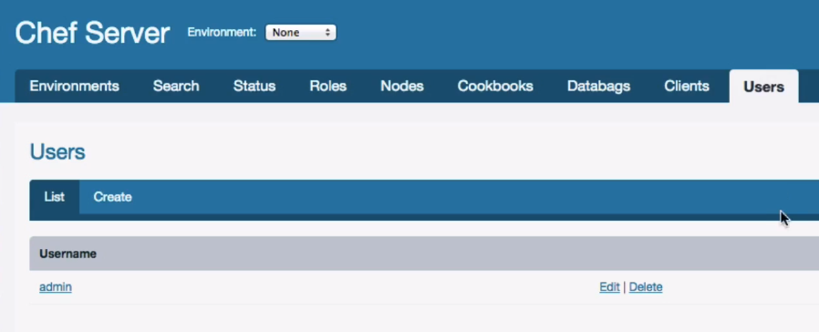

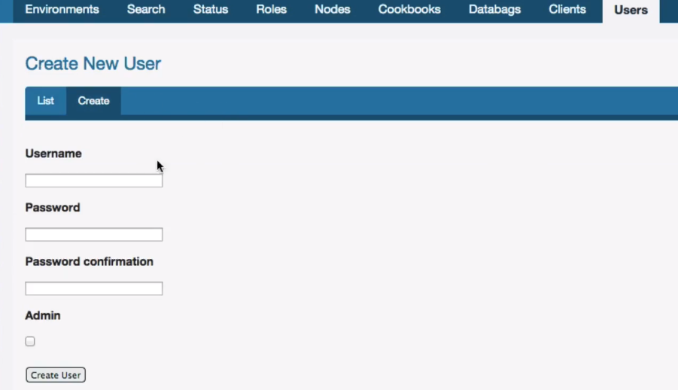

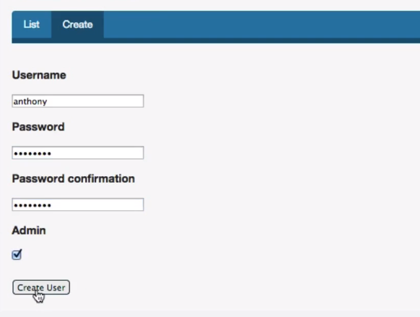

Anthony because we gave this name while we were configuring the workstation.

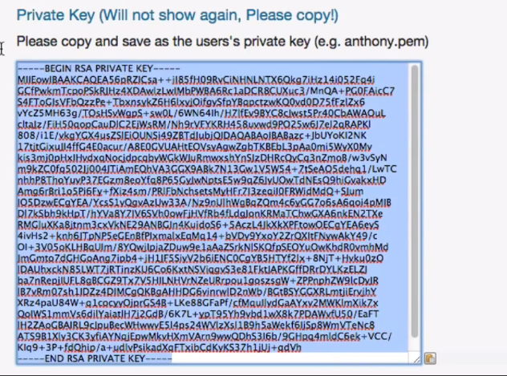

Again copy the private key and place it inside Anthony.pem.

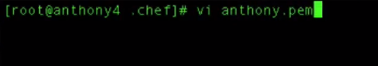

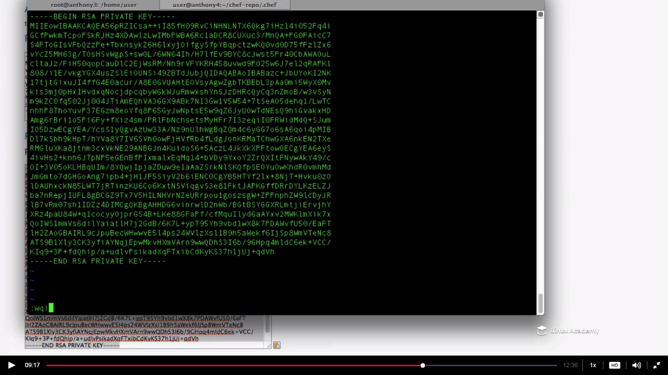

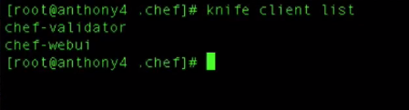

Lets bootstrap a node and connect it to the chef-server.

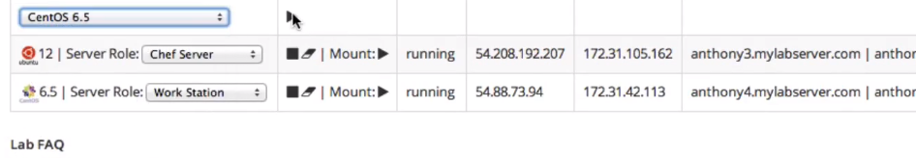

Fire a new instance.

Connect to the node just launced via public ip

Enable the root user login

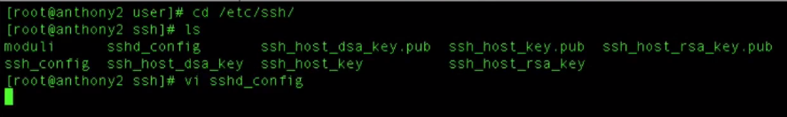

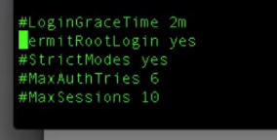

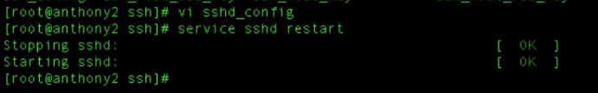

Head back to the workstation and bootstrap the node



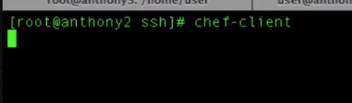

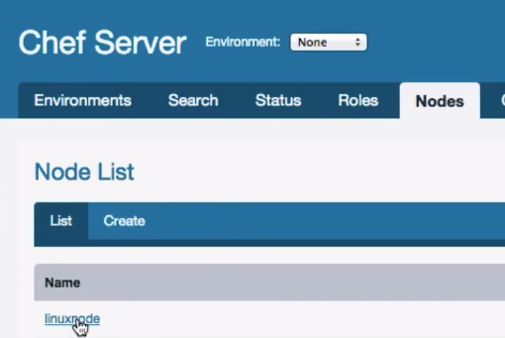

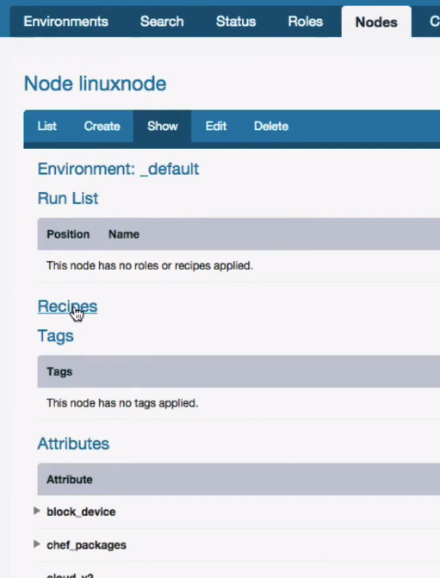

**Lecture: Closing: Bootstrapping Nodes And Deploying Cookbooks**

In this lesson we are going to demonstrate that our workstation will work correctly with our opensource chef server. At the end of this lesson we will conclude the course!

